Network Camera

User Manual

Thank you for purchasing our product. If there are any questions, or requests, please do not hesitate to contact the dealer.
This manual applies to Network Camera.
This manual may contain several technical incorrect places or printing errors, and the content is subject to change without notice. The updates will be added to the new version of this manual. We will readily improve or update the products or procedures described in the manual.
DISCLAIMER STATEMENT
“Underwriters Laboratories Inc. (“UL”) has not tested the performance or reliability of the security or signaling aspects of this product. UL has only tested for fire, shock or casualty hazards as outlined in UL’s Standard(s) for Safety, UL60950-1. UL Certification does not cover the performance or reliability of the security or signaling aspects of this product. UL MAKES NO REPRESENTATIONS, WARRANTIES OR CERTIFICATIONS WHATSOEVER REGARDING THE PERFORMANCE OR RELIABILITY OF ANY SECURITY OR SIGNALING RELATED FUNCTIONS OF THIS PRODUCT.”
Regulatory Information
FCC Information
FCC compliance: This equipment has been tested and found to comply with the limits for a digital device, pursuant to part 15 of the FCC Rules. These limits are designed to provide reasonable protection against harmful interference when the equipment is operated in a commercial environment. This equipment generates, uses, and can radiate radio frequency energy and, if not installed and used in accordance with the instruction manual, may cause harmful interference to radio communications. Operation of this equipment in a residential area is likely to cause harmful interference in which case the user will be required to correct the interference at his own expense.
FCC Conditions
This device complies with part 15 of the FCC Rules. Operation is subject to the following two conditions:
1. This device may not cause harmful interference.
2. This device must accept any interference received, including interference that may cause undesired operation.
EU Conformity Statement

This product and - if applicable - the supplied accessories too are marked with "CE" and comply therefore with the applicable harmonized European standards listed under the Low Voltage Directive 2006/95/EC, the EMC Directive 2004/108/EC, the RoHS Directive 2011/65/EU.


2012/19/EU (WEEE directive): Products marked with this symbol cannot be disposed of as unsorted municipal waste in the European Union. For proper recycling, return this product to your local supplier upon the purchase of equivalent new equipment, or dispose of it at designated collection points. For more information see: www.recyclethis.info.


2006/66/EC (battery directive): This product contains a battery that cannot be disposed of as unsorted municipal waste in the European Union. See the product documentation for specific battery information. The battery is marked with this symbol, which may include lettering to indicate cadmium (Cd), lead (Pb), or mercury (Hg). For proper recycling, return the battery to your supplier or to a designated collection point. For more information see: www.recyclethis.info.

Safety Instruction
These instructions are intended to ensure that the user can use the product correctly to avoid danger or property loss.
The precaution measure is divided into ‘Warnings’ and ‘Cautions’:
Warnings: Serious injury or death may be caused if any of these warnings are neglected.
Cautions: Injury or equipment damage may be caused if any of these cautions are neglected.
 | 
Warnings Follow these safeguards to prevent serious injury or death. | Cautions Follow these precautions to prevent potential injury or material damage.
Warnings:
- Please adopt the power adapter which can meet the safety extra low voltage (SELV) standard. And source with 12 VDC or 24 VAC (depending on models) according to the IEC60950-1 and Limited Power Source standard.
- If the product does not work properly, please contact your dealer or the nearest service center. Never attempt to disassemble the camera yourself. (We shall not assume any responsibility for problems caused by unauthorized repair or maintenance.)
- To reduce the risk of fire or electrical shock, do not expose this product to rain or moisture.
- This installation should be made by a qualified service person and should conform to all the local codes.
- Please install blackouts equipment into the power supply circuit for convenient supply interruption.
- Please make sure that the ceiling can support more than 50(N) Newton gravities if the camera is fixed to the ceiling.
- If the product does not work properly, please contact your dealer or the nearest service center. Never attempt to disassemble the camera yourself. (We shall not assume any responsibility for problems caused by unauthorized repair or maintenance.)
Cautions:
- Make sure the power supply voltage is correct before using the camera.
- Do not drop the camera or subject it to physical shock.
- Do not touch sensor modules with fingers. If cleaning is necessary, use a clean cloth with a bit of ethanol and wipe it gently. If the camera will not be used for an extended period of time, put on the lens cap to protect the sensor from dirt.
- Do not aim the camera lens at the strong light such as sun or incandescent lamp. The strong light can cause fatal damage to the camera.
- The sensor may be burned out by a laser beam, so when any laser equipment is being used, make sure that the surface of the sensor not be exposed to the laser beam.
- Do not place the camera in extremely hot, cold temperatures (the operating temperature should be between -30°C ~ 60°C, or -40°C ~ 60°C if the camera model has an “H” in its suffix), dusty or damp environment, and do not expose it to high electromagnetic radiation.
- To avoid heat accumulation, good ventilation is required for a proper operating environment.
- Keep the camera away from water and any liquid.
- While shipping, the camera should be packed in its original packing.
- Improper use or replacement of the battery may result in hazard of explosion. Please use the manufacturer recommended battery type.

Notes:
For the dome camera that supports IR, you are required to pay attention to the following precautions to prevent IR reflection:
- Dust or grease on the dome cover will cause IR reflection. Please do not remove the dome cover film until the installation is finished. If there is dust or grease on the dome cover, clean the dome cover with clean soft cloth and isopropyl alcohol.
- Make certain the installation location does not have reflective surfaces of objects too close to the camera. The IR light from the camera may reflect back into the lens causing reflection.
- The foam ring around the lens must be seated flush against the inner surface of the bubble to isolate the lens from the IR LEDS. Fasten the dome cover to camera body so that the foam ring and the dome cover are attached seamlessly.
Table of Contents
Chapter 1 System Requirement 9
Chapter 2 Network Connection 10
2.1 Setting the Network Camera over the LAN 10
2.1.1 Wiring over the LAN 10
2.1.2 Detecting and Changing the IP Address 11
2.2 Setting the Network Camera over the WAN 12
2.2.1 Static IP Connection 12
2.2.2 Dynamic IP Connection 13
Chapter 3 Access to the Network Camera 16
3.1 Accessing by Web Browsers 16
3.2 Accessing by Client Software 18
3.2.1 Accessing by CMS 18
3.2.2 Accessing by Guarding Expert Software 19
Chapter 4 Wi-Fi Settings 20
4.1 Configuring Wi-Fi Connection in Manage and Ad-hoc Modes 20
4.2 Easy Wi-Fi Connection with WPS function 24
4.3 IP Property Settings for Wireless Network Connection 27
Chapter 5 Live View 28
5.1 Live View Page 28
5.2 Starting Live View 29
5.3 Recording and Capturing Pictures Manually 30
5.4 Operating PTZ Control 30
5.4.1 PTZ Control Panel 30
5.4.2 Setting / Calling a Preset 31
Chapter 6 Network Camera Configuration 33
6.1 Configuring Local Parameters 33
6.2 Configuring Time Settings 35
6.3 Configuring Network Settings 37
6.3.1 Configuring TCP/IP Settings 37
6.3.2 Configuring Port Settings 38
6.3.3 Configuring PPPoE Settings 39
6.3.4 Configuring DDNS Settings 39
6.3.5 Configuring SNMP Settings 43
6.3.6 Configuring 802.1X Settings 44
6.3.7 Configuring QoS Settings 45
6.3.8 Configuring UPnP™ Settings 46
6.3.9 Email Sending Triggered by Alarm 47
6.3.10 Configuring NAT (Network Address Translation) Settings 49
6.3.11 Configuring FTP Settings 49
6.4 Configuring Video and Audio Settings 51
6.4.1 Configuring Video Settings 51
6.4.2 Configuring Audio Settings 53
6.4.3 Configuring ROI Encoding 53
6.5 Configuring Image Parameters 55
6.5.1 Configuring Display Settings 55
6.5.2 Configuring OSD Settings 60
6.5.3 Configuring Text Overlay Settings 61
6.5.4 Configuring Privacy Mask 62
6.6 Configuring and Handling Alarms 63
6.6.1 Configuring Motion Detection 63
6.6.2 Configuring Video Tampering Alarm 69
6.6.3 Configuring Alarm Input 70
6.6.4 Configuring Alarm Output 71
6.6.5 Handling Exception 72
Chapter 7 Storage Settings 74
7.1 Configuring NAS Settings 74
7.2 Configuring Recording Schedule 76
7.3 Configuring Snapshot Settings 80
Chapter 8 Playback 83
Chapter 9 Log Searching 85
Chapter 10 Others 86
10.1 Managing User Accounts 86
10.2 Configuring RTSP Authentication 88
10.3 Anonymous Visit 88
10.4 IP Address Filter 89
10.5 Viewing Device Information 91
10.6 Maintenance 92
10.6.1 Rebooting the Camera 92
10.6.2 Restoring Default Settings 92
10.6.3 Exporting / Importing Configuration File 93
10.6.4 Upgrading the System 94
10.7 RS-232 Settings 94
Appendix 96
Appendix 1 SADP Software Introduction 96
Appendix 2 Port Mapping 99

System Requirement

Operating System: Microsoft Windows XP SP1 and above version / Vista / Win7 / Server 2003 / Server 2008 32bits
CPU: Intel Pentium IV 3.0 GHz or higher
RAM: 1G or higher
Display: 1024×768 resolution or higher
Web Browser: Internet Explorer 6.0 and above version, Safari 5.02 and above version, Mozilla Firefox 3.5 and above version and Google Chrome8 and above versions.

Network Connection

Before you start:
- If you want to set the network camera via a LAN (Local Area Network), please refer to Section 2.1 Setting the Network Camera over the LAN.
- If you want to set the network camera via a WAN (Wide Area Network), please refer to Section 2.2 Setting the Network Camera over the WAN.

Setting the Network Camera over the LAN
Purpose:
To view and configure the camera via a LAN, you need to connect the network camera in the same subnet with your computer, and install the SADP or CMS software to search and change the IP of the network camera.
Note: For the detailed introduction of SADP, please refer to Appendix 1.

Wiring over the LAN
The following figures show the two ways of cable connection of a network camera and a computer:
Purpose:
- To test the network camera, you can directly connect the network camera to the computer with a network cable as shown in Figure 2-1.
- Refer to the Figure 2-2 to set network camera over the LAN via a switch or a router.
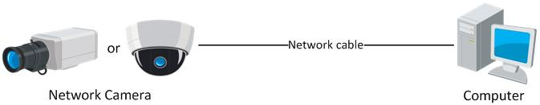
              - Connecting Directly
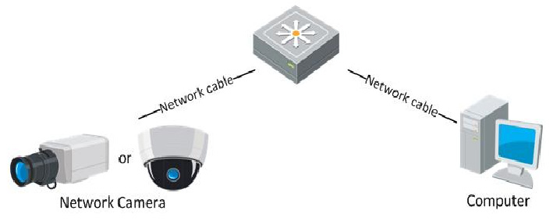
              - Connecting via a Switch or a Router

Detecting and Changing the IP Address
You need the IP address to visit the network camera.
Steps:
- To get the IP address, you can choose either of the following methods:
  - Use SADP, a software tool which can automatically detect the online network cameras in the LAN and list the device information including IP address, subnet mask, port number, device serial number, device version, etc., shown in Figure 2-3.
  - Use the CMS software to list the online devices. Please refer to the user manual of CMS software for detailed information.
- Change the IP address and subnet mask to the same subnet as that of your computer.
- Enter the IP address of network camera in the address field of the web browser to view the live video.
Notes:
- The default IP address is 192.0.0.64 and the port number is 8000. The default user name is admin, and password is 12345.
- For accessing the network camera from different subnets, please set the gateway for the network camera after you logged in. For detailed information, please refer to Section 6.3.1 Configuring TCP/IP Settings.
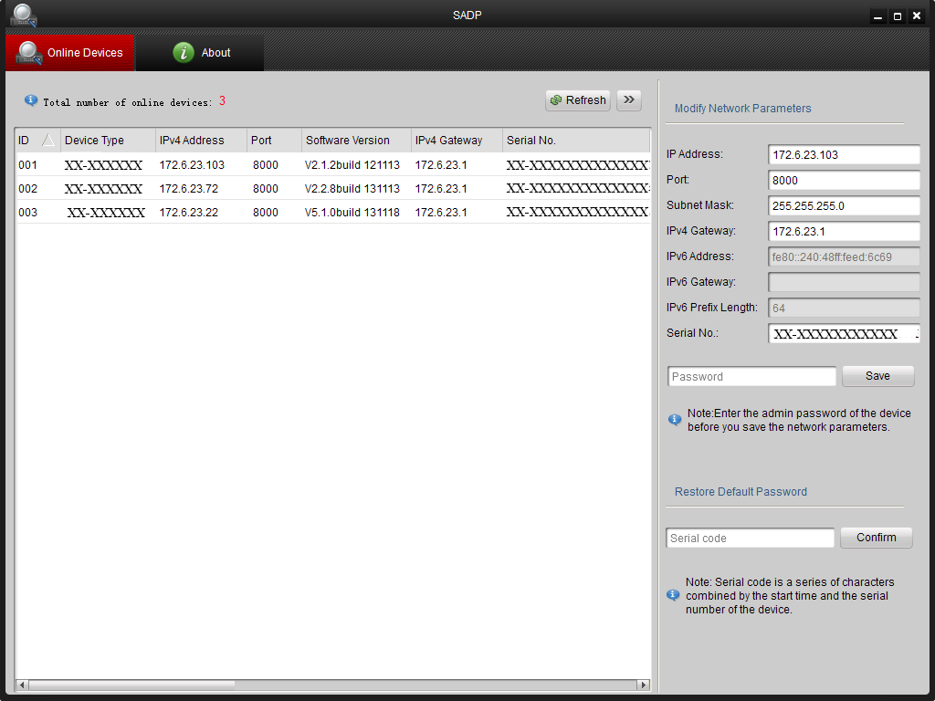
              - SADP Interface

Setting the Network Camera over the WAN
Purpose:
This section explains how to connect the network camera to the WAN with a static IP or a dynamic IP.

Static IP Connection
Before you start:
Please apply a static IP from an ISP (Internet Service Provider). With the static IP address, you can connect the network camera via a router or connect it to the WAN directly.
- Connecting the network camera via a router
Steps:
- Connect the network camera to the router.
- Assign a LAN IP address, the subnet mask and the gateway. Refer to Section 2.1.2 Detecting and Changing the IP Address for detailed IP address configuration of the camera.
- Save the static IP in the router.
- Set port mapping, e.g., 80, 8000, and 554 ports. The steps for port mapping vary according to the different routers. Please call the router manufacturer for assistance with port mapping.
Note: Refer to Appendix 2 for detailed information about port mapping.
- Visit the network camera through a web browser or the client software over the internet.
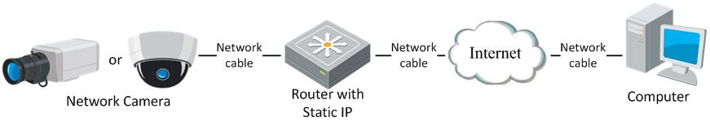
              - Accessing the Camera through Router with Static IP
- Connecting the network camera with static IP directly
You can also save the static IP in the camera and directly connect it to the internet without using a router. Refer to Section 2.1.2 Detecting and Changing the IP Address for detailed IP address configuration of the camera.
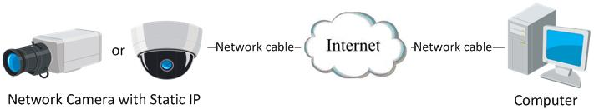
              - Accessing the Camera with Static IP Directly

Dynamic IP Connection
Before you start:
Please apply a dynamic IP from an ISP. With the dynamic IP address, you can connect the network camera to a modem or a router.
- Connecting the network camera via a router
Steps:
- Connect the network camera to the router.
- In the camera, assign a LAN IP address, the subnet mask and the gateway. Refer to Section 2.1.2 Detecting and Changing the IP Address for detailed LAN configuration.
- In the router, set the PPPoE user name, password and confirm the password.
- Set port mapping. E.g. 80, 8000, and 554 ports. The steps for port mapping vary depending on different routers. Please call the router manufacturer for assistance with port mapping.
Note: Refer to Appendix 2 for detailed information about port mapping.
- Apply a domain name from a domain name provider.
- Configure the DDNS settings in the setting interface of the router.
- Visit the camera via the applied domain name.

- Connecting the network camera via a modem
Purpose:
This camera supports the PPPoE auto dial-up function. The camera gets a public IP address by ADSL dial-up after the camera is connected to a modem. You need to configure the PPPoE parameters of the network camera. Refer to Section 5.3.3 Configuring PPPoE Settings for detailed configuration.
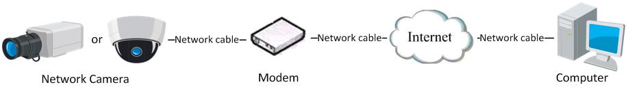
              - Accessing the Camera with Dynamic IP
Note: The obtained IP address is dynamically assigned via PPPoE, so the IP address always changes after rebooting the camera. To solve the inconvenience of the dynamic IP, you need to get a domain name from the DDNS provider (E.g. DynDns.com). Please follow the steps below for normal domain name resolution and private domain name resolution to solve the problem.
- Normal Domain Name Resolution
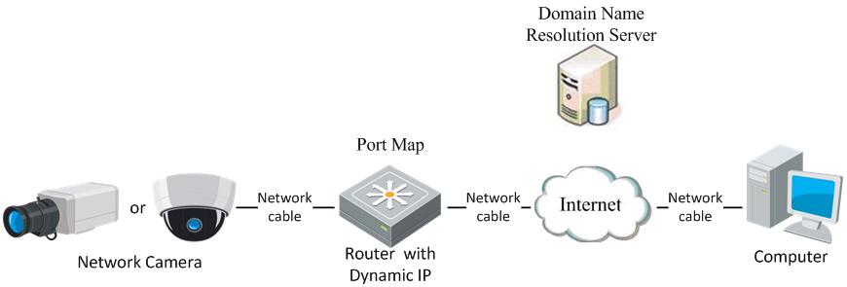
              - Normal Domain Name Resolution
Steps:
- Apply a domain name from a domain name provider.
- Configure the DDNS settings in the DDNS Settings interface of the network camera. Refer to Section 6.3.4 Configuring DDNS Settings for detailed configuration.
- Visit the camera via the applied domain name.

- Private Domain Name Resolution
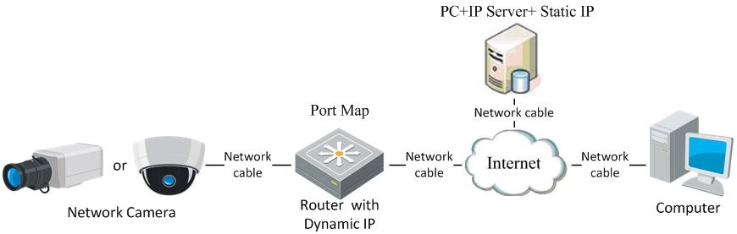
              - Private Domain Name Resolution
Steps:
- Install and run the IP Server software in a computer with a static IP.
- Access the network camera through the LAN with a web browser or the client software.
- Enable DDNS and select IP Server as the protocol type. Refer to Section 6.3.4 Configuring DDNS Settings for detailed configuration.

Access to the Network Camera

Accessing by Web Browsers
Steps:
- Open the web browser.
- Input the IP address of the network camera in the address bar, e.g., 192.0.0.64 and press the Enter key to enter the login interface.
- Input the user name and password and click Login.
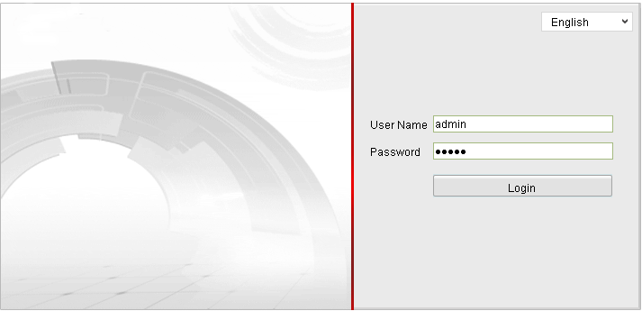
              - Login Interface
Notes:
- The default user name is admin, and the default password is 12345.
- Multi-language is supported. English, Simplified Chinese, Traditional Chinese, Russian, Turkish, Japanese, Korean, Thai, Vietnamese, Estonian, Bulgarian, Hungarian, Czech, Slovak, French, Italian, German, Spanish, Portuguese, Polish, Greek, Dutch, etc.
- Install the plug-in before viewing the live video and operating the camera. Please follow the installation prompts to install the plug-in.
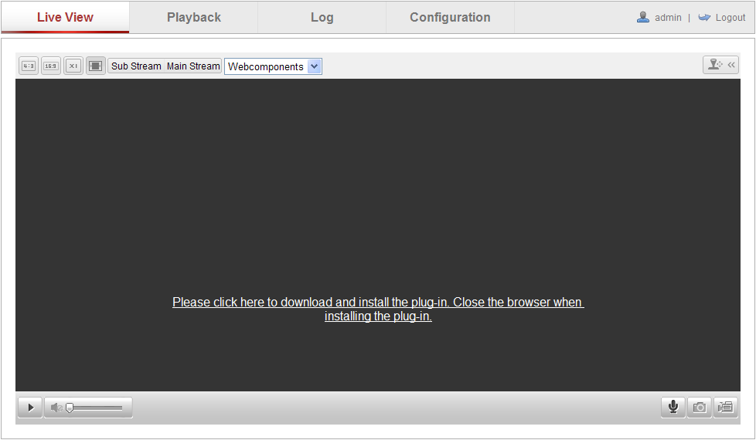
              - Download and Install Plug-in
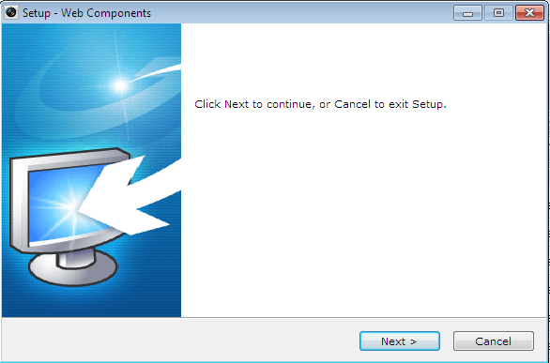
              - Install Plug-in (1)
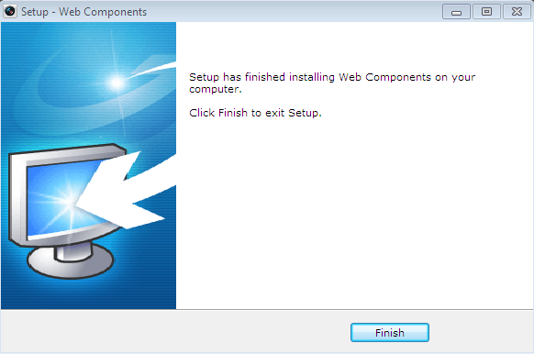
              - Install Plug-in (2)
Note: You may have to close the web browser to install the plug-in. Please reopen the web browser and log in again after installing the plug-in.

Accessing by Client Software

Accessing by CMS
The product CD contains the CMS. You can view the live video and manage the camera with the software.
Follow the installation prompts to install the software. The control panel and live view interface of CMS are shown as bellow.
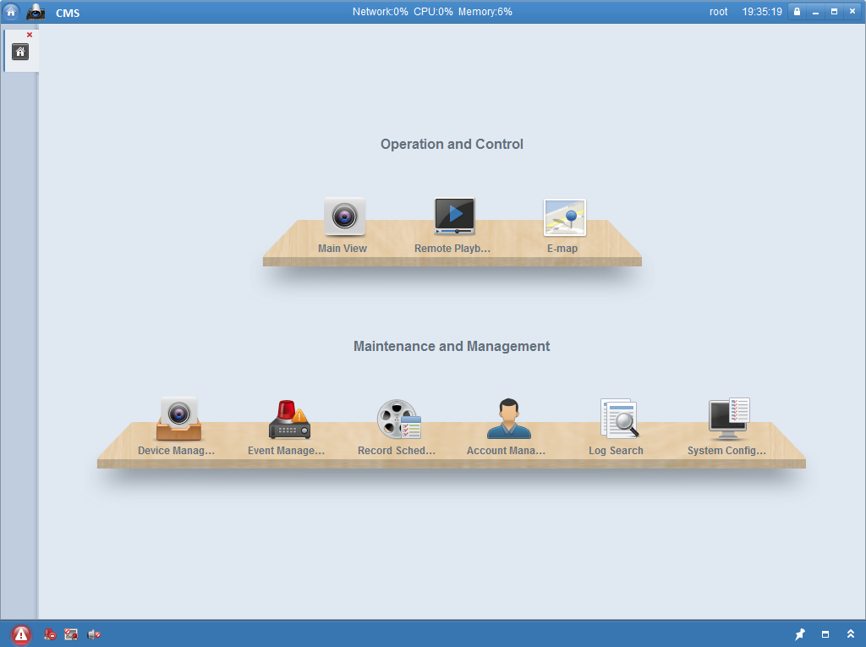
              - CMS Control Panel
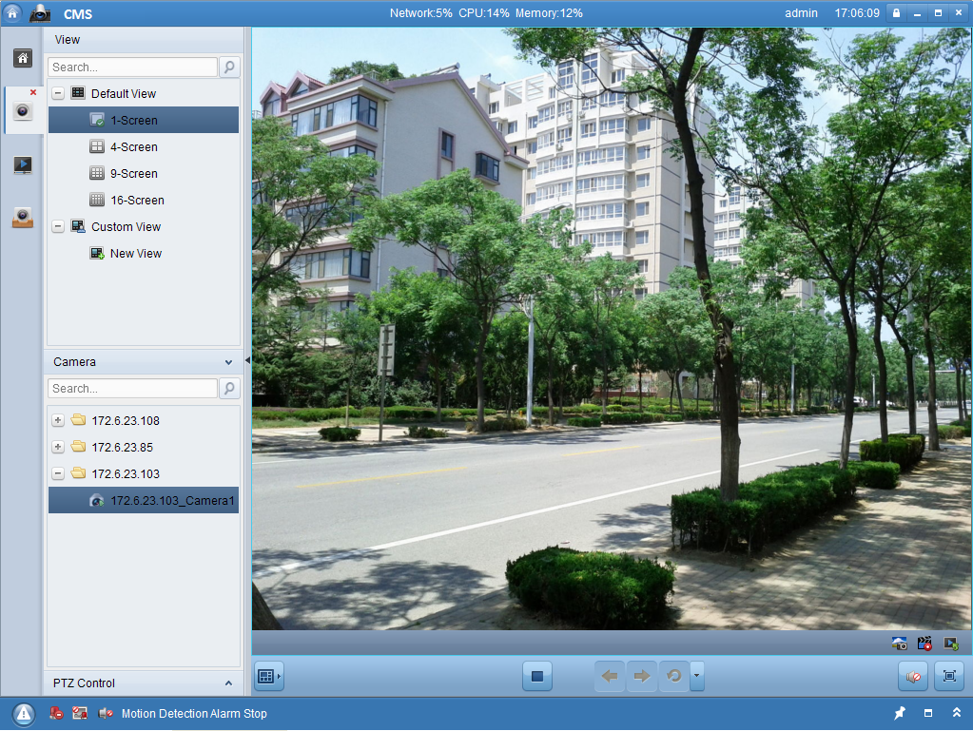
              - CMS Live View Interface
Note: For detailed information about the software, please refer to the user manual of the CMS.

Accessing by Guarding Expert Software
To view the camera with a mobile phone, you can just install the Guarding Expert software in your mobile phone. The software can be found in the mobile app store.
Note: For detailed information about Guarding Expert software, please refer to the user manual of Guarding Expert.

Wi-Fi Settings
Purpose:
By connecting to the wireless network, you don’t need to use cable of any kind for network connection, which is very convenient for the actual surveillance application.
Note: This chapter is only applicable for the cameras with the built-in Wi-Fi module.

Configuring Wi-Fi Connection in Manage and Ad-hoc Modes
Before you start:
A wireless network must be configured.
Wireless Connection in Manage Mode

Steps:
- Enter the Wi-Fi configuration interface.
Configuration> Advanced Configuration> Network> Wi-Fi
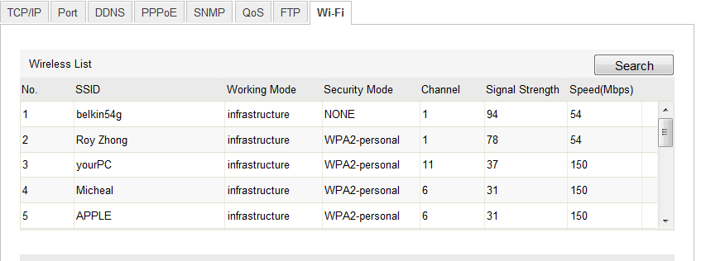
              - Wireless Network List
- Click Search to search the online wireless connections.
- Click to choose a wireless connection on the list.
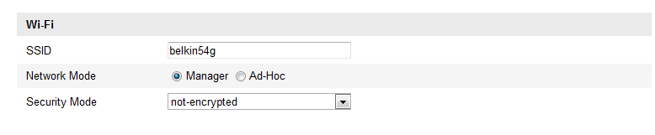
              - Wi-Fi Setting- Manage Mode
- Check the checkbox to select the Network mode as Manage, and the Security mode of the network is automatically shown when you select the wireless network, please don’t change it manually.
Note: These parameters are exactly identical with those of the router.
- Enter the key to connect the wireless network. The key should be that of the wireless network connection you set on the router.
Wireless Connection in Ad-hoc Mode

If you choose the Ad-hoc mode, you don’t need to connect the wireless camera via a router. The scenario is the same as you connect the camera and the PC directly with a network cable.
Steps:
- Choose Ad-hoc mode.
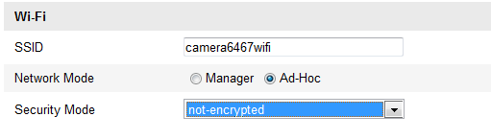
              - Wi-Fi Setting- Ad-hoc

- Customize a SSID for the camera.
- Choose the Security Mode of the wireless connection.
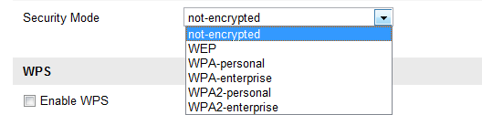
              - Security Mode- Ad-hoc Mode
- Enable the wireless connection function for your PC.
- On the PC side, search the network and you can see the SSID of the camera listed.
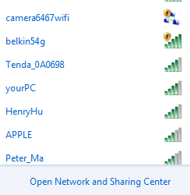
              - Ad-hoc Connection Point
- Choose the SSID and connect.
Security Mode Description:
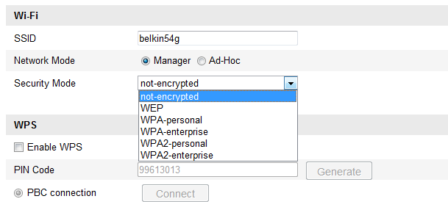
              - Security Mode
You can choose the Security Mode as not-encrypted, WEP, WPA-personal, WPA-enterprise, WPA2-personal, and WPA2-enterprise.
WEP mode:
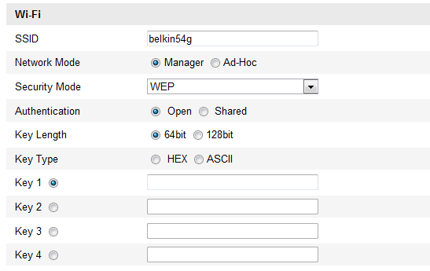
              - WEP Mode
- Authentication - Select Open or Shared Key System Authentication, depending on the method used by your access point. Not all access points have this option, in which case they probably use Open System, which is sometimes known as SSID Authentication.
- Key length - This sets the length of the key used for the wireless encryption, 64 or 128 bit. The encryption key length can sometimes be shown as 40/64 and 104/128.
- Key type - The key types available depend on the access point being used. The following options are available:
HEX - Allows you to manually enter the hex key.
ASCII - In this method the string must be exactly 5 characters for 64-bit WEP and 13 characters for 128-bit WEP.
WPA-personal and WPA2-personal Mode:
Enter the required Pre-shared Key for the access point, which can be a hexadecimal number or a passphrase.
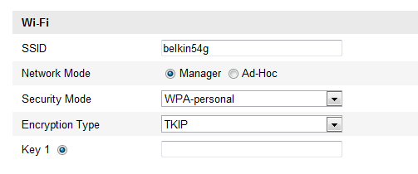
              - Security Mode- WPA-personal
WPA- enterprise and WPA2-enterprise Mode:
Choose the type of client/server authentication being used by the access point; EAP-TLS or EAP-PEAP.
EAP-TLS
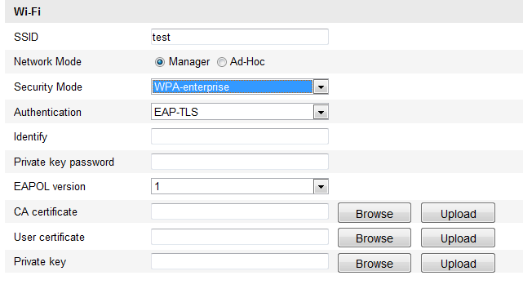
              - EAP-TLS
- Identity - Enter the user ID to present to the network.
- Private key password – Enter the password for your user ID.
- EAPOL version - Select the version used (1 or 2) in your access point.
- CA Certificates - Upload a CA certificate to present to the access point for authentication.
EAP-PEAP:
- User Name - Enter the user name to present to the network
- Password - Enter the password of the network
- PEAP Version - Select the PEAP version used at the access point.
- Label - Select the label used by the access point.
- EAPOL version - Select version (1 or 2) depending on the version used at the access point
- CA Certificates - Upload a CA certificate to present to the access point for authentication

Easy Wi-Fi Connection with WPS function
Purpose:
The setting of the wireless network connection is never easy. To avoid the complex setting of the wireless connection you can enable the WPS function.
WPS (Wi-Fi Protected Setup) refers to the easy configuration of the encrypted connection between the device and the wireless router. The WPS makes it easy to add new devices to an existing network without entering long passphrases. There are two modes of the WPS connection, the PBC mode and the PIN mode.
Note: If you enable the WPS function, you do not need to configure the parameters such as the encryption type and you don’t need to know the key of the wireless connection.
Steps:
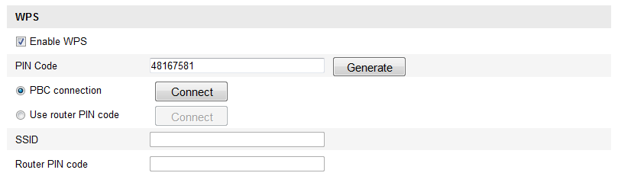
              - Wi-Fi Settings - WPS
PBC Mode:
PBC refers to the Push-Button-Configuration, in which the user simply has to push a button, either an actual or virtual one (as the button on the configuration interface of the IE browser), on both the Access Point (and a registrar of the network) and the new wireless client device.
- Check the checkbox of to enable WPS.
- Choose the connection mode as PBC.
Note: Support of this mode is mandatory for both the Access Points and the connecting devices.
- Check on the Wi-Fi router to see if there is a WPS button. If yes push the button and you can see the indicator near the button start flashing, which means the WPS function of the router is enabled. For detailed operation, please see the user guide of the router.
- Push the WPS button to enable the function on the camera.
If there is not a WPS button on the camera, you can also click the virtual button to enable the PBC function on the web interface.
- Click Connect button.
When the PBC mode is both enabled in the router and the camera, the camera and the wireless network is connected automatically.
PIN Mode:
The PIN mode requires a Personal Identification Number (PIN) to be read from either a sticker or the display on the new wireless device. This PIN must then be entered to connect the network, usually the Access Point of the network.
Steps:
- Choose a wireless connection on the list and the SSID is shown.
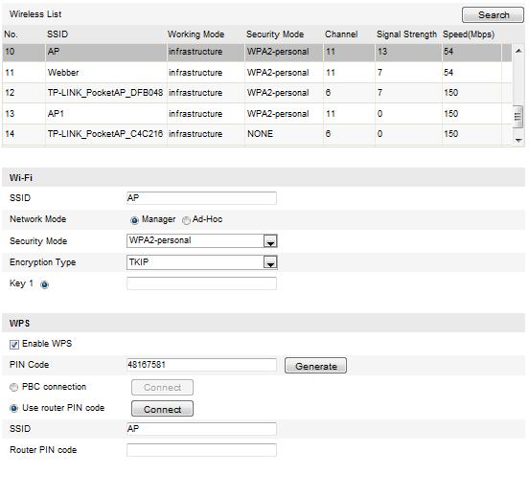
              - Wi-Fi Settings – WPS PIN Mode

- Choose Use route PIN code.
If the PIN code is generated from the router side, you should enter the PIN code you get from the router side in the Router PIN code field.
- Click Connect.
Or
You can generate the PIN code on the camera side. And the expired time for the PIN code is 120 seconds.
- Click Generate.
- Enter the code to the router, in the example, enter 48167581 to the router.

IP Property Settings for Wireless Network Connection
The default IP address of wireless network interface controller is 192.168.1.64. When you connect the wireless network you can change the default IP.
Steps:
- Enter the TCP/IP configuration interface.
Configuration> Advanced Configuration> Network> TCP/IP
or
Configuration> Basic Configuration> Network> TCP/IP
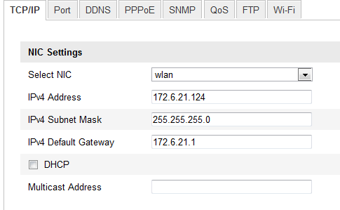
              - TCP/IP Settings
- Select the NIC as wlan.
- Customize the IPv4 address, the IPv4 Subnet Mask and the Default Gateway.
The setting procedure is the same with that of LAN.
If you want to be assigned the IP address you can check the checkbox to enable the DHCP.

Live View

Live View Page
Purpose:
The live view page allows you to view the real-time video, capture images, realize PTZ control, set/call presets and configure video parameters.
Log in the network camera to enter the live view page, or you can click Live View on the menu bar of the main page to enter the live view page.
Descriptions of the live view page:
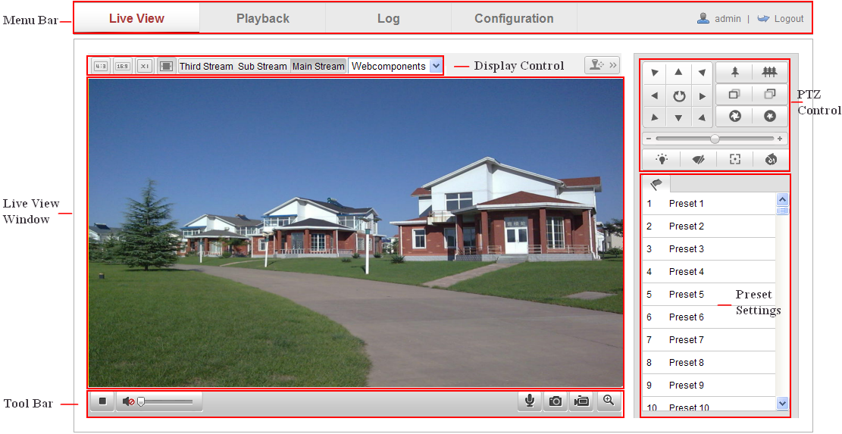
              - Live View Page
Menu Bar:
Click each tab to enter Live View, Playback, Log and Configuration page respectively.
Display Control:
Click each tab to adjust the layout and the stream type of the live view. And you can click the drop-down to select the plug-in. For IE (internet explorer) user, webcomponents and quick time are selectable. And for Non-IE user, webcomponents, quick time, VLC or MJPEG is selectable if they are supported by the web browser.
Live View Window:
Display the live video.
Toolbar:
Operations on the live view page, e.g., live view, capture, record, audio on/off, two-way audio, etc.
PTZ Control:
Panning, tilting and zooming actions of the camera and the lighter and wiper control (if it supports PTZ function or an external pan/tilt unit has been installed).
Preset Setting/Calling:
Set and call the preset for the camera (if supports PTZ function or an external pan/tilt unit has been installed).

Starting Live View
In the live view window as shown in Figure 5-2, click on the toolbar to start the live view of the camera.
              - Live View Toolbar
                - Descriptions of the Toolbar
Icon | Description
/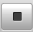 | Start/Stop live view.
 | The window size is 4:3.
 | The window size is 16:9.
 | The original widow size.
 | Self-adaptive window size.
 | Live view with the main stream.
 | Live view with the sub stream.
 | Live view with the third stream.
 | Click to select the third-party plug-in.
 | Manually capture the picture.
/ | Manually start/stop recording.
/ | Audio on and adjust volume /Mute.
/ | Turn on/off microphone.
/ | Turn on/off 3D zooming function.

Recording and Capturing Pictures Manually
In the live view interface, click on the toolbar to capture the live pictures or click to record the live view. The saving paths of the captured pictures and clips can be set on the Configuration > Local Configuration page. To configure remote scheduled recording, please refer to Section 7.2.
Note: The captured image will be saved as JPEG file or BMP file in your computer.

Operating PTZ Control
Purpose:
In the live view interface, you can use the PTZ control buttons to realize pan/tilt/zoom control of the camera.
Before you start:
To realize PTZ control, the camera connected to the network must support the PTZ function or a pan/tilt unit has been installed to the camera.

PTZ Control Panel
On the live view page, click to show the PTZ control panel or click to hide it.
Click the direction buttons to control the pan/tilt movements.
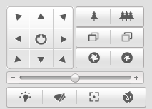
              - PTZ Control Panel
Click the zoom/iris/focus buttons to realize lens control.
Notes:
- There are 8 direction arrows (,,, ,,,,) in the live view window when you click and drag the mouse in the relative positions.
- For the cameras which support lens movements only, the direction buttons are invalid.
                - Descriptions of PTZ Control Panel
Icon | Description
 | Zoom in/out
 | Focus near/far
 | Iris +/-
 | Light on/off
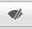 | Wiper on/off
 | One-touch focus
 | Initialize lens
 | Adjust speed of pan/tilt movements

Setting / Calling a Preset
- Setting a Preset:
- In the PTZ control panel, select a preset number from the preset list.
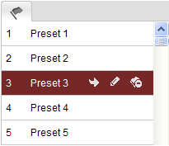
              - Setting a Preset
- Use the PTZ control buttons to move the lens to the desired position.
• Pan the camera to the right or left.
• Tilt the camera up or down.
• Zoom in or out.
• Refocus the lens.
- Click to finish the setting of the current preset.
- You can click to delete the preset.
Note: You can configure up to 128 presets.

- Calling a Preset:
This feature enables the camera to point to a specified preset scene manually or when an event takes place.
For the defined preset, you can call it at any time to the desired preset scene.
In the PTZ control panel, select a defined preset from the list and click to call the preset.
Or you can place the mouse on the presets interface, and call the preset by typing the preset No. to call the corresponding presets.
              - Calling a Preset

Network Camera Configuration

Configuring Local Parameters
Note: The local configuration refers to the parameters of the live view, record files and captured pictures. The record files and captured pictures are the ones you record and captured using the web browser and thus the saving paths of them are on the PC running the browser.
Steps:
- Enter the Local Configuration interface:
Configuration > Local Configuration
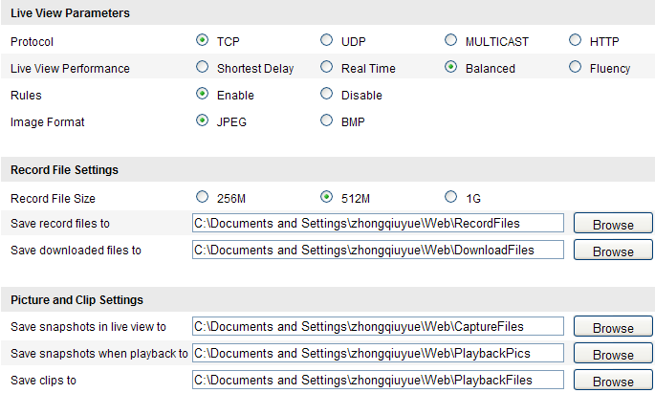
              - Local Configuration Interface
- Configure the following settings:
- Live View Parameters: Set the protocol type and live view performance.
- Protocol Type: TCP, UDP, MULTICAST and HTTP are selectable.
TCP: Ensures complete delivery of streaming data and better video quality, yet the real-time transmission will be affected.
UDP: Provides real-time audio and video streams.
HTTP: Allows the same quality as of TCP without setting specific ports for streaming under some network environments.
MULTICAST: It’s recommended to select MCAST type when using the Multicast function. For detailed information about Multicast, refer to Section 6.3.1 TCP/IP Settings.
- Live View Performance: Set the live view performance to Shortest Delay, Real Time, Balanced or Best Fluency.
- Rules: It refers to the rules on your local browser, select enable or disable to display or not display the colored marks when the motion detection is triggered.
- Image Format: Choose the image format for picture capture.
- Record File Settings: Set the saving path of the recorded video files. Valid for the record files you recorded with the web browser.
- Record File Size: Select the packed size of the manually recorded and downloaded video files to 256M, 512M or 1G. After the selection, the maximum record file size is the value you selected.
- Save record files to: Set the saving path for the manually recorded video files.
- Save downloaded files to: Set the saving path for the downloaded video files in playback mode.
- Picture and Clip Settings: Set the saving paths of the captured pictures and clipped video files. Valid for the pictures you captured with the web browser.
- Save snapshots in live view to: Set the saving path of the manually captured pictures in live view mode.
- Save snapshots when playback to: Set the saving path of the captured pictures in playback mode.
- Save clips to: Set the saving path of the clipped video files in playback mode.
Note: You can click Browse to change the directory for saving the clips and pictures.
- Click Save to save the settings.

Configuring Time Settings
Purpose:
You can follow the instructions in this section to configure the time synchronization and DST settings.
Steps:
1. Enter the Time Settings interface:
Configuration > Basic Configuration > System > Time Settings
Or Configuration > Advanced Configuration > System > Time Settings
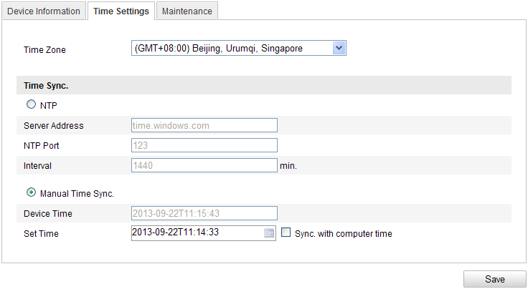
              - Time Settings
- Select the Time Zone.
Select the Time Zone of your location from the drop-down menu.
- Synchronizing Time by NTP Server.
- Check the checkbox to enable the NTP function.
- Configure the following settings:
Server Address: IP address of NTP server.
NTP Port: Port of NTP server.
Interval: The time interval between the two synchronizing actions with NTP server.
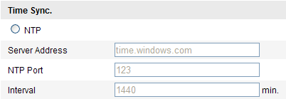
              - Time Sync by NTP Server
Note: If the camera is connected to a public network, you should use a NTP server that has a time synchronization function, such as the server at the National Time Center (IP Address: 210.72.145.44). If the camera is set in a customized network, NTP software can be used to establish a NTP server for time synchronization.
- Synchronizing Time Synchronization Manually
Enable the Manual Time Sync function and then click to set the system time from the pop-up calendar.
Note: You can also check the Sync with computer time checkbox to synchronize the time of the camera with that of your computer.
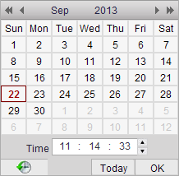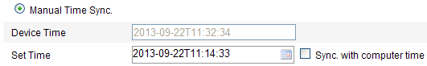
              - Time Sync Manually
- Click the DST tab page to enable the DST function and Set the date of the DST period.
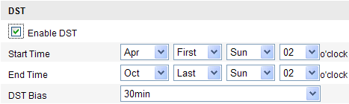
              - DST Settings
2. Click Save to save the settings.

Configuring Network Settings

Configuring TCP/IP Settings
Purpose:
TCP/IP settings must be properly configured before you operate the camera over network. The camera supports both the IPv4 and IPv6. Both versions may be configured simultaneously without conflicting to each other, and at least one IP version should be configured.
Steps:
- Enter TCP/IP Settings interface:
Configuration > Basic Configuration > Network > TCP/IP
Or Configuration > Advanced Configuration > Network > TCP/IP
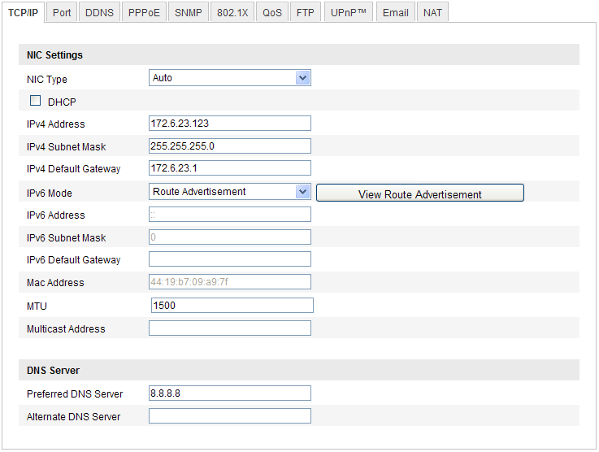
              - TCP/IP Settings
- Configure the basic network settings, including the NIC Type, IPv4 or IPv6 Address, IPv4 or IPv6 Subnet Mask, IPv4 or IPv6 Default Gateway, MTU settings and Multicast Address.
Notes:
- The valid value range of MTU is 500 ~ 1500.
- The Multicast sends a stream to the multicast group address and allows multiple clients to acquire the stream at the same time by requesting a copy from the multicast group address. Before utilizing this function, you have to enable the Multicast function of your router.
- Click Save to save the above settings.
Note: A reboot is required for the settings to take effect.

Configuring Port Settings
Purpose:
You can set the port No. of the camera, e.g. HTTP port, RTSP port and HTTPS port.
Steps:
- Enter the Port Settings interface:
Configuration > Basic Configuration > Network > Port
Or Configuration > Advanced Configuration > Network > Port
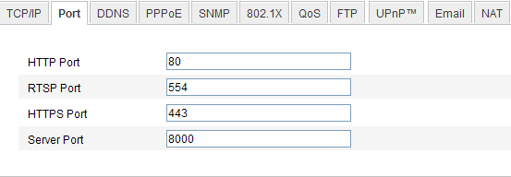
              - Port Settings
- Set the HTTP port, RTSP port and HTTPS port of the camera.
HTTP Port: The default port number is 80, and it can be changed to any port No. which is not occupied.
RTSP Port: The default port number is 554 and it can be changed to any port No. ranges from 1024 to 65535.
HTTPS Port: The default port number is 443, and can be changed to any port No. which is not occupied.
Server Port: The default server port number is 8000, and it can be changed to any port No. ranges from 2000 to 65535.
- Click Save to save the settings.
Note: A reboot is required for the settings to take effect.

Configuring PPPoE Settings
Steps:
- Enter the PPPoE Settings interface:
Configuration >Advanced Configuration > Network > PPPoE
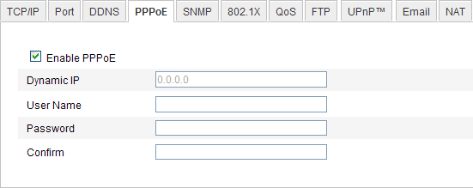
              - PPPoE Settings
- Check the Enable PPPoE checkbox to enable this feature.
- Enter User Name, Password, and Confirm password for PPPoE access.
Note: The User Name and Password should be assigned by your ISP.
- Click Save to save and exit the interface.
Note: A reboot is required for the settings to take effect.

Configuring DDNS Settings
Purpose:
If your camera is set to use PPPoE as its default network connection, you can use the Dynamic DNS (DDNS) for network access.
Before you start:
Registration on the DDNS server is required before configuring the DDNS settings of the camera.
Steps:
- Enter the DDNS Settings interface:
Configuration > Advanced Configuration > Network > DDNS
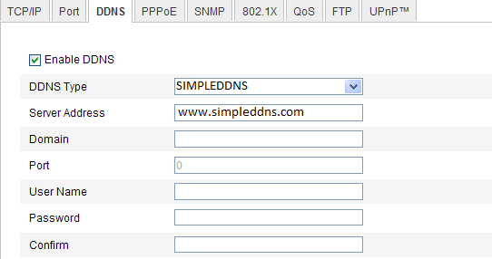
              - DDNS Settings
- Check the Enable DDNS checkbox to enable this feature.
- Select DDNS Type. Four DDNS types are selectable: SIMPLEDDNS, NO-IP IPServer and DynDNS.
  - DynDNS:
Steps:
- Enter Server Address of DynDNS (e.g. members.dyndns.org).
- In the Domain text field, enter the domain name obtained from the DynDNS website.
- Enter the Port of DynDNS server.
- Enter the User Name and Password registered on the DynDNS website.
- Click Save to save the settings.
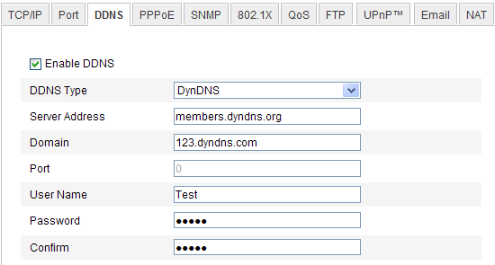
              - DynDNS Settings
  - IP Server:
Steps:
- Enter the Server Address of the IP Server.
- Click Save to save the settings.
Note: For the IP Server, you have to apply a static IP, subnet mask, gateway and preferred DNS from the ISP. The Server Address should be entered with the static IP address of the computer that runs the IP Server software.
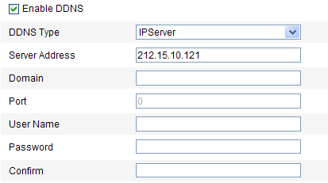
              - IPServer Settings
Note: For the US and Canada area, you can enter 173.200.91.74 as the server address.
  - NO-IP:
Steps:
- Choose the DDNS Type as NO-IP.
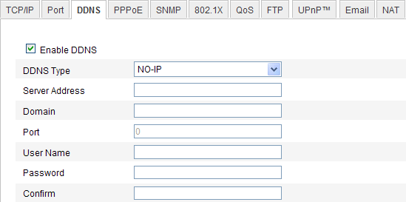
              - NO-IP DNS Settings
- Enter the Server Address as www.noip.com
- Enter the Domain name you registered.
- Enter the Port number, if needed.
- Enter the User Name and Password.
- Click Save and then you can view the camera with the domain name.
  - SIMPLEDDNS
Steps:
- Choose the DDNS Type as SIMPLEDDNS.
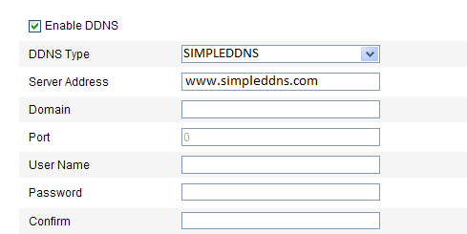
              - SIMPLEDDNS Settings
- Enter the Server Address www.simpleddns.com.
- Enter the Domain name of the camera. The domain is the same with the device alias in the SIMPLEDDNS server.
- Click Save to save the new settings.

Configuring SNMP Settings
Purpose:
You can set the SNMP function to get camera status, parameters and alarm related information and manage the camera remotely when it is connected to the network.
Before you start:
Before setting the SNMP, please download the SNMP software and manage to receive the camera information via SNMP port. By setting the Trap Address, the camera can send the alarm event and exception messages to the surveillance center.
Note: The SNMP version you select should be the same as that of the SNMP software. And you also need to use the different version according to the security level you required. SNMP v1 provides no security and SNMP v2 requires password for access. And SNMP v3 provides encryption and if you use the third version, HTTPS protocol must be enabled.
Steps:
- Enter the SNMP Settings interface:
Configuration > Advanced Configuration > Network > SNMP
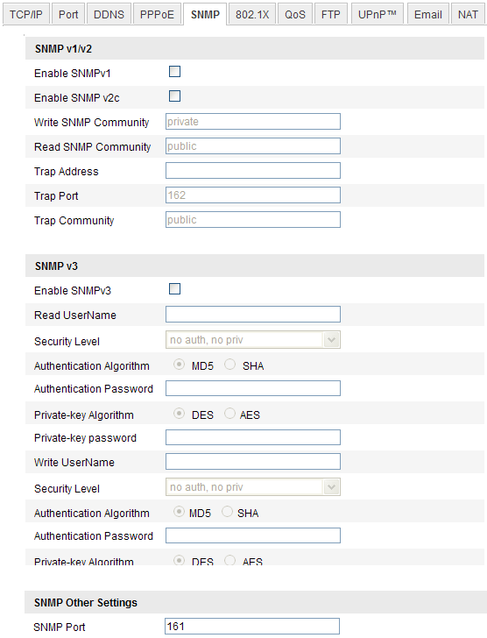
              - SNMP Settings
- Check the corresponding version checkbox (, , ) to enable the feature.
- Configure the SNMP settings.
Note: The settings of the SNMP software should be the same as the settings you configure here.
- Click Save to save and finish the settings.
Note: A reboot is required for the settings to take effect.

Configuring 802.1X Settings
Purpose:
The IEEE 802.1X standard is supported by the network cameras, and when the feature is enabled, the camera data is secured and user authentication is needed when connecting the camera to the network protected by the IEEE 802.1X.
Before you start:
The authentication server must be configured. Please apply and register a user name and password for 802.1X in the server.
Steps:
- Enter the 802.1X Settings interface:
Configuration > Advanced Configuration > Network > 802.1X
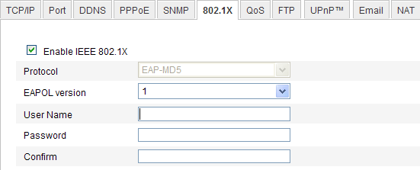
              - 802.1X Settings
- Check the Enable IEEE 802.1X checkbox to enable the feature.
- Configure the 802.1X settings, including EAPOL version, user name and password.
Note: The EAPOL version must be identical with that of the router or the switch.
- Enter the user name and password to access the server.
- Click Save to finish the settings.
Note: The camera supports Wi-Fi function doesn’t support 802.1X.

Configuring QoS Settings
Purpose:
QoS (Quality of Service) can help solve the network delay and network congestion by configuring the priority of data sending.
Steps:
- Enter the QoS Settings interface:
Configuration >Advanced Configuration > Network > QoS
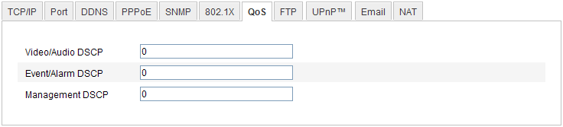
              - QoS Settings
- Configure the QoS settings, including video / audio DSCP, event / alarm DSCP and Management DSCP.
The valid value range of the DSCP is 0-63. The bigger the DSCP value is, the higher the priority is.
Note: DSCP refers to the Differentiated Service Code Point; and the DSCP value is used in the IP header to indicate the priority of the data.
- Click Save to save the settings.

Configuring UPnP™ Settings
Universal Plug and Play (UPnP™) is a networking architecture that provides compatibility among networking equipment, software and other hardware devices. The UPnP protocol allows devices to connect seamlessly and to simplify the implementation of networks in the home and corporate environments.
With the function enabled, you don’t need to configure the port mapping for each port, and the camera is connected to the Wide Area Network via the router.
Steps:
- Enter the UPnP™ settings interface.
Configuration >Advanced Configuration > Network > UPnP
- Check the checkbox to enable the UPnP™ function.
The name of the device when detected online can be edited.
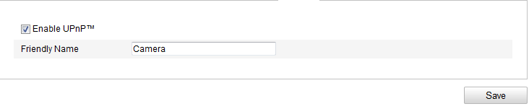
              - Configure UPnP Settings

Email Sending Triggered by Alarm
Purpose:
The system can be configured to send an Email notification to all designated receivers if an alarm event is detected, e.g., motion detection event, video loss, video tampering, etc.
Before you start:
Please configure the DNS Server settings under Basic Configuration > Network > TCP/IP or Advanced Configuration > Network > TCP/IP before using the Email function.
Steps:
- Enter the TCP/IP Settings (Configuration > Basic Configuration > Network > TCP/IP or Configuration > Advanced Configuration > Network > TCP/IP) to set the IPv4 Address, IPv4 Subnet Mask, IPv4 Default Gateway and the Preferred DNS Server.
Note: Please refer to Section 6.3.1 Configuring TCP/IP Settings for detailed information.
- Enter the Email Settings interface:
Configuration > Advanced Configuration > Network > Email
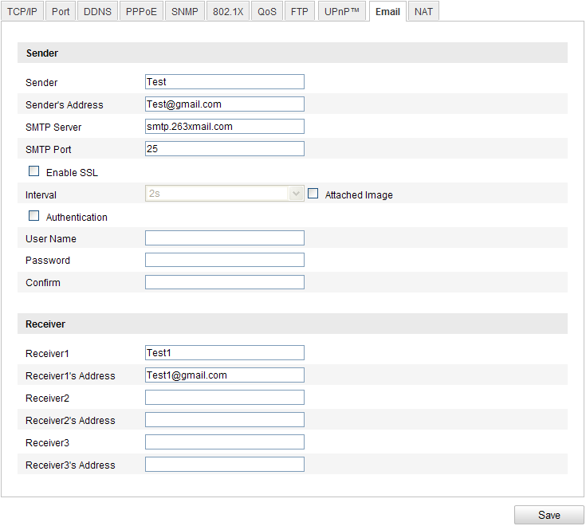
              - Email Settings
- Configure the following settings:
Sender: The name of the email sender.
Sender’s Address: The email address of the sender.
SMTP Server: The SMTP Server IP address or host name (e.g., smtp.263xmail.com).
SMTP Port: The SMTP port. The default TCP/IP port for SMTP is 25 (not secured). And the SSL SMTP port is 465.
Enable SSL: Check the checkbox to enable SSL if it is required by the SMTP server.
Attached Image: Check the checkbox of Attached Image if you want to send emails with attached alarm images.
Interval: The interval refers to the time between two actions of sending attached pictures.
Authentication (optional): If your email server requires authentication, check this checkbox to use authentication to log in to this server and enter the login user Name and password.
Choose Receiver: Select the receiver to which the email is sent. Up to 2 receivers can be configured.
Receiver: The name of the user to be notified.
Receiver’s Address: The email address of user to be notified.
- Click Save to save the settings.

Configuring NAT (Network Address Translation) Settings
Purpose:
- Enter the NAT settings interface.
Configuration >Advanced Configuration > Network > NAT
- Choose the port mapping mode.
To port mapping with the default port numbers:
Choose Port Mapping Mode.
To port mapping with the customized port numbers:
Choose
And for manual port mapping, you can customize the value of the port number by yourself.
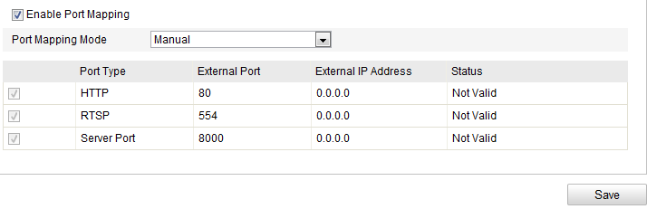
              - Configure NAT Settings
- Click Save to save the settings.

Configuring FTP Settings
Purpose:
You can configure the FTP server related information to enable the uploading of the captured pictures to the FTP server. The captured pictures can be triggered by events or a timing snapshot task.
Steps:
- Enter the FTP Settings interface:
Configuration >Advanced Configuration > Network > FTP
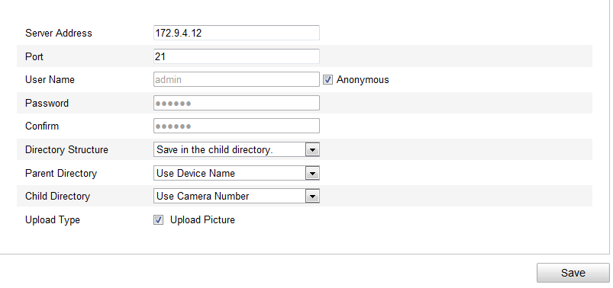
              - FTP Settings
- Configure the FTP settings; and the user name and password are required for login the FTP server.
Directory: In the Directory Structure field, you can select the root directory, parent directory and child directory. When the parent directory is selected, you have the option to use the Device Name, Device Number or Device IP for the name of the directory; and when the Child Directory is selected, you can use the Camera Name or Camera No. as the name of the directory.
Upload type: To enable uploading the captured picture to the FTP server.
Anonymous Access to the FTP Server (in which case the user name and password won’t be required.): Check the Anonymous checkbox to enable the anonymous access to the FTP server.
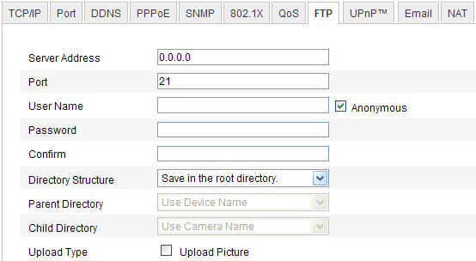
              - FTP Settings
Note: The anonymous access function must be supported by the FTP server.
- Click Save to save the settings.
Note: If you want to upload the captured pictures to FTP server, you have to enable the continuous snapshot or event-triggered snapshot on Snapshot page. For detailed information, please refer to the Section 6.6.7.

Configuring Video and Audio Settings

Configuring Video Settings
Steps:
- Enter the Video Settings interface:
Configuration >Basic Configuration > Video / Audio > Video
Or Configuration > Advanced Configuration > Video / Audio > Video
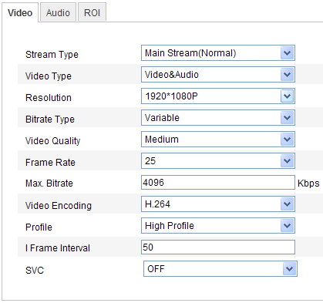
              - Configure Video Settings
- Select the Stream Type of the camera to main stream (normal), sub-stream or third stream.
The main stream is usually for recording and live viewing with good bandwidth, and the sub-stream and third stream can be used for live viewing when the bandwidth is limited.
- You can customize the following parameters for the selected main stream or sub-stream:
Video Type:
Select the stream type to video stream, or video & audio composite stream. The audio signal will be recorded only when the Video Type is Video & Audio.
Resolution:
Select the resolution of the video output.
Bitrate Type:
Select the bitrate type to constant or variable.
Video Quality:
When bitrate type is selected as Variable, 6 levels of video quality are selectable.
Frame Rate:
Set the frame rate to 1/16~30 fps. The frame rate is to describe the frequency at which the video stream is updated and it is measured by frames per second (fps). A higher frame rate is advantageous when there is movement in the video stream, as it maintains image quality throughout.
Max. Bitrate:
Set the max. bitrate to 32~16384 Kbps. The higher value corresponds to the higher video quality, but the higher bandwidth is required.
Video Encoding:
If the Stream Type is set to main stream, H.264 and MJPEG are selectable, and if the stream type is set to sub stream, H.264, MJPEG, and MPEJ4 are selectable.
Note: The supported video encoding may differ according to the different platform.
Profile:
Basic profile, Main Profile and High Profile for coding are selectable.
I Frame Interval:
Set the I-Frame interval to 1~400.
SVC:
Scalable Video Coding is an extension of the H.264/AVC standard. Set it OFF or ON according to your actual needs.
- Click Save to save the settings.

Configuring Audio Settings
Steps:
- Enter the Audio Settings interface
Configuration > Basic Configuration > Video / Audio > Audio
Or Configuration > Advanced Configuration > Video / Audio > Audio
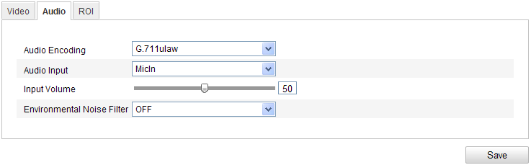
              - Audio Settings
- Configure the following settings.
Audio Encoding: G.711 ulaw, G.711alaw, G.726, and MP2L2 are selectable. And 32kbps, 64kbps, and 128kbps are supported if MP2L2 is selected.
Audio Input: MicIn and Linein are selectable for the connected microphone and pickup respectively.
Input Volume: 0-100
Environmental Noise Filter: Set it as OFF or ON. When you set the function on the noise detected can be filtered.
- Click Save to save the settings.
Note: This setting is only for certain modules, check the specification for whether the module supports the function.

Configuring ROI Encoding
ROI stands for the region of interest. And the ROI encoding enables you to discriminate the ROI and background information in compression, that is to say, the technology assigns more encoding resource to the region of interest to increase the quality of the ROI whereas the background information is less focused.
Steps:
- Enter the ROI settings interface
Configuration > Advanced Configuration > Video / Audio >ROI
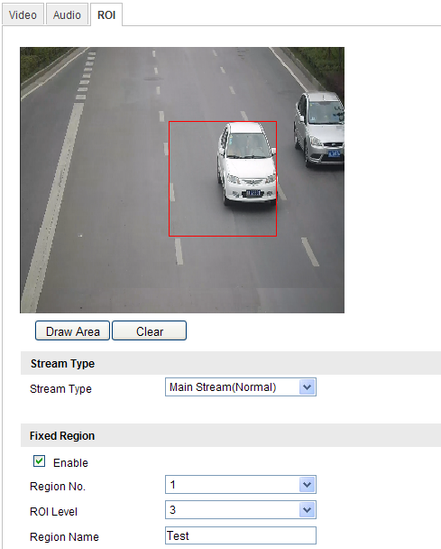
              - Region of Interest Settings
- Draw the region of interest on the image. There are four regions can be drawn.
- Choose the stream type to set the ROI encoding.
- Check the checkbox of to enable Fixed Region encoding. The fixed region encoding is the ROI encoding for the manually configured area. And you can choose the Image Quality Enhancing level for ROI encoding, and you can also name the ROI area.
- Click Save to save the settings.

Configuring Image Parameters

Configuring Display Settings
Purpose:
You can set the image quality of the camera, including brightness, contrast, saturation, hue, sharpness, etc.
Note:
The display parameters vary according to the different camera model. Please refer to the actual interface for details.
Steps:
- Enter the Display Settings interface:
Configuration > Basic Configuration> Image> Display Settings
Or Configuration > Advanced Configuration> Image> Display Settings
- Set the image parameters of the camera.
Note:
In order to guarantee the image quality in the different illumination, it provides two sets of parameters for user to configure.
Day/night Auto-switch
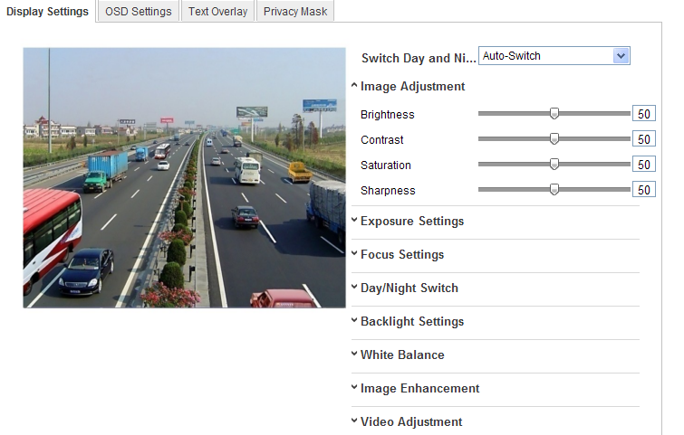
              - Display Settings of Day/night Auto-switch
- Image Adjustment
Brightness describes bright of the image, which ranges from 1~100, and the default value is 50.
Contrast describes the contrast of the image, which ranges from 1~100, and the default value is 50.
Saturation describes the colorfulness of the image color, which ranges from 1~100, and the default value is 50.
Sharpness describes the edge contrast of the image, which ranges from 1~100, and the default value is 50.
- Exposure Settings
If the camera is equipped with the fixed lens, only Manual is selectable, and the iris mode is not configurable.
If Auto is selected, you can set the auto iris level from 0~ 100.
For the camera supports P-Iris lens, if P-Iris lens is adopted, then the P-Iris lens type is selectable, e.g.: Tamron 2.8-8mm F1.2 (M13VP288-IR), or if DC lens is adopted, then manual and auto are selectable.
The exposure time refers to the electronic shutter time, which ranges from 1 ~ 1/100,000s. Adjust it according to the actual luminance condition.
- Focus Settings
For the camera supports electronic lens, you can set the focus mode as Manual or Auto. If auto is selected, the focus is adjusted automatically, and if manual is selected, you can control the lens by adjusting the zoom, focus, lens initialization, and auxiliary focus via the PTZ control interface.
- Day/Night Switch
Select the day/night switch mode, and configure the smart IR settings from this option.
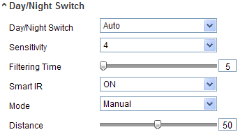
              - Day/Night Switch
Day, night, auto, schedule, and triggered by alarm input are selectable for day/night switch.
Day: the camera stays at day mode.
Night: the camera stays at night mode.
Auto: the camera switches between the day mode and the night mode according to the illumination automatically. The sensitivity ranges from 0~7, the higher the value is, the easier the mode switches. The filtering time refers to the interval time between the day/night switch. You can set it from 5s to 120s.
Schedule: Set the start time and the end time to define the duration for day/night mode.
Triggered by alarm input: The switch is triggered by alarm input, and you can set the triggered mode to day or night.
Smart IR gives user an option to turn ON / OFF the IR LED.
Set the smart IR to ON, and Auto and Manual are selectable for IR mode. Select AUTO, and the IR LED changes according to the actual luminance. E.g.: if the current scene is bright enough, then the IR LED adjusts itself to lower power; and if the scene is not bright enough, the IR LED adjusts itself to higher power.
Select Manual, and you can adjust the IR LED by adjusting the distance. E.g.: If the object is near the camera, the device adjusts the IR LED to lower power, and the IR LED is in higher power if the object is far.
- Backlight Settings
BLC: If you focus on an object against strong backlight, the object will be too dark to be seen clearly. BLC compensates light to the object in the front to make it clear. OFF, Up, Down, Left, Right, Center and customize are selectable.
WDR: Wide Dynamic Range can be used when there is a high contrast of the bright area and the dark area of the scene.
HLC: High Light Compression function can be used when there are strong lights in the scene affecting the image quality.
- White Balance
White balance is the white rendition function of the camera used to adjust the color temperature according to the environment.
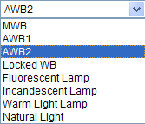
              - White Balance
- Image Enhancement
Digital Noise Reduction: DNR reduces the noise in the video stream. Set the DNR level from 0~100, and the default value is 50.
- Video Adjustment
Mirror: It mirrors the image so you can see it inversed. Left/Right, Up/Down, Center, and OFF are selectable.
Rotate: To make a complete use of the 16:9 aspect ratio, you can enable the rotate function when you use the camera in a narrow view scene.
When installing, turn the camera to the 90 degrees or rotate the 3-axis lens to 90 degrees, and set the rotate mode as on, you will get a normal view of the scene with 9:16 aspect ratio to ignore the needless information such as the wall, and get more meaningful information of the scene.
Video Standard: 50 Hz and 60 Hz are selectable. Choose according to the different video standards; normally 50 Hz for PAL standard and 60 Hz for NTSC standard.
Capture Mode: It’s the selectable video input mode to meet the different demands of field of view and resolution.
Day/Night Scheduled-Switch
Day/Night scheduled-switch configuration interface enables you to set the separate camera parameters for day and night to guarantee the image quality in different illumination.
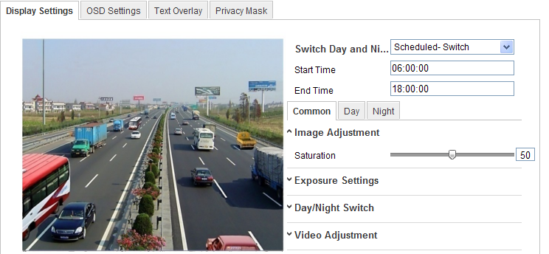
              - Day/Night Scheduled-Switch Configuration Interface

Steps:
- Click the time line to select the start time and the end time of the switch.
- Click Common tab to configure the common parameters applicable to the day mode and night mode.
Note:
The detailed information of each parameter please refers to day/night auto switch session.
- Click Day tab to configure the parameters applicable for day mode.
- Click Night tab to configure the parameters applicable for night mode.
Note:
The settings saved automatically if any parameter is changed.

Configuring OSD Settings
Purpose:
You can customize the camera name and time on the screen.
Steps:
- Enter the OSD Settings interface:
Configuration > Advanced Configuration > Image > OSD Settings
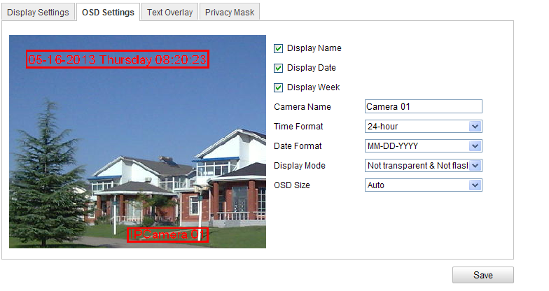
              - OSD Settings
- Check the corresponding checkbox to select the display of camera name, date or week if required.
- Edit the camera name in the text field of Camera Name.
- Select from the drop-down list to set the time format, date format, display mode and the OSD font size.
- You can use the mouse to click and drag the text frame in the live view window to adjust the OSD position.
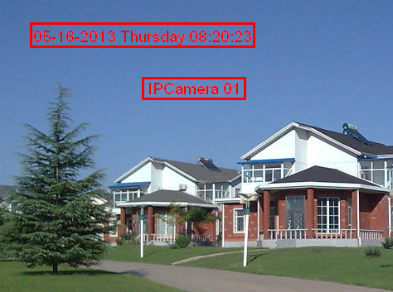
              - Adjust OSD Location
- Click Save to activate above settings.

Configuring Text Overlay Settings
Purpose:
You can customize the text overlay.
Steps:
- Enter the Text Overlay Settings interface:
Configuration > Advanced Configuration > Image > Text Overlay
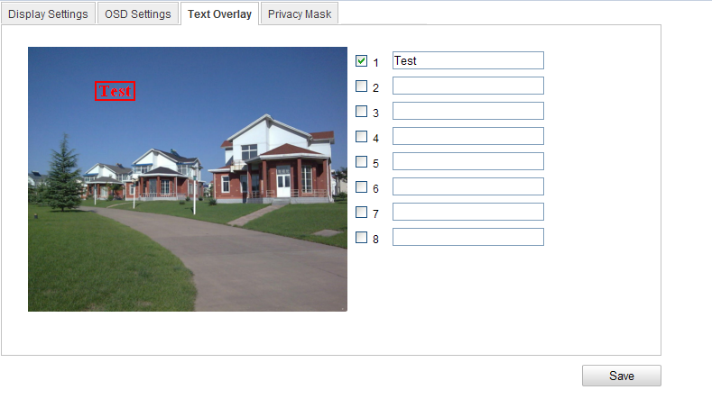
              - Text Overlay
- Check the checkbox in front of textbox to enable the on-screen display.
- Input the characters in the textbox.
- (Optional)Use the mouse to click and drag the red text frame in the live view window to adjust the text overlay position.
- Click Save.
Note: Up to 8 text overlays are configurable.

Configuring Privacy Mask
Purpose:
Privacy mask enables you to cover certain areas on the live video to prevent certain spots in the surveillance area from being live viewed and recorded.
Steps:
- Enter the Privacy Mask Settings interface:
Configuration > Advanced Configuration> Image > Privacy Mask
- Check the checkbox of Enable Privacy Mask to enable this function.
- Click Draw Area.
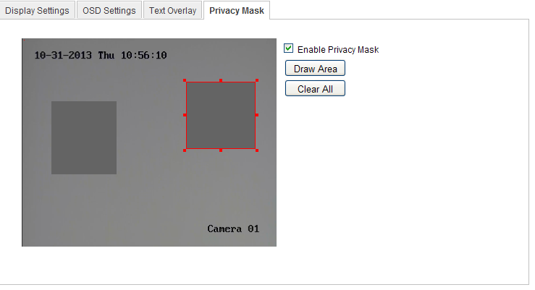
              - Privacy Mask Settings
- Click and drag the mouse in the live video window to draw the mask area.
Note: You are allowed to draw up to 4 areas on the same image.
- Click Stop Drawing to finish drawing or click Clear All to clear all of the areas you set without saving them.
- Click Save to save the settings.

Configuring and Handling Alarms
This section explains how to configure the network camera to respond to alarm events, including motion detection, video tampering, alarm input, alarm output, exception, etc. These events can trigger the alarm actions, such as Notify Surveillance Center, Send Email, Trigger Alarm Output, etc.
Notes:
- Check the checkbox of Notify Surveillance Center if you want to the alarm information pushed to your mobile phone as soon as the alarm is triggered.

Configuring Motion Detection
Purpose:
Motion detection detects the moving objects in the configured surveillance area, and triggers the certain action as a respond to detection.
In order to detect the moving objects accurately and reduce the false alarm rate, normal configuration and expert configuration are selectable for different motion detection environment.
- Normal Configuration
Normal configuration adopts one set of parameter for motion detection during the day and at night.
Tasks:
- Set the Motion Detection Area.
Steps:
- Enter the motion detection settings interface
Configuration > Advanced Configuration> Events > Motion Detection
- Check the checkbox of Enable Motion Detection.
- Check the checkbox of Enable Dynamic Analysis for Motion if you want to mark the detected objects with green rectangles.
Note: Select Disable for rules if you don’t want the detected objected displayed with the rectangles. Select disable from Configuration-Local Configuration-Live View Parameters-rules.
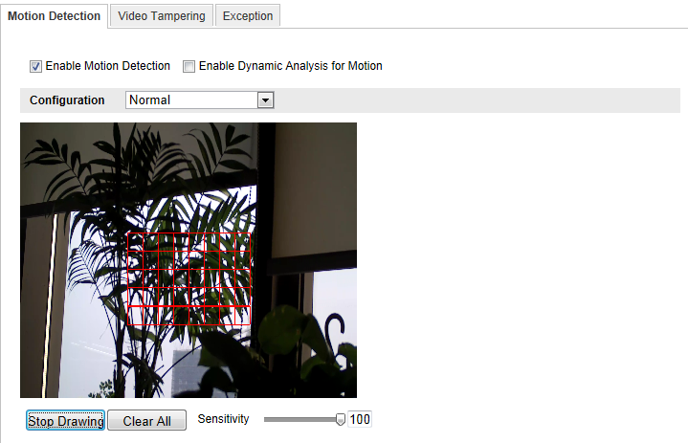
              - Enable Motion Detection
- Click Draw Area. Click and drag the mouse on the live video to draw a motion detection area.
- Click Stop Drawing to finish drawing one area.
- (Optional) Click Clear All to clear all of the areas.
- (Optional) Move the slider to set the sensitivity of the detection.
- Set the Arming Schedule for Motion Detection.
Steps:
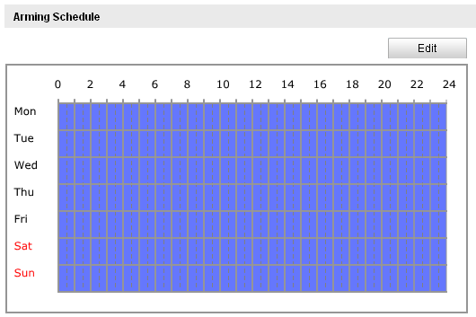
              - Arming Time
- Click Edit to edit the arming schedule. The Figure 6-34 shows the editing interface of the arming schedule.
- Choose the day you want to set the arming schedule.
- Click to set the time period for the arming schedule.
- (Optional) After you set the arming schedule, you can copy the schedule to other days.
- Click OK to save the settings.
Note: The time of each period can’t be overlapped. Up to 4 periods can be configured for each day.
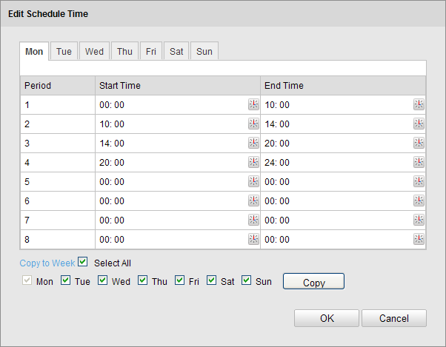
              - Arming Time Schedule
- Set the Alarm Actions for Motion Detection.
Check the checkbox to select the linkage method. Notify surveillance center, send email, upload to FTP, trigger channel and trigger alarm output are selectable. You can specify the linkage method when an event occurs.
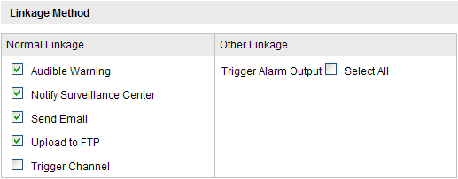
              - Linkage Method
- Audible Warning
Trigger the audible warning locally. And it only supported by the device have the audio output.
- Notify Surveillance Center
Send an exception or alarm signal to remote management software when an event occurs.
- Send Email
Send an email with alarm information to a user or users when an event occurs.
Note: To send the Email when an event occurs, you need to refer to Section 6.6.6 to set the related parameters.
- Upload to FTP
Capture the image when an alarm is triggered and upload the picture to a FTP server.
Note: Set the FTP address and the remote FTP server first. Refer to Section 6.3.10 for detailed information.
- Trigger Channel
The video will be recorded when the motion is detected. You have to set the recording schedule to realize this function. Please refer to Section 7.2 for detailed information.
- Trigger Alarm Output
Trigger one or more external alarm outputs when an event occurs.
Note: To trigger an alarm output when an event occurs, please refer to Section 6.6.4 to set the related parameters.
- Expert Configuration
Expert mode is mainly used to configure the sensitivity and proportion of object on area of each area for different day/night switch.
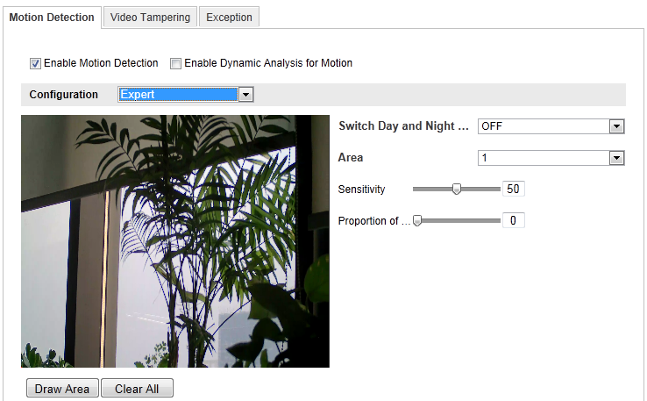
              - Expert Mode of Motion Detection
- Day/Night Switch OFF
Steps:
- Draw the detection area as in the normal configuration mode. Up to 8 areas are supported.
- Select OFF for Switch Day and Night Settings.
- Select the area by clicking the area No.
- Slide the cursor to adjust the sensitivity and proportion of object on the area for the selected area.
- Set the arming schedule and linkage method as in the normal configuration mode.
- Click Save to save the settings.

- Day/Night Auto-Switch
Steps:
- Draw the detection area as in the normal configuration mode. Up to 8 areas are supported.
- Select Auto-Switch for Switch Day and Night Settings.
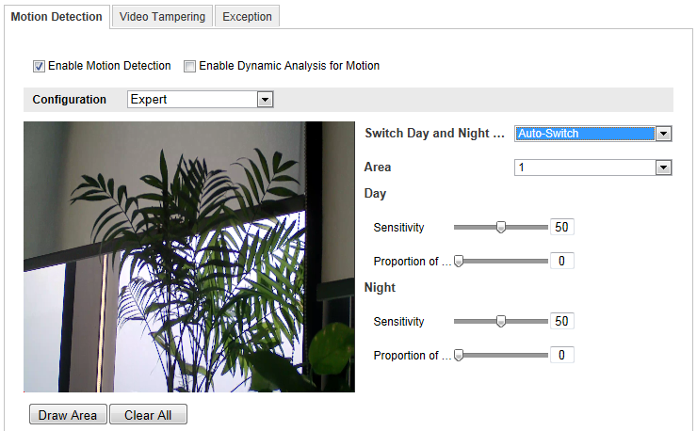
              - Day/Night Auto-Switch
- Select the area by clicking the area No.
- Slide the cursor to adjust the sensitivity and proportion of object on the area for the selected area in the daytime.
- Slide the cursor to adjust the sensitivity and proportion of object on the area for the selected area at night.
- Set the arming schedule and linkage method as in the normal configuration mode.
- Click Save to save the settings.

- Day/Night Scheduled-Switch
- Draw the detection area as in the normal configuration mode. Up to 8 areas are supported.
- Select Scheduled-Switch for Switch Day and Night Settings.
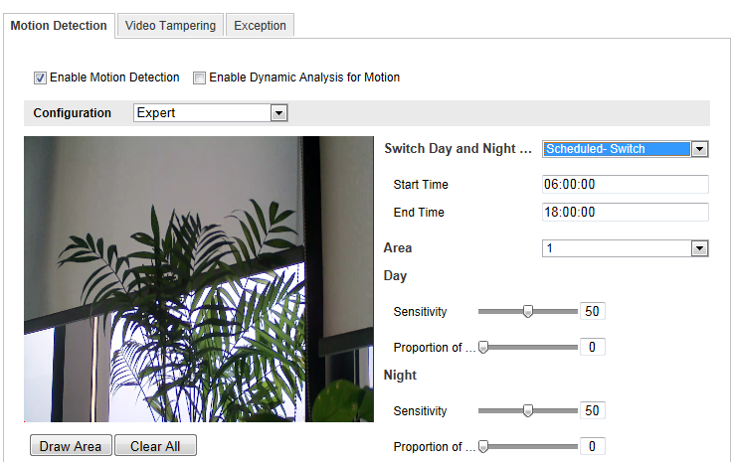
              - Day/Night Scheduled-Switch
- Select the start time and the end time for the switch timing.
- Select the area by clicking the area No.
- Slide the cursor to adjust the sensitivity and proportion of object on the area for the selected area in the daytime.
- Slide the cursor to adjust the sensitivity and proportion of object on the area for the selected area at night.
- Set the arming schedule and linkage method as in the normal configuration mode.
- Click Save to save the settings.

Configuring Video Tampering Alarm
Purpose:
You can configure the camera to trigger the alarm when the lens is covered and take alarm response action.
Steps:
- Enter the video tampering Settings interface:
Configuration > Advanced Configuration > Events > Video Tampering
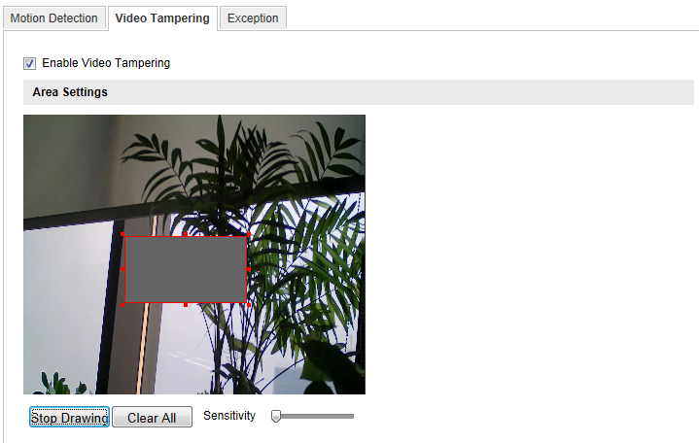
              - Video Tampering Alarm
- Check Enable Video Tampering checkbox to enable the video tampering detection.
- Set the video tampering area; refer to Task 1 Set the Motion Detection Area in Section 6.6.1.
- Click Edit to edit the arming schedule for video tampering. The arming schedule configuration is the same as the setting of the arming schedule for motion detection. Refer to Task 2 Set the Arming Schedule for Motion Detection in Section 6.6.1.
- Check the checkbox to select the linkage method taken for the video tampering. Audible warning, notify surveillance center, send email and trigger alarm output are selectable. Please refer to Task 3 Set the Alarm Actions for Motion Detection in Section 6.6.1.
- Click Save to save the settings.

Configuring Alarm Input
Steps:
- Enter the Alarm Input Settings interface:
Configuration > Advanced Configuration> Events > Alarm Input:
- Choose the alarm input No. and the Alarm Type. The alarm type can be NO (Normally Open) and NC (Normally Closed). Edit the name to set a name for the alarm input (optional).
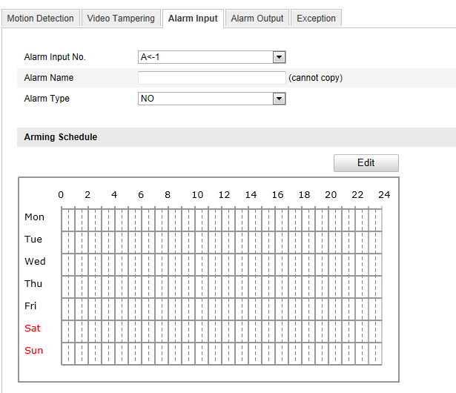
              - Alarm Input Settings
- Click Edit to set the arming schedule for the alarm input. Refer to Task 2 Set the Arming Schedule for Motion Detection in Section 6.6.1.
- Check the checkbox to select the linkage method taken for the alarm input. Refer to Task 3 Set the Alarm Actions for Motion Detection in Section 6.6.1.
- You can also choose the PTZ linking for the alarm input if your camera is installed with a pan/tilt unit. Check the relative checkbox and select the No. to enable Preset Calling, Patrol Calling or Pattern Calling.
- You can copy your settings to other alarm inputs.
- Click Save to save the settings.

Configuring Alarm Output
Steps:
- Enter the Alarm Output Settings interface:
Configuration>Advanced Configuration> Events > Alarm Output
- Select one alarm output channel in the Alarm Output drop-down list. You can also set a name for the alarm output (optional).
- The Delay time can be set to 5sec, 10sec, 30sec, 1min, 2min, 5min, 10min or Manual. The delay time refers to the time duration that the alarm output remains in effect after alarm occurs.
- Click Edit to enter the Edit Schedule Time interface. The time schedule configuration is the same as the settings of the arming schedule for motion detection Refer to Task 2 Set the Arming Schedule for Motion Detection in Section 6.6.1.
- You can copy the settings to other alarm outputs.
- Click Save to save the settings.
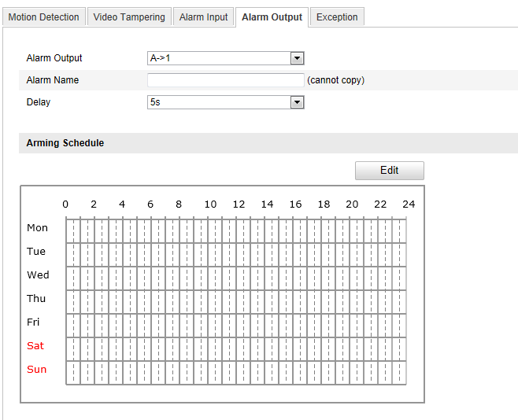
              - Alarm Output Settings

Handling Exception
The exception type can be HDD full, HDD error, network disconnected, IP address conflicted and illegal login to the cameras.
Steps:
- Enter the Exception Settings interface:
Configuration > Advanced Configuration> Events > Exception
- Check the checkbox to set the actions taken for the Exception alarm. Refer to Task 3 Set the Alarm Actions Taken for Motion Detection in Section 6.6.1.
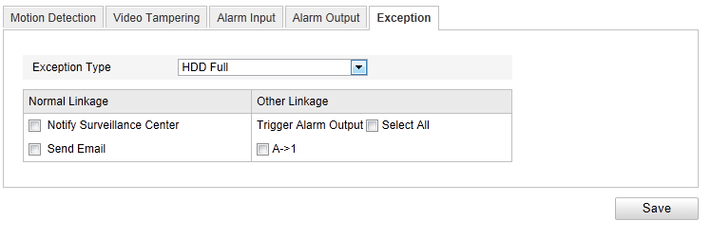
              - Exception Settings
- Click Save to save the settings.

Storage Settings
Before you start:
To configure record settings, please make sure that you have the network storage device within the network or the SD card inserted in your camera.

Configuring NAS Settings
Before you start:
The network disk should be available within the network and properly configured to store the recorded files, log files, etc.
Steps:
- Add the network disk
- Enter the NAS (Network-Attached Storage) Settings interface:
Configuration > Advanced Configuration > Storage > NAS
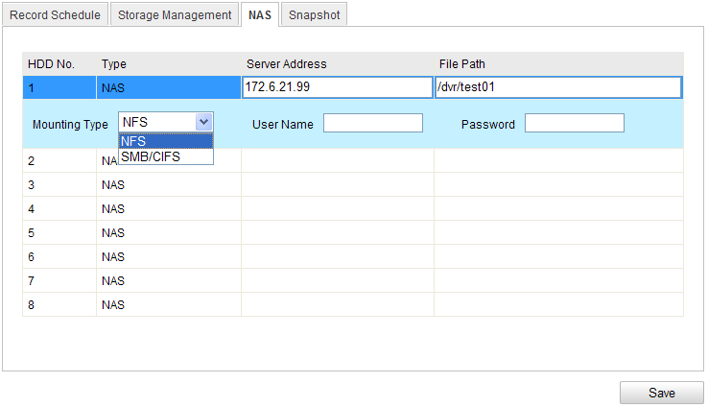
              - Add Network Disk
- Enter the IP address of the network disk, and enter the file path.
- Select the mounting type. NFS and SMB/CIFS are selectable. And you can set the user name and password to guarantee the security if SMB/CIFS is selected.
Note: Please refer to the User Manual of NAS for creating the file path.
- Click Save to add the network disk.
- Initialize the added network disk.
- Enter the HDD Settings interface (Advanced Configuration > Storage > Storage Management), in which you can view the capacity, free space, status, type and property of the disk.
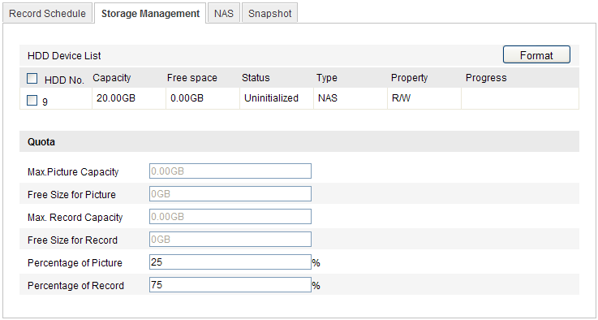
              - Storage Management Interface
- If the status of the disk is Uninitialized, check the corresponding checkbox to select the disk and click Format to start initializing the disk.
When the initialization completed, the status of disk will become Normal.
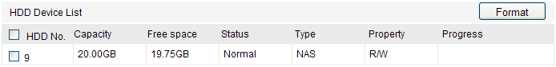
              - View Disk Status
- Define the quota for record and pictures.
- Input the quota percentage for picture and for record.
- Click Save and refresh the browser page to activate the settings.
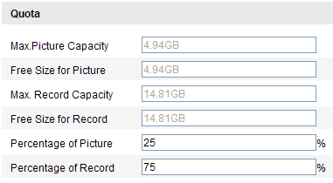
              - Quota Settings
Notes:
- Up to 8 NAS disks can be connected to the camera.
- To initialize and use the SD card after insert it to the camera, please refer to the steps of NAS disk initialization.

Configuring Recording Schedule
Purpose:
There are two kinds of recording for the cameras: manual recording and scheduled recording. For the manual recording, refer to Section 5.3 Recording and Capturing Pictures Manually. In this section, you can follow the instructions to configure the scheduled recording. By default, the record files of scheduled recording are stored in the SD card (if supported) or in the network disk.
Steps:
- Enter the Record Schedule Settings interface:
Configuration > Advanced Configuration> Storage > Record Schedule
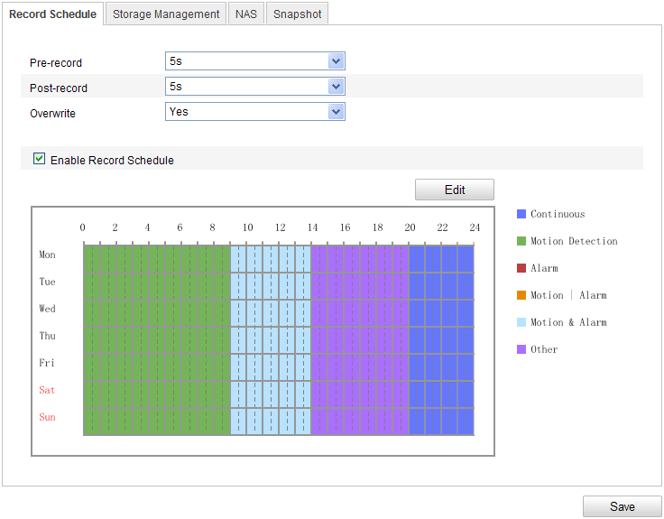
              - Recording Schedule Interface
- Check the checkbox of Enable Record Schedule to enable scheduled recording.
- Set the record parameters of the camera.
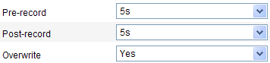
              - Record Parameters
- Pre-record: The time you set to start recording before the scheduled time or the event. For example, if an alarm triggers recording at 10:00, and the pre-record time is set as 5 seconds, the camera starts to record at 9:59:55.
The Pre-record time can be configured as No Pre-record, 5 s, 10 s, 15 s, 20 s, 25 s, 30 s or not limited.
- Post-record: The time you set to stop recording after the scheduled time or the event. For example, if an alarm triggered recording ends at 11:00, and the post-record time is set as 5 seconds, the camera records until 11:00:05.
The Post-record time can be configured as 5 s, 10 s, 30 s, 1 min, 2 min, 5 min or 10 min.
Note: The record parameter configurations vary depending on the camera model.
- Click Edit to edit the record schedule.
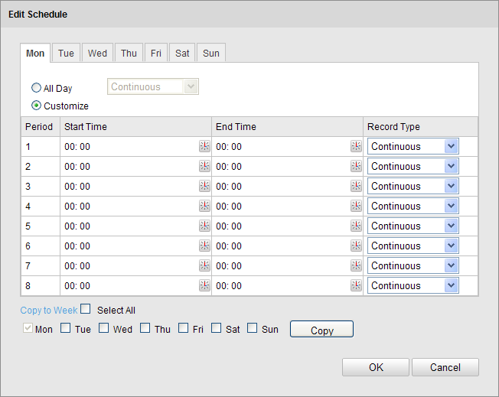
              - Record Schedule
- Choose the day to set the record schedule.
- Set all-day record or segment record:
- If you want to configure the all-day recording, please check the All Day checkbox.
- If you want to record in different time sections, check the Customize checkbox. Set the Start Time and End Time.
Note: The time of each segment can’t be overlapped. Up to 4 segments can be configured.
- Select a Record Type. The record type can be Continuous, Motion Detection, Alarm, Motion | Alarm, Motion & Alarm, etc.
- Continuous
If you select Continuous, the video will be recorded automatically according to the time of the schedule.
- Record Triggered by Motion Detection
If you select Motion Detection, the video will be recorded when the motion is detected.
Besides configuring the recording schedule, you have to set the motion detection area and check the checkbox of Trigger Channel in the Linkage Method of Motion Detection Settings interface. For detailed information, please refer to the Step 1 Set the Motion Detection Area in the Section 6.6.1.
- Record Triggered by Alarm
If you select Alarm, the video will be recorded when the alarm is triggered via the external alarm input channels.
Besides configuring the recording schedule, you have to set the Alarm Type and check the checkbox of Trigger Channel in the Linkage Method of Alarm Input Settings interface. For detailed information, please refer to Section 6.6.4.
- Record Triggered by Motion & Alarm
If you select Motion & Alarm, the video will be recorded when the motion and alarm are triggered at the same time.
Besides configuring the recording schedule, you have to configure the settings on the Motion Detection and Alarm Input Settings interfaces. Please refer to Section 6.6.1 and Section 6.6.4 for detailed information.
- Record Triggered by Motion | Alarm
If you select Motion | Alarm, the video will be recorded when the external alarm is triggered or the motion is detected.
Besides configuring the recording schedule, you have to configure the settings on the Motion Detection and Alarm Input Settings interfaces. Please refer to Section 6.6.1 and Section 6.6.4 for detailed information.
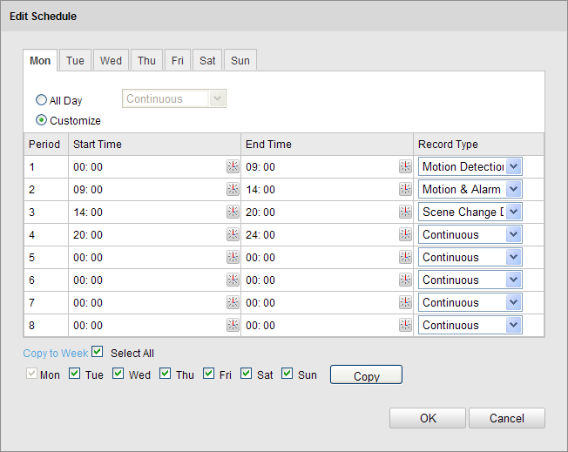
              - Edit Record Schedule
- Check the checkbox of Select All and click Copy to copy settings of this day to the whole week. You can also check any of the checkboxes before the date and click Copy.
- Click OK to save the settings and exit the Edit Record Schedule interface.
- Click Save to save the settings.

Configuring Snapshot Settings
Purpose:
You can configure the scheduled snapshot and event-triggered snapshot. The captured picture can be stored in the SD card (if supported) or the netHDD (For detailed information about netHDD, please refer to Section 7.1 Configuring NAS Settings). You can also upload the captured pictures to a FTP server.
Basic Settings
Steps:
- Enter the Snapshot Settings interface:
Configuration > Advanced Configuration > Storage > Snapshot
- Check the Enable Timing Snapshot checkbox to enable continuous snapshot. Check the Enable Event-triggered Snapshot checkbox to check event-triggered snapshot.
- Select the quality of the snapshot.
- Set the time interval between two snapshots.
- Click Save to save the settings.
Uploading to FTP
You can follow below configuration instructions to upload the snapshots to FTP.
- Upload continuous snapshots to FTP
Steps:
- Configure the FTP settings and check Upload Picture checkbox in FTP Settings interface. Please refer to Section 6.3.10 Configuring FTP Settings for more details to configure FTP parameters.
- Check the Enable Timing Snapshot checkbox.
- Upload event-triggered snapshots to FTP
Steps:
- Configure the FTP settings and check Upload Picture checkbox in FTP Settings interface. Please refer to Section 6.3.8 Configuring FTP Settings for more details to configure FTP parameters.
- Check Upload Picture checkbox in Motion Detection Settings or Alarm Input interface. Please refer to Step 3 Set the Alarm Actions Taken for Motion Detection in Section 6.6.1, or Step 4 Configuring External Alarm Input in Section 6.6.4.
- Check the Enable Event-triggered Snapshot checkbox.
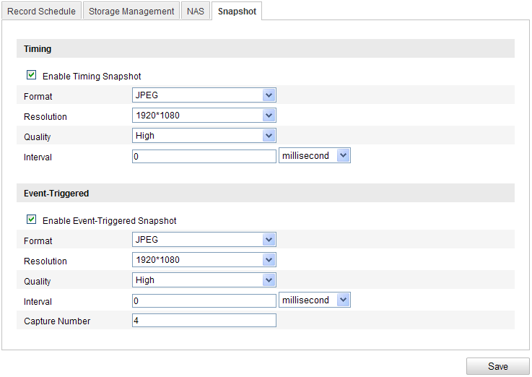
              - Snapshot Settings

Playback
Purpose:
This section explains how to view the remotely recorded video files stored in the network disks or SD cards.
Steps:
1. Click Playback on the menu bar to enter playback interface.
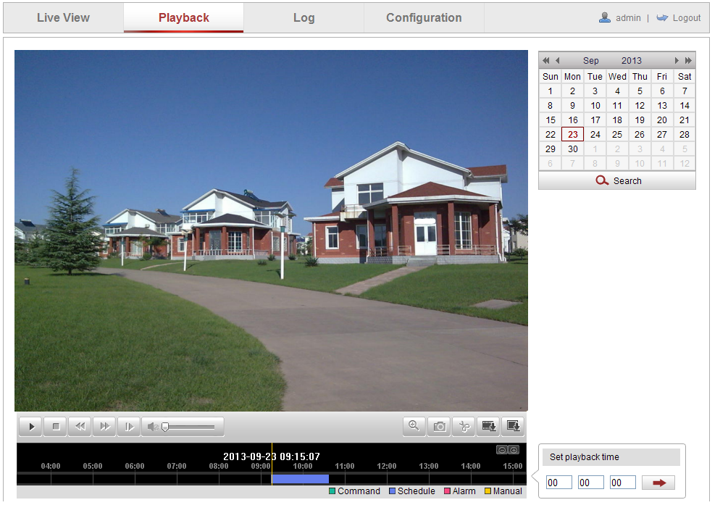
              - Playback Interface
2. Select the date and click Search.
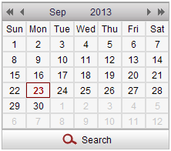
              - Search Video
3. Click to play the video files found on this date.
The toolbar on the bottom of Playback interface can be used to control playing process.
              - Playback Toolbar
                - Description of the buttons
Button | Operation | Button | Operation
 | Play |  | Capture a picture
 | Pause | / | Start/Stop clipping video files
 | Stop | / | Audio on and adjust volume/Mute
 | Speed down |  | Download video files
 | Speed up |  | Download captured pictures
 | Playback by frame | / | Enable/Disable digital zoom

Note: You can choose the file paths locally for downloaded playback video files and pictures in Local Configuration interface. Please refer to Section 6.1 for details.
Drag the progress bar with the mouse to locate the exact playback point. You can also input the time and click to locate the playback point in the Set playback time field. You can also click to zoom out/in the progress bar.
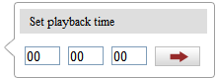
              - Set Playback Time
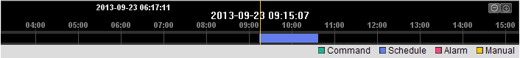
              - Progress Bar
The different colors of the video on the progress bar stand for the different video types.
              - Video Types

Log Searching
Purpose:
The operation, alarm, exception and information of the camera can be stored in log files. You can also export the log files on your demand.
Before you start:
Please configure network storage for the camera or insert a SD card in the camera.
Steps:
- Click Log on the menu bar to enter log searching interface.
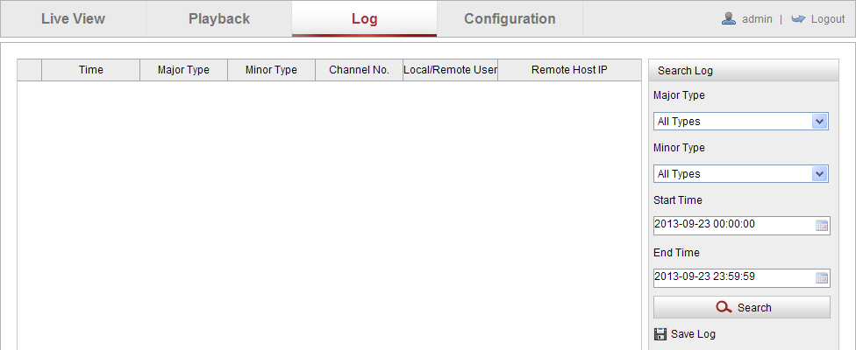
              - Log Searching Interface
- Set the log search conditions to specify the search, including the Major Type, Minor Type, Start Time and End Time.
- Click Search to search log files. The matched log files will be displayed on the Log interface.
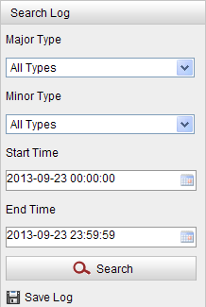
              - Log Searching
- To export the log files, click Save log to save the log files in your computer.

Others

Managing User Accounts
Enter the User Management interface:
Configuration >Basic Configuration> Security > User
Or Configuration > Advanced Configuration> Security > User
The admin user has access to create, modify or delete other accounts. Up to 15 user accounts can be created.
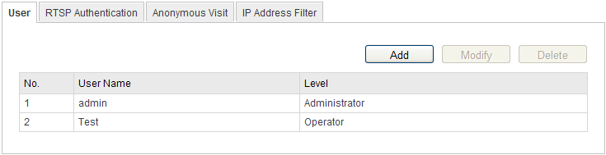
              - User Information
- Add a User
Steps:
- Click Add to add a user.
- Input the new User Name, select Level and input Password.
Note: The level indicates the permissions you give to the user. You can define the user as Operator or User.
- In the Basic Permission field and Camera Configuration field, you can check or uncheck the permissions for the new user.
- Click OK to finish the user addition.
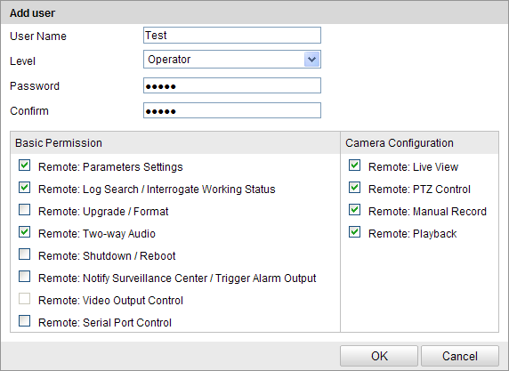
              - Add a User
- Modify a User
Steps:
- Left-click to select the user from the list and click Modify.
- Modify the User Name, Level or Password.
- In the Basic Permission field and Camera Configuration field, you can check or uncheck the permissions.
- Click OK to finish the user modification.
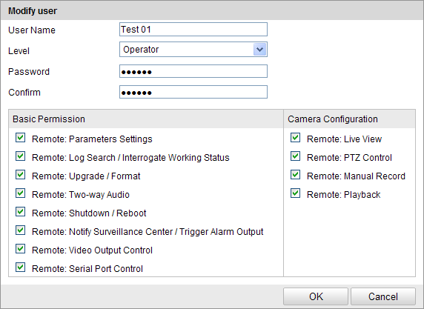
              - Modify a User
- Delete a User
Steps:
- Click to select the user you want to delete and click Delete.
- Click OK on the pop-up dialogue box to delete the user.

Configuring RTSP Authentication
Purpose:
You can specifically secure the stream data of live view.
Steps:
- Enter the RTSP Authentication interface:
Configuration> Advanced Configuration> Security > RTSP Authentication
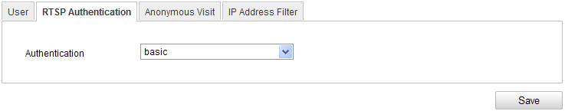
              - RTSP Authentication
- Select the Authentication type basic or disable in the drop-down list to enable or disable the RTSP authentication.
Note: If you disable the RTSP authentication, anyone can access the video stream by the RTSP protocol via the IP address.
- Click Save to save the settings.

Anonymous Visit
Purpose:
Enabling this function allows visit for whom doesn’t have the user name and password of the device.
Steps:
- Enter the Anonymous Visit interface:
Configuration> Advanced Configuration> Security > Anonymous Visit
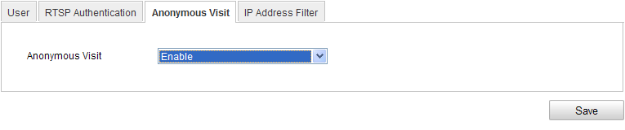
              - Anonymous Visit
- Set the Anonymous Visit permission Enable or Disable in the drop-down list to enable or disable the anonymous visit.
- Click Save to save the settings.
There will be a checkbox of Anonymous by the next time you logging in.
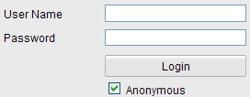
              - Login Interface with an Anonymous Checkbox
- Check the checkbox of Anonymous and click Login.
Note: Only live view is available for the anonymous user.

IP Address Filter
Purpose:
This function makes it possible for access control.
Steps:
- Enter the IP Address Filter interface:
Configuration> Advanced Configuration> Security > IP Address Filter
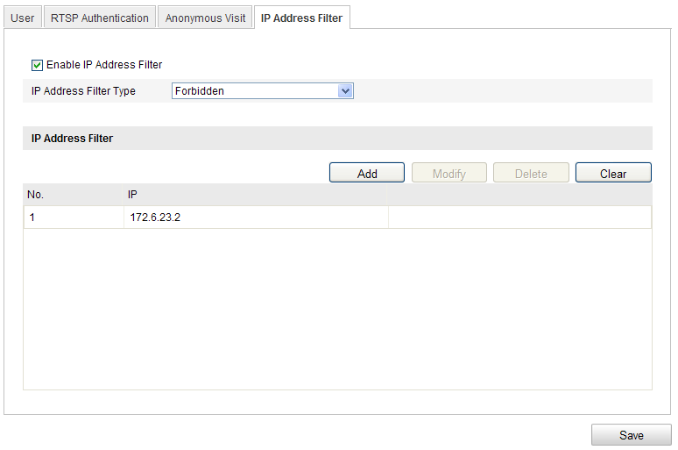
              - IP Address Filter Interface
- Check the checkbox of Enable IP Address Filter.
- Select the type of IP Address Filter in the drop-down list, Forbidden and Allowed are selectable.
- Set the IP Address Filter list.
- Add an IP Address
Steps:
- Click the Add to add an IP.
- Input the IP Adreess.
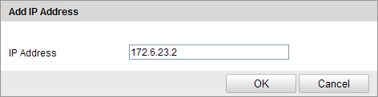
              - Add an IP
- Click the OK to finish adding.
- Modify an IP Address
Steps:
- Left-click an IP address from filter list and click Modify.
- Modify the IP address in the text filed.
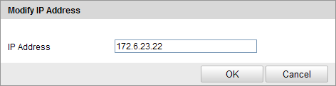
              - Modify an IP
- Click the OK to finish modifying.
- Delete an IP Address
Left-click an IP address from filter list and click Delete.
- Delete all IP Addresses
Click Clear to delete all the IP addrsses.
- Click Save to save the settings.

Viewing Device Information
Enter the Device Information interface:
Configuration > Basic Configuration> System > Device Information
Or Configuration > Advanced Configuration> System > Device Information
In the Device Information interface, you can edit the Device Name.
Other information of the network camera, such as Model, Serial No., Firmware Version, Encoding Version, Number of Channels, Number of HDDs, Number of Alarm Input and Number of Alarm Output are displayed. The information cannot be changed in this menu. It is the reference for maintenance or modification in future.
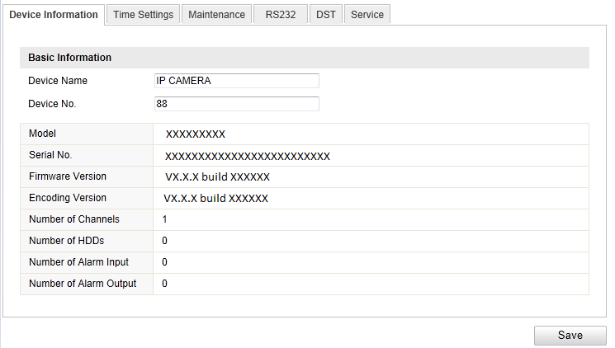
              - Device Information

Maintenance

Rebooting the Camera
Steps:
- Enter the Maintenance interface:
Configuration > Basic Configuration> System > Maintenance
Or Configuration > Advanced Configuration> System > Maintenance
- Click Reboot to reboot the network camera.
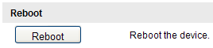
              - Reboot the Device

Restoring Default Settings
Steps:
- Enter the Maintenance interface:
Configuration > Basic Configuration> System > Maintenance
Or Configuration > Advanced Configuration> System > Maintenance
- Click Restore or Default to restore the default settings.
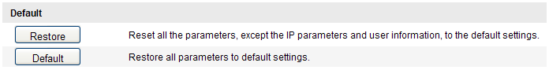
              - Restore Default Settings
Note: After restoring the default settings, the IP address is also restored to the default IP address, please be careful for this action.

Exporting / Importing Configuration File
Purpose:
Configuration file is used for the batch configuration of the camera, which can simplify the configuration steps when there are a lot of cameras needing configuring.
Steps:
Enter the Maintenance interface:
Configuration > Basic Configuration> System > Maintenance
Or Configuration > Advanced Configuration> System > Maintenance
- Click Export to export the current configuration file, and save it to the certain place.
- Click Browse to select the saved configuration file and then click Import to start importing configuration file.
Note: You need to reboot the camera after importing configuration file.
- Click Export and set the saving path to save the configuration file in local storage.
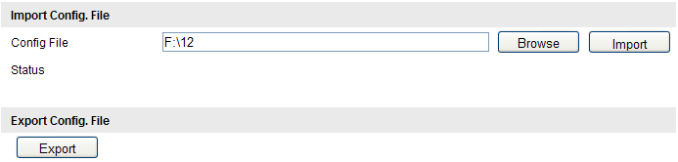
              - Import/Export Configuration File

Upgrading the System
Steps:
- Enter the Maintenance interface:
Configuration > Basic Configuration> System > Maintenance
Or Configuration > Advanced Configuration> System > Maintenance
- Click Browse to select the local upgrade file and then click Upgrade to start remote upgrade.
Note: The upgrading process will take 1 to 10 minutes. Please don't disconnect power of the camera during the process. The camera reboots automatically after upgrading.
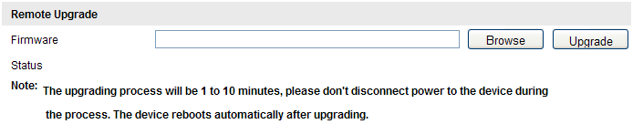
              - Remote Upgrade

RS-232 Settings
Purpose:
The RS-232 port can be used in two ways:
- Parameters Configuration: Connect a computer to the camera through the serial port. Device parameters can be configured by using software such as HyperTerminal. The serial port parameters must be the same as the serial port parameters of the camera.
- Transparent Channel: Connect a serial device directly to the camera. The serial device will be controlled remotely by the computer through the network.
Steps:
- Enter RS-232 Port Setting interface:
Configuration> Advanced Configuration> System > RS232
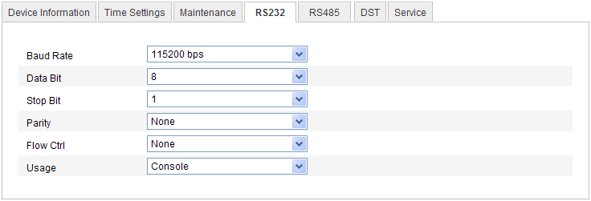
              - RS-232 Settings
Note: If you want to connect the camera by the RS-232 port, the parameters of the RS-232 should be exactly the same with the parameters you configured here.
- Click Save to save the settings.

Appendix

Appendix 1 SADP Software Introduction
- Description of SADP
SADP (Search Active Devices Protocol) is a kind of user-friendly and installation-free online device search tool. It searches the active online devices within your subnet and displays the information of the devices. You can also modify the basic network information of the devices using this software.
- Search active devices online
  - Search online devices automatically
After launch the SADP software, it automatically searches the online devices every 15 seconds from the subnet where your computer locates. It displays the total number and information of the searched devices in the Online Devices interface. Device information including the device type, IP address, port number, gateway, etc. will be displayed.
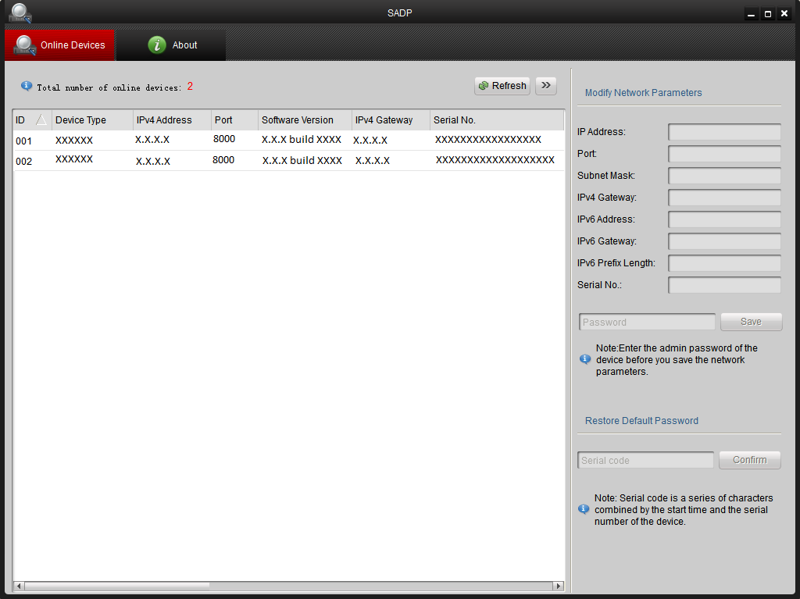
Figure A.1.1 Search Online Devices
Note: Device can be searched and displayed in the list in 15 seconds after it went online; it will be removed from the list in 45 seconds after it went offline.
  - Search online devices manually
You can also click Refresh to refresh the online device list manually. The newly searched devices will be added to the list.
Note: You can click or on each column heading to order the information; you can click to expand the device table and hide the network parameter panel on the right side, or click to show the network parameter panel.
- Modify network parameters
Steps:
- Select the device to be modified in the device list and the network parameters of the device will be displayed in the Modify Network Parameters panel on the right side.
- Edit the modifiable network parameters, e.g. IP address and port number.
- Enter the password of the admin account of the device in the Password field and click to save the changes.
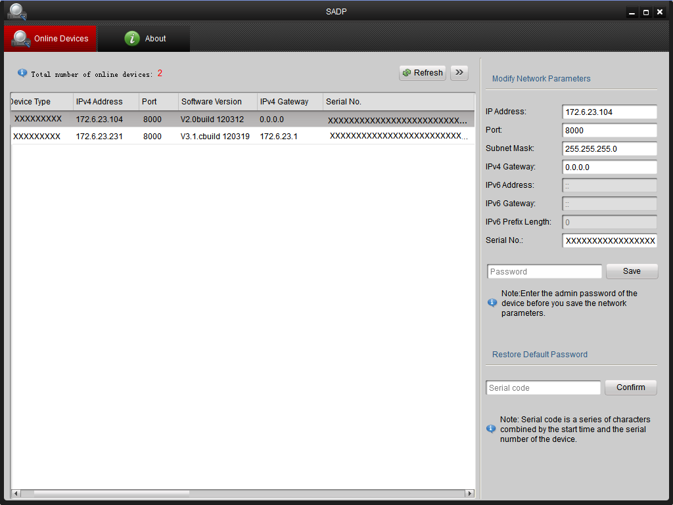
Figure A.1.2 Modify Network Parameters
- Restore default password
Steps:
- Contact our technical engineers to get the serial code.
- Input the code in the Serial code field and click Confirm to restore the default password.

Appendix 2 Port Mapping
The following settings are for TP-LINK router (TL-WR641G). The settings vary depending on different models of routers.
Steps:
- Select the WAN Connection Type, as shown below:
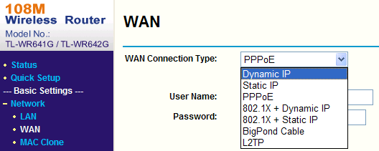
Figure A.2.1 Select the WAN Connection Type

- Set the LAN parameters of the router as in the following figure, including IP address and subnet mask settings.
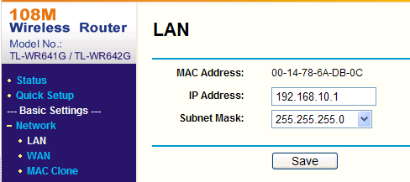
Figure A.2.2 Set the LAN parameters

- Set the port mapping in the virtual severs of Forwarding. By default, camera uses port 80, 8000 and 554. You can change these ports value with web browser or client software.
Example:
When the cameras are connected to the same router, you can configure the ports of a camera as 80, 8000, and 554 with IP address 192.168.1.23, and the ports of another camera as 81, 8001, 555, 8201 with IP 192.168.1.24. Refer to the steps as below:
Steps:
- As the settings mentioned above, map the port 80, 8000, 554 and 8200 for the network camera at 192.168.1.23
- Map the port 81, 8001, 555 and 8201 for the network camera at 192.168.1.24.
- Enable ALL or TCP protocols.
- Check the Enable checkbox and click Save.
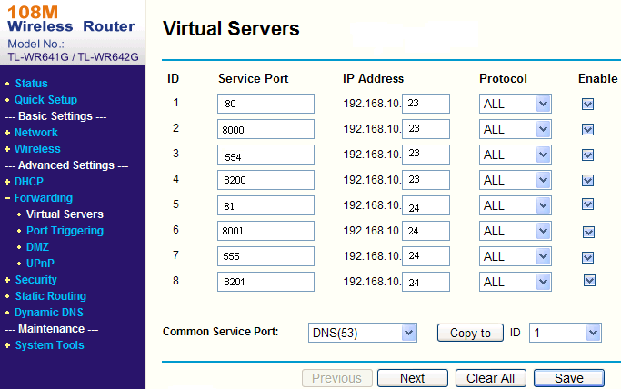
Figure A.2.3 Port Mapping

Note: The port of the network camera cannot conflict with other ports. For example, some web management port of the router is 80. Change the camera port if it is the same as the management port.

