**User Manual of HKB-1004KI Keyboard**

UD.6L0203D1098A02

**Preventive and Cautionary Tips**

Before connecting and operating your keyboard, please be advised of the following tips:

* Ensure unit is placed in a well-ventilated, dust-free environment.
* Keep all liquids away from the keyboard.
* Please check the power supply to avoid the damage caused by voltage mismatch.
* Please make sure the keyboard work in the allowed range of temperature and humidity.
* Please keep the device horizontal and avoid the installation under severe vibration environment.
* The dust board will cause a short circuit after damping. Please dedust regularly for the board, connector, and chassis fan with brush.

Contents

Chapter 1 Product Overview 3

Chapter 2 Device Appearance 5

2.1 Rear Panel Description 5

2.2 Front Panel Description 6

2.3 Joystick Function 7

2.4 Typical Wiring Methods 8

Chapter 3 Keyboard Operation 14

3.1 Controlling DVR/NVR by Keyboard 14

Setting the Keyboard Parameters to Control DVR/NVR 14

Operating DVR/NVR by Keyboard 15

3.2 Controlling Dome Cameras by Keyboard 17

Setting the Keyboard Parameters to Control Dome Camera 17

Dome Camera Control Operation 18

3.3 Controlling the VMS by Keyboard 19

Setting the Keyboard Parameters to Control VMS 19

VMS Control Operation 19

3.4 Controlling the Analog Matrix by Keyboard 21

Setting the Keyboard Parameters to Control Analog Matrix 21

Analog Matrix Controlling Operation 21

3.5 Controlling the Matrix Access Gateway by Keyboard 21

Setting the Keyboard Parameters to Control Matrix Access Gateway 21

Matrix Gateway Control Operation 22

Appendix 1：Specification 24

# Product Overview

HKB-1004KI keyboard can be used to control the DVR, the analog dome, the video management platform and the analog matrix. The keyboard is featured in its steady and friendly operation.

**Multiple Controlling Modes**

The keyboard controls the DVR, Dome Camera, VMS and Analog Matrix.

Controlling modes determine the devices controlled by the keyboard; e.g. if you choose the control mode as DVR, all the commands and the controlling signal will be applied to the DVR. The controlling mode of the HKB-1004KI keyboard can be shifted by pressing the MODE button on the panel.

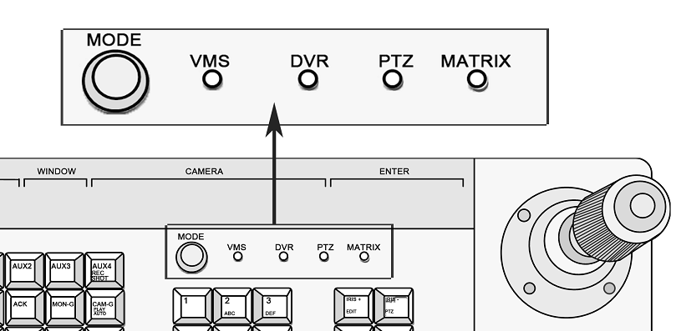

Figure - Mode Buttons

* **DVR controlling**：The keyboard can fulfill the complete function of the front panel operation of the DVR. And there are LED screen displays for all the operation. One keyboard can connect to 128 DVRs and the address code of the DVR ranges from 0 to 255.
* **Analog Dome Controlling**：The keyboard controls the PTZ function of the analog domes, the address code of the dome ranges from 0 to 255. A maximum 128 analog domes can be connected.
* **VMS Controlling**: The keyboard controls the video management platform, the TV wall switching and display, PTZ parameters setting and PTZ controlling.
* **Analog Matrix Controlling**: Control the signal input and output switch in the analog matrix.

**Multiple Working Modes**

The working modes are chosen by turning the key on the front panel. See the figure below.

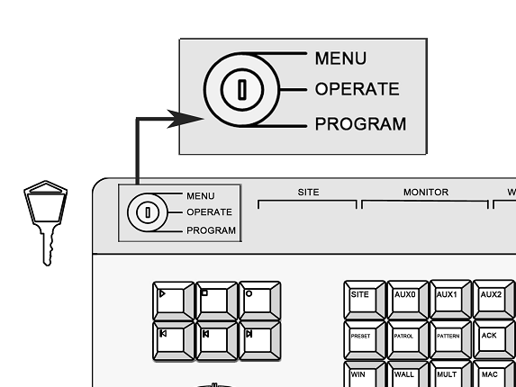

Figure - Turning the Key to Change Working Mode

* **MENU:** Keyboard Configuration Mode. Turn the key to the **MENU**. Set the keyboard parameters, such as the keyboard address, the RS-485 parameters and the RS-232 parameters.
* **OPERATE:** Keyboard Operation Mode. Turn the key to **OPERATE**. Under this mode, the keyboard can control the DVR, PTZ of the dome camera and the matrix.
* **PROGRAM**: Keyboard Function Settings Mode. Turn the key to **PROGRAM**. Under this mode, the keyboard can set the parameters for preset, pattern and patrol.

**Protocols**

There are 63 protocols of the PTZ control of dome camera, and the main protocols are PRIVATE, PELCO-P, PELCO-D, SAMSUNG, YAAN-1, SONY, SIEMENS, DRAGON, NAIJIE, KALATEL, VICON and etc..

The control protocols for the analog matrix are ZT-1.0, ZT-2.0, EXTRON, and CREATOR.

**Cascade Connection**

HKB-1004KI provides the cascade connection, and 16 auxiliary keyboards are connectable. The address of the auxiliary keyboard ranges from 0 to 255.

**Other Features**

* The keyboard can set different RS-485 parameters such as the protocol and the Baudrate, which enables the flexible parallel connection to different devices.
* The convenient key locking function ensures the security of operation.
* The keyboard integrates multiple control functions as the controlling of DVR, analog dome cameras and matrix. It can be used in the complex surveillance system.
* LED panel display is provided.

# Device Appearance

## Rear Panel Description

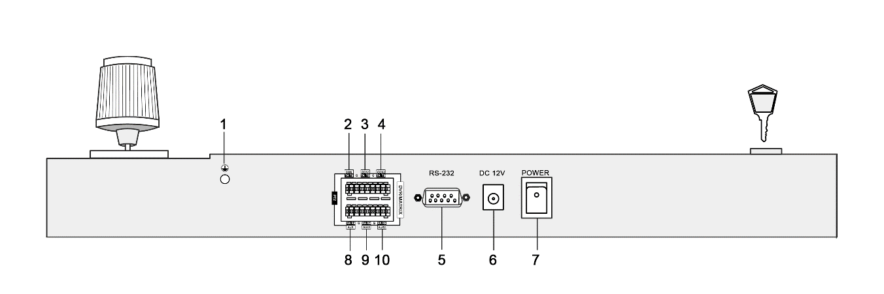

Figure 2-1 The Rear Panel of HKB-1004KI Keyboard

***Notes：***

The green end with a **G** identifier on the rear panel is for grounding.

|  |  |  |
| --- | --- | --- |
| Number | Physical Interfaces | Description |
| 1 | Grounding | The pillar for grounding. |
| 2 | PTZ-CON  (PTZ Control Signal Output) | As main keyboard: Connect the dome camera or the RS-485 of the PTZ: **TA** connects to **RS-485+**, and **TB** connects to **RS-485-.**  As auxiliary keyboard: Connect the PTZ-AUX interface of the upper level keyboard: **TA** connects to **RA** and **TB** connects to **RB**. |
| 3 | DVR/MATRIX-CON1  (DVR Control Signal Output) | As main keyboard: Connect the DVR KB interface; **TA** connects **D+**, **TB** connects **D-**; When connecting the RS-485 of the VMS: TA connects to the 6th pin and TB connects to 5th pin. When using the RS-485-to-RS-232 interface: **TA** connects to 4th pin and **TB** connects to 3rd pin.  As auxiliary keyboard: Connect the AUX2 interface of the upper level keyboard. **TA** connects to **RA** and **TB** connects to **RB.** |
| 4 | DVR/MATRIX-CON2  (Control Signal Output) | Output the RS-485 signal received by the 9th interface identified in the figure above (AUX 1 interface). |
| 5 | RS-232 Serial Interface | For the keyboard firmware upgrading and the control interface for the analog matrix. |
| 6 | Power Supply | 12VDC |
| 7 | Power Switch | Power on/ off |
| 8 | PTZ-AUX  (Auxiliary keyboard PTZ control signal input) | Connect to the lower level PTZ-CON interface; **RA** connects to **TA** and **RB** connects to **TB.** |
| 9 | DVR/MATRIX-AUX1 (Auxiliary keyboard DVR control signal input) | Connect a RS-485 signal source to receive the RS-485 signal. |
| 10 | DVR/MATRIX-AUX2  (Auxiliary keyboard control signal input) | Connect to the DVR/MATRIX-CON interface of the lower level keyboard: **RA** connects to **TA**, **RB** connects to **TB.** |

We name the keyboard directly connecting the main keyboard *upper level keyboard* and we call the keyboard connecting to the upper level keyboard the *lower level keyboard*. For detailed information, see Chapter 2.4 for typical wiring methods.

## Front Panel Description

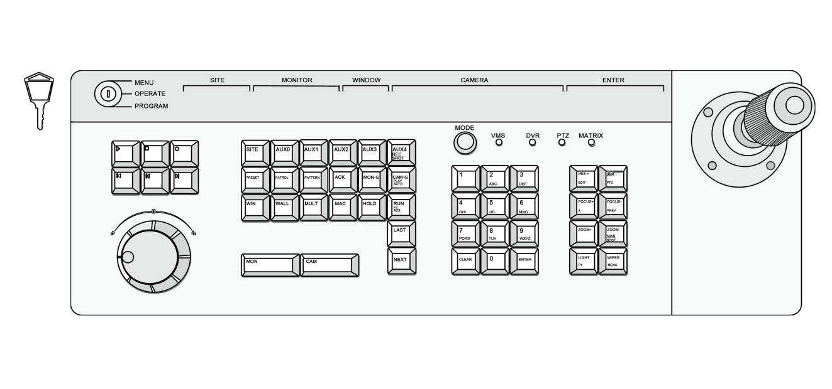

Figure 2-2 Front Panel of HKB-1004KI Keyboard

***Note:***

Buttons on the keyboard have different functions in different controlling modes. For example, the **IRIS+/EDIT** button realizes the **IRIS+** in PTZ control mode and in the DVR control mode, it is the EDIT button, when pressing, you can edit the combox field.

| Button | Description |
| --- | --- |
| Lock | Switch to change the working mode of the keyboard. |
| Playback Buttons | Reserved |
| Jog Shuttle Button | Reserved |
| SITE | Press this button to enter the DVR No., dome camera No., analog matrix No. or the VMS No.. |
| AUX0 | When controlling VMS, call the patrol of the dome camera. |
| AUX1 | Reserved |
| AUX2 | Reserved |
| AUX3 | Reserved |
| AUX4/ REC/SHOT | DVR control mode: Audio on/ off and |
| PRESET | Set and call the preset |
| PATROL | Set and call the patrol |
| PATTERN | Set and call the pattern |
| ACK | Reserved |
| MON-G | When controlling VMS, choose the monitor group. |
| CAM-G/PLAY/AUTO | When controlling VMS, choose the camera group. |
| DVR control mode: Fast play when playing back. |
| WIN | When controlling VMS, press the button to choose windows. |
| WALL | When controlling VMS, select the TV wall after montage is done. |
| MULT | When controlling VMS, select the small screen which has not been montaged. |
| MAC | Reserved |
| HOLD | Stop cycling |
| RUN/F2/AUX | Start or Go on the cycling |
| DVR control mode: change the tab menu |
| NEXT | The next item, can be a channel or menu setting field. |
| LAST | The previous item, can be a channel or menu setting field. |
| MON | When controlling the VMS or analog matrix, press this button to choose the monitor. |
| CAM | When controlling the VMS or analog matrix, press this button to choose the camera. |
| MODE | Press to switch the control mode of the keyboard |
| Numeric & characters buttons（0-9） | Input the number or character; choose the live view or playback channel. |
| CLEAR | Clear the numbers input and exit. |
| ENTER | Enter |
| IRIS+/EDIT | PTZ control mode: iris+ |
| DVR control mode: enable editing |
| IRIS-/PTZ | PTZ control mode: iris- |
| DVR control mode: show the PTZ control menu |
| FOCUS+/A | PTZ control mode: focus+ |
| DVR control mode: switch the input methods |
| FOCUS-/PREV | PTZ control mode: focus- |
| DVR control mode: switch the screen display. |
| ZOOM+ | PTZ control mode: zoom+ |
| ZOOM-/ MAIN/SPOT | PTZ control mode: zoom- |
| DVR control mode: switch between main and auxiliary mode |
| LIGHT/F1 | PTZ control mode: turn on the light |
| WIPER/MENU | PTZ control mode: enable wiper |
| DVR control mode: open the main men |

## Joystick Function

|  |  |  |
| --- | --- | --- |
| Graphic | Operation | Function |
|  | Up | PTZ control mode: Move the PTZ up. |
| DVR control mode: Fast play when playback, or navigate to the previous item when operating the menu. |
|  | Down | PTZ control mode: Move the PTZ down. |
| DVR control mode: Slow play when playback, or navigate to the next item when operating the menu. |
|  | Left | PTZ control mode: Move the PTZ to the left. |
| DVR control mode: Skip backward when playback, or navigate to the previous menu when operating the menu. |
|  | Right | PTZ control mode: Move the PTZ right. |
| DVR control mode: Skip forward when playback, or navigate to the next menu when operating the menu. |
|  | Rotate Left | Zoom out |
|  | Rotate Right | Zoom in |

***Notes：***

The joystick realizes pan and tilt movement at 8 directions.

The 4-axis joystick can be used to control the zoom; and the central button used as Enter button and to realize picture capture as well.

## Typical Wiring Methods

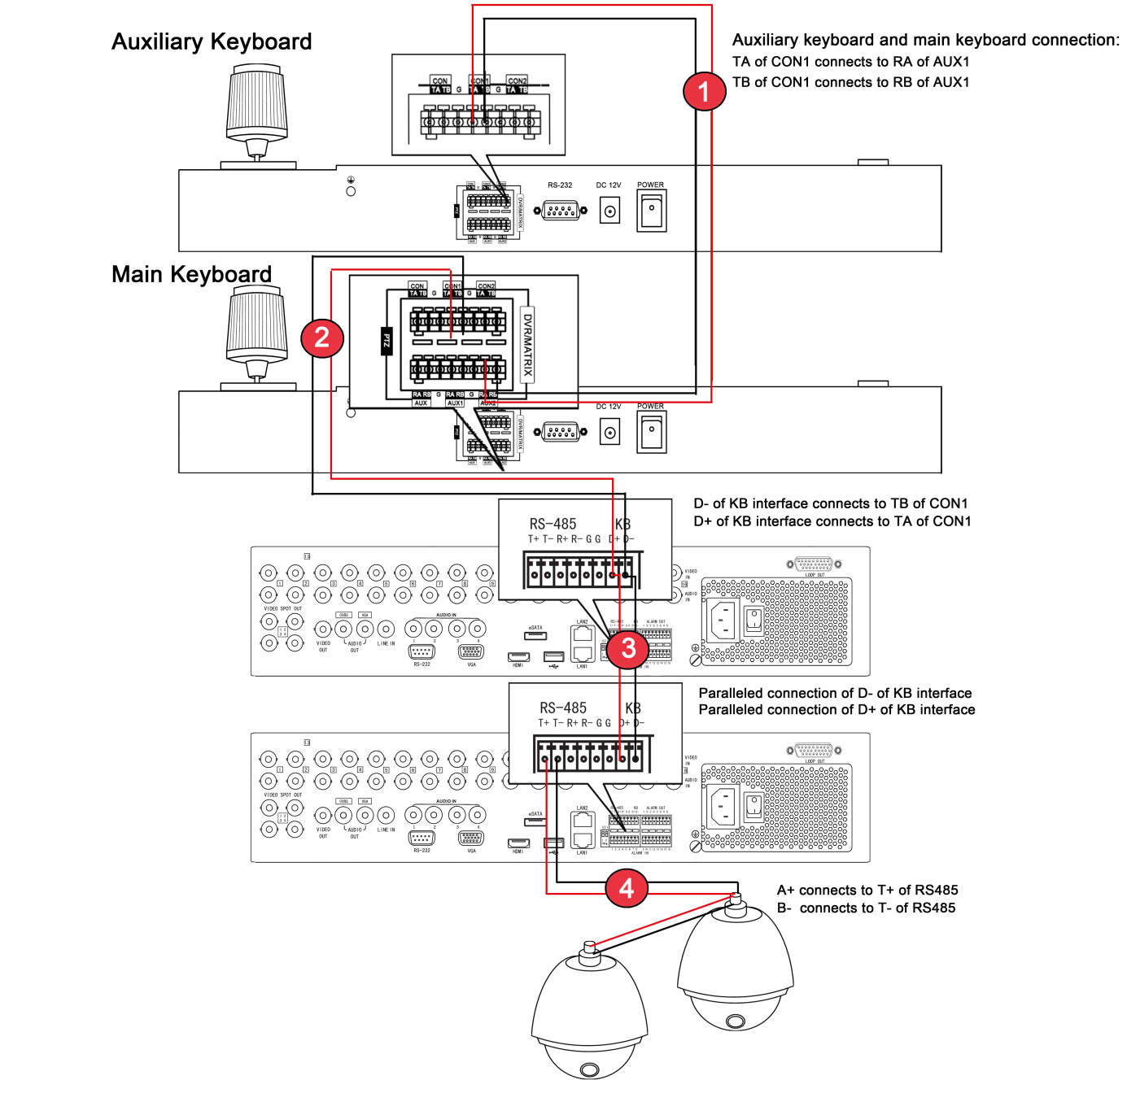

**Figure 2-3 Connection between the keyboards, the keyboards and the dome camera, the keyboard and the DVRs**

① shows the connection of the auxiliary keyboard and the main keyboard. You can connect many auxiliary keyboards to the main keyboard.

② shows the connection between the keyboard and the DVR/NVR.

③ shows the connection of DVRs when they are all connected and controlled by the keyboard.

④ shows the connection between DVR and dome cameras.

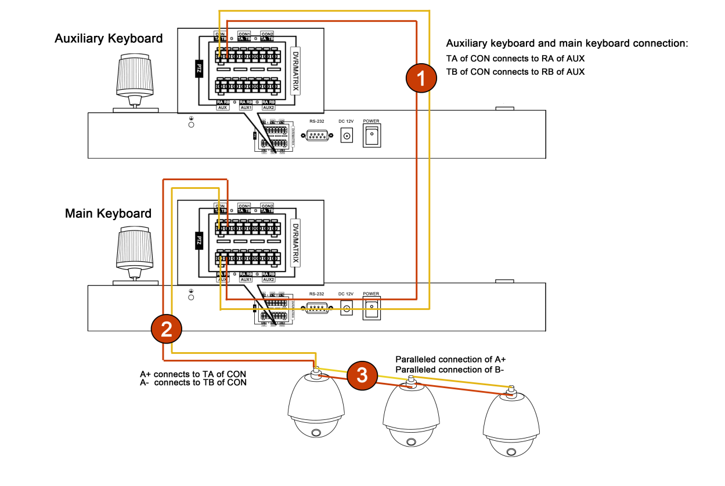  
**Figure 2-4 Connection between the main and auxiliary keyboards, and the keyboards and the dome camera**

① shows the connection of the auxiliary keyboard and the main keyboard. You can connect many auxiliary keyboards to the main keyboard.

② shows the connection between keyboard and dome camera.

③ shows the connection between dome cameras when they are all connected and controlled by the keyboard.

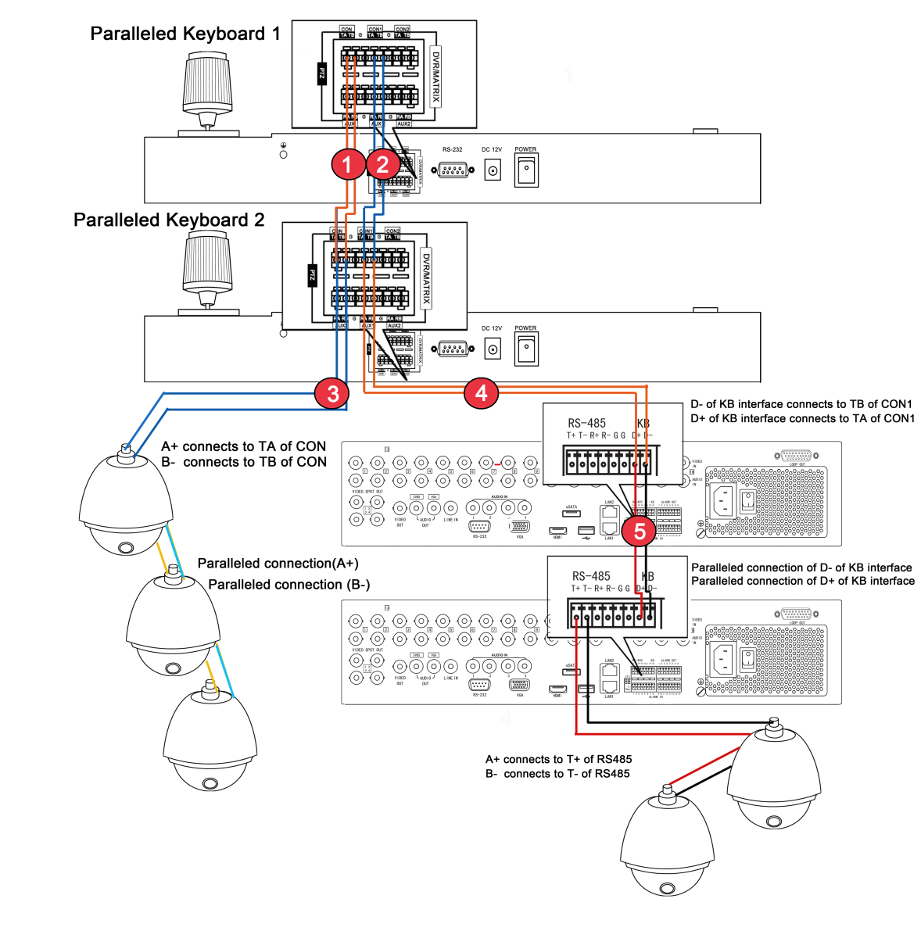

**Figure 2-5 Connection of the paralleled keyboards, the keyboards and the dome camera, the keyboard and the DVRs**

① shows the connection of keyboard when they are connected to each other to control the dome camera. PTZ-CON interface: TA connects TA, TB connects TB.

③ shows the connection between the keyboard and the dome camera. PTZ-CON TA connects RS-485+, TB connects RS-485-.

② shows the connection between the paralleled connected keyboard and DVR/NVR. DVR-CON: TA connects TA and TB connects TB.

④ shows the connection between the keyboard and DVR/NVR. DVR-CON1 TA connects D+ of KB and DVR-CON1 TB connects D- of KB.

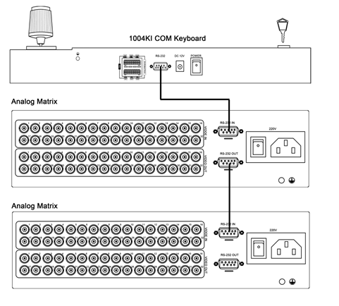

**Figure 2-6 Connection between the keyboard and the analog matrix**

The RS-232 interface of the HKB-1004KI keyboard uses the DB9 interface. And the definition of pins of DB9 interface is written in the table below.

|  |  |  |
| --- | --- | --- |
| **No.** | **Name** | **Function** |
| 1 | DCD | -- |
| 2 | RXD | Receiving Data |
| 3 | TXD | Transmitting Data |
| 4 | DTR | -- |
| 5 | GND | Grounding |
| 6 | DSR | -- |
| 7 | RTS | -- |
| 8 | CTS | -- |
| 9 | RI | -- |

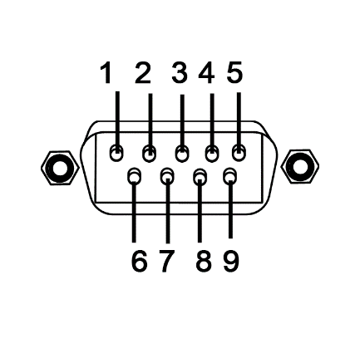

The HKB-1004KI keyboard uses RS-232 interface, the RS-232 interface connects the keyboard control interface on the analog matrix. The above figure shows the connection between keyboard and the analog matrix via RS-232 interface.

When connecting to more than one analog matrix, the analog matrix connected in parallel, showing in the above figure.

***Note:***

When controlling more than one analog matrix, the protocol is the ZT-1.0. Otherwise the cascading matrix cannot be controlled.

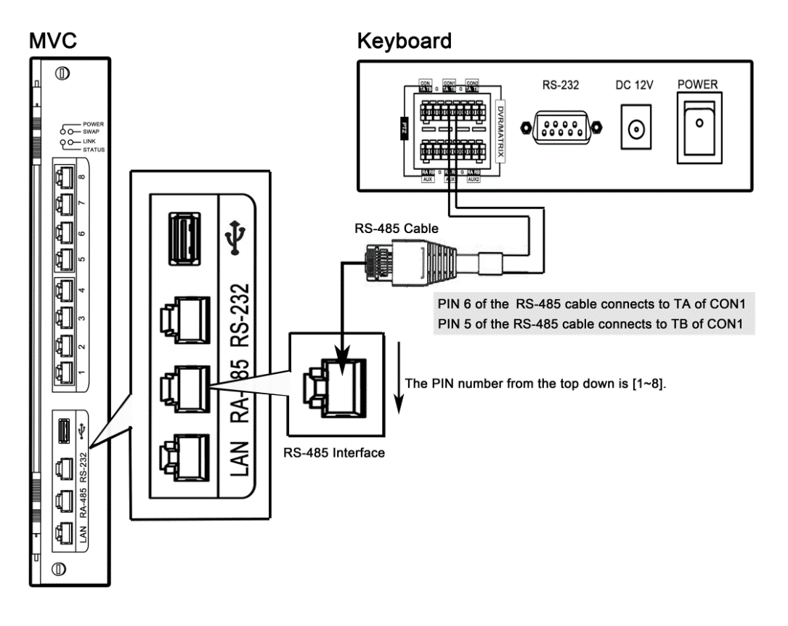  
**Figure 2-7 Connection between the keyboard and the VMS**

The HKB-1004KI keyboard controls the VMS, and to control it, you need to configure the VMS with the cascading configuration tool. Please refer to the manual of the VMS.

The DVR-CON TA connects the pin6 of RS-485 interface on the VMS side, and the DVR-CON TB connects the pin5 of RS-485 interface on the VMS side.



**Figure 2-8 Connection between the keyboard and the matrix access gateway**

***Notes:***

* The COM ports 1-4 of the matrix access gateway support RS-422 protocol, and the COM ports 5-8 support RS-485 protocol. Please connect the keyboard to the COM ports 1-4.
* Connect the pin3 of the matrix access gateway’s COM port to the TB of the keyboard’s CON2 port, pin4 to the TA of CON2, pin5 to the RB of AUX1, and pin6 to the RA of AUX1. During the control operation, the corresponding value can be dispalyed on the LED panel of the keyboard.
* When there are main and auxilliary keyboards for connecting with the matrix access gateway, the TA and TB of the auxilliary keyboard’s CON1 port should be connected to the RA and RB of the main keyboard’s AUX2 repectively, and the RA and RB of the auxilliary keyboard’s AUX1 to the the TA and TB of the main keyboard’s CON port respectively.
* When the main and auxilliary keyboards are controlling the matrix access gateway, unique ID must be assigned to the main keyboard and auxilliary keyboard respecively.

# Keyboard Operation

## Controlling DVR/NVR by Keyboard

### Setting the Keyboard Parameters to Control DVR/NVR

Once the keyboard is connected to the DVR, it can be used just as the front panel of the DVR/NVR. The joystick can move the cursor.

***Before you start:***

Check the connection between the DVR/NVR and the Keyboard.

TA and TB of CON1 on the keyboard connect to D+ and D- of the DVR/NVR. The following figure shows the simplest way of connection between a DVR/NVR and keyboard.

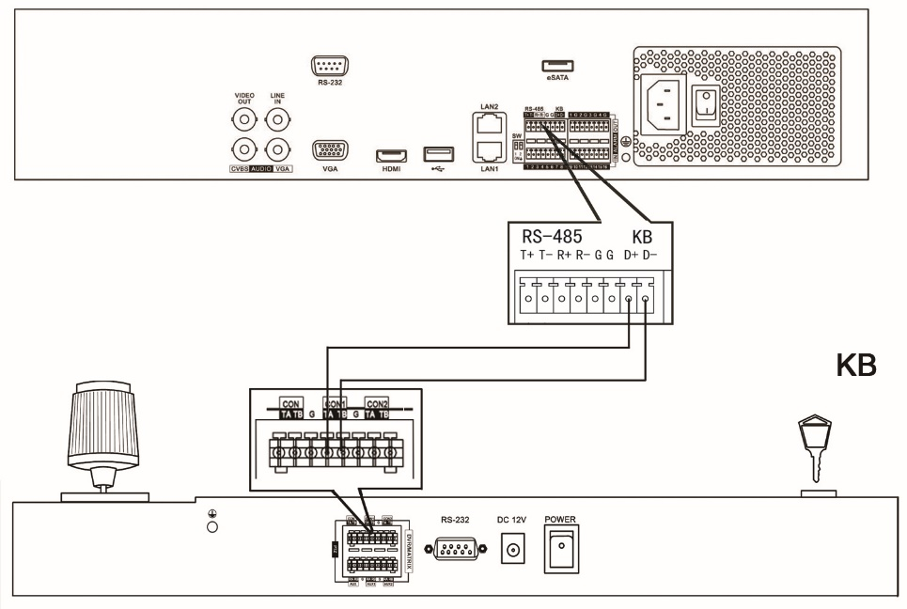

Figure - A Simple Connection between Keyboard and DVR/NVR

***Steps:***

1. On the keyboard, turn the key to the MENU item, and press the Mode button to select the DVR/NVR as the controlled device.

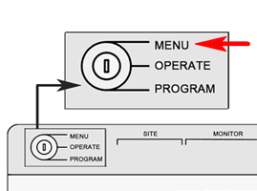

Figure - Turn the key to MENU

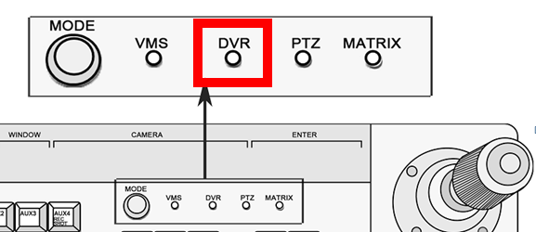

Figure - Choose MODE as DVR/NVR

1. Press the numeric button and press SITE to connect the DVR/NVR.

***Note***: The keyboard identifies the DVR/NVR by **SITE** value, and the **SITE** value must be exactly the same with the device number. E.g. the device number is 1, press the numeric button 1 and press **SITE** button again.

The keyboard only connects the DVR/NVR with device number ranging from 1 to 255.

1. You can move the joystick up and down to choose value and move the joystick left and right to switch the parameter to configure. The RS-485 parameters should be exactly the same with those of the DVR/NVR you controlled. The parameters include the baud rate, data bit, stop bit, and parity.

*By default, the baud rate is 9600, the data bit is 8, the stop bit is 1 and the parity is none.*

1. When the LED screen shows COPYALL, you can move the joystick to choose YES or NO.
2. If you choose **YES**, those parameters such as baud rate you set will be copied to all the DVR/NVRs you controlled by the keyboard.
3. Press Enter button to confirm your settings.

Now you can turn the key to the **OPERATE** item to control the DVR/NVR.

### Operating DVR/NVR by Keyboard

The keyboard, once connected, functions as the front panel of the DVR/NVR. You can refer to the front panel button description to see the function of each button. See the below information for complicated operation.

***Before you start:***

To control DVR/NVR, make sure that the key is turned to the **OPERATE** mode.

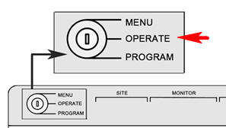

Figure - Turn the Key to OPERATE

* Select the DVR/NVR to control. Press the **SITE**, numeric button and **SITE** in sequence to select the number of DVR/NVR to control. Example: to control the DVR/NVR 23, press the **SITE**+**2**+**3**+**SITE** buttons in sequence.
* In live view mode, press numeric button to enter the corresponding one-channel live view. Use the **NEXT** and **LAST** button to choose the next or previous channel. When you open the menu, the **NEXT** and **LAST** button can be used to select the next or previous item.
* In the **OPERATE** mode, the **PLAY/AUTO** button functions as the **PLAY/AUTO** button on the DVR/NVR front panel. Press it to play the record file within the 5 minutes of current channel. If you want to play back more record files, you should enter the main menu and choose Playback.
* **CLEAR** button functions as an ESC button.

**To call the preset/patrol/pattern:**

***Steps:***

1. Press **IRIS-/PTZ** button to enter the PTZ control interface of the DVR/NVR
2. Press the **PRESET**/**PATROL**/**PATTERN** button.
3. Press the numeric button.
4. Press **ENTER** button.

## Controlling Dome Cameras by Keyboard

### Setting the Keyboard Parameters to Control Dome Camera

***Before you start:***

Check the connection between the keyboard and dome camera. The **TA** and **TB** interfaces of CON of keyboard should be connected to the **RA** and **RB** interfaces of the dome camera respectively. The following figure shows the simplest way of connection between a dome camera and keyboard.

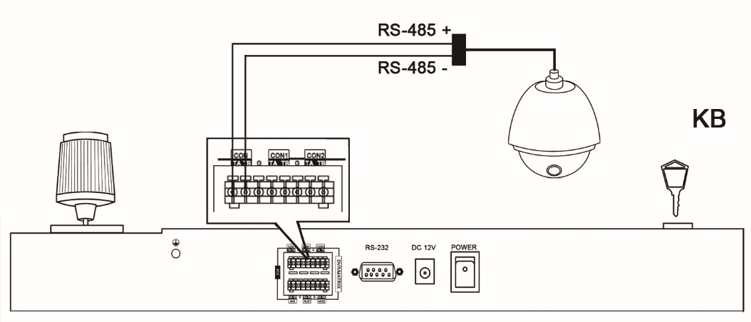

Figure - Dome and Keyboard Connection

***Steps:***

1. Turn the key to the **MENU** item, and press the **Mode** button to select **PTZ**.



Figure - Turning the Key to MENU

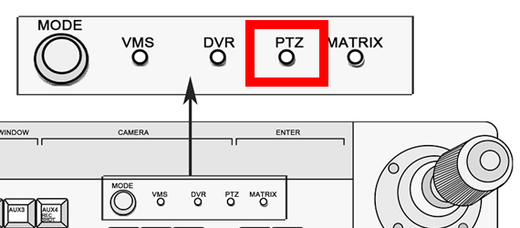

Figure - Choose Mode as PTZ

1. Enter the device number. E.g. the device number is 1, press the numeric button 1 and press **SITE** button again.

***Note***: The keyboard identifies the dome camera by **SITE** value, and the **SITE** value must be exactly the same with the dome camera No..

1. Use the joystick to set the RS-485 parameters.

The parameters include the protocol, baud rate, data bit, stop bit, and parity.

1. When the LED screen shows **COPYALL**, you can choose **YES** or **NO**.

When you choose **YES**, the parameters you just set will be copied to other dome cameras connected.

1. Press **Enter** button to confirm your settings.
2. Turn the key to the **OPERATE** item to control the dome camera.

### Dome Camera Control Operation

The keyboard mainly controls the PTZ function of the dome camera. The PTZ function of the dome camera is realized by the compound operation of the joystick and the PTZ buttons.

* To call the preset, switch to the **OPERATE** mode, press PTZ button to enter PTZ control mode and press the numeric button and then press the preset button.

***Note:*** Call preset No. 95 to open the menu of the dome camera.

* To call patrol, switch to the **OPERATE** mode, press the numeric button and then press the patrol button;
* To call pattern, switch to the **OPERATE** mode, press the numeric button and then press the pattern button.

To set preset, patrol and pattern for the dome camera, you turn the key to the **PROGRAM** mode

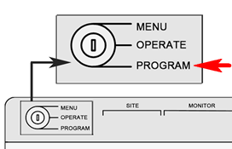

Figure - Turn the Key to PROGRAM

**Setting the preset**

Press the numeric button and then press the preset button.

And the LED screen returns PRESET DONE, indicating that the preset is set.

**Setting the patrol:**

***Note:*** the patrol is a group of presets.

***Steps:***

1. In the **PROGRAM** mode. Press the numeric button and press the **PATROL** button.

And then you can see the LED screen shows **PATROL SET.**

1. Press numeric button and press **Enter** button to choose the preset for the patrol.
2. Press the numeric button again and press **Enter** button again to set the patrol time.
3. Press the numeric button and press **Enter** button to set the patrol speed.
4. Press the **PATROL** button to finish the setting.

And the LED screen returns **PATROL DONE**, indicating that the patrol is set.

**Setting the pattern:**

***Steps:***

1. Switch to the **PROGRAM** mode.
2. Press the numeric button and press the pattern button.
3. Use the joystick and **ZOOM+/-** button to control the PTZ and record the PTZ movement.
4. Press the **PATTERN** button again to set the pattern.

## Controlling the VMS by Keyboard

### Setting the Keyboard Parameters to Control VMS

There is no RS-485 interface for the VMS, you can use the RS-485-to-RS-232 converter to connect the VMS.

1. Turn the key to the **MENU** item, and press the **Mode** button to select the **Matrix** as the controlled device.
2. Press the **SITE** button to set the device identifier.

***Note***: The keyboard identifies the controlled device by the device address. You can set the **SITE** value to identify the device, and the **SITE** value must be exactly the same with the VMS address.

1. Enter the number. E.g. the device address is 1, press the numeric button 1 and press **SITE** button again.
2. Use the joystick to set the RS-485 parameters.

The parameters include the baud rate, data bit, stop bit, and parity.

1. When the LED screen shows **COPYALL**, you can use the joystick to choose **YES** or **NO**.
2. Press **Enter** button to confirm your settings.
3. Turn the key to the **OPERATE** item to control the VMS.

### VMS Control Operation

***Note:***

When using HKB-1004KI to control the VMS, the parameters of the keyboard should be consistent to that of the VMS software and the VMS should be configured by the cascade configuration tools. For the detailed information of the configuration, refer to the user manual of the VMS. And since there is no RS-485 interface for VMS, you need to choose the RS-485-to-RS-232 interface as RS-485.

The monitor in this chapter refers to the single monitor without montaging. Sub-screen refers to the small screens in single monitor.

**Complicated Operation:**

* Press the numeric button and then press the **MON** button to select the video output monitor.
* Press the numeric button and then press **CAM** button to choose video input channel.
* Press the numeric button and press **MULT** button to set the sub-screen. Press the numeric button and the WIN button to choose the sub-screen.

***Example:***

To set 4 sub-screens to the monitor 1 and display the video from camera 1 to the second window:

***Steps:***

1. Press numeric button 1 and press **MON** button.
2. Press numeric button 4 and press **MULT** button.
3. Press numeric button 2 and press **WIN** button.
4. Press numeric button 1 and press **CAM** button.

The monitor group and the camera group refer to the video output group and video input group respectively. When displaying the video from one camera group on one monitor, the cycle play function can be enabled. **HOLD** button can stop the cycle play and the **RUN** button can start or go on the cycle play. NEXT and LAST button can be used to switch to the next group or last group respectively.

***Example:***

To display the camera group 2 on the monitor 1 to cycle play and then stop cycle play and then go on the cycle play, and then switch to the camera group 1.

***Steps:***

1. Press numeric button 1 and press MON.
2. Press numeric button 2 and press CAM-G button.
3. Press **HOLD** button.
4. Press **RUN** button.
5. Press **LAST** button.

* To set the preset, turn the key to the **PROGRAM** mode, press the numeric button and press **CAM** button to choose camera.

Press numeric button and press preset button the set preset.

* To call the preset, switch to the **OPERATE** mode and press the numeric button and press **CAM** button to choose the camera.

Press the numeric button and press preset button to call the preset.

**Setting the patrol:**

***Steps:***

1. Turn the key to **PROGRAM** mode, press the numeric and press **CAM** button to choose camera.
2. Press the numeric button and press **patrol** button to choose patrol to set.
3. Press the numeric button and **ENTER** button to call the preset you want to add to the patrol.
4. Press the numeric button and the **ENTER** button to set the interval for patrol.
5. Press the numeric button and **ENTER** button to set patrol speed.
6. Press **patrol** button again to finish your setting.

**Calling the patrol:**

***Steps:***

1. Turn the key to the **OPERATE** mode, press the numeric button and press **CAM** button to choose camera.
2. Press the numeric button and press **patrol** button to call the patrol.

**Setting and Calling the pattern,**

***Steps:***

1. Switch to the **PROGRAM** mode, and press the numeric button and press the **CAM** button to choose camera.
2. Press the numeric button and press the **pattern** button
3. Use the joystick to control the PTZ to record the PTZ movement.
4. Press the **pattern** button again to set the pattern.
5. To call the pattern, switch to the **OPERATE** mode, press the numeric button and press **CAM** button to choose camera.
6. Press the numeric button and press pattern to call the pattern.

***Note***: The maximum value of the monitor/camera/monitor group/camera group is 999999/99999999 99999999/128/128 respectively, and the maximum value of windows is 32, with 1/2/4/9/16/32-division window display modes configurable.

## Controlling the Analog Matrix by Keyboard

### Setting the Keyboard Parameters to Control Analog Matrix

The RS-232 communication is used when the HKB-1004KI keyboard is controlling the analog matrix system. And the following parameters must be correctly configured for the RS-232 port: protocol, baud rate, data bit, stop bit and parity. ZT-1.0, ZT-2.0, EXTRON and CREATOR protocols are supported by the keyboard.

Turn the key to **MENU**; press the **SITE** button to select the address for analog matrix to be configured; and set the RS-232 parameters.

**To set the RS-232 parameters:**

***Steps:***

1. Move the joystick left/right to view selections.

2. Move the joystick up/down to select a parameter.

3. Move the joystick up/down to select YES in the COPYALL selection if you want to copy the settings to all the other devices. The default setting is NO.

4. Turn the key to Operate to operate the device remotely.

### Analog Matrix Controlling Operation

**Main Operation：**

* Use the **SITE** button to choose the analog matrix by its address.
* To display the video from a camera to a certain monitor.

In the **OPERATE** mode, press the numeric button and the press the **MON** button to choose the video output monitor.

Press the numeric button and press **CAM** button.

* Use the **NEXT** button and the **LAST** button to realize the switch of the video input.
* Use **CLEAR** button to delete the number you input or exit the operation.

***Note***: The maximum value of the monitor/camera is 128.

## Controlling the Matrix Access Gateway by Keyboard

### Setting the Keyboard Parameters to Control Matrix Access Gateway

1. Turn the key to the **MENU** item, and press the **Mode** button to select the **Matrix** as the controlled device.
2. Move the joystick left/right to view selections.
3. Move the joystick up/down to select a parameter.
4. When the LED screen shows **COPYALL**, use the joystick to choose **NO** by default.
5. Press **Enter** button to confirm your settings.
6. Turn the key to the **OPERATE** item to control the Matrix Access Gateway.

***Note***: Please make sure the baud rate of the keyboard and the matrix gateway must be the same with each other, and the other parameters can be left as the default settings.

### Matrix Gateway Control Operation

**Complicated Operation:**

* Press the numeric button and then press the **MON** button to select the video output monitor.
* Press the numeric button and then press **CAM** button to choose video input channel.
* Press the numeric button and press **MULT** button to set the sub-screen. Press the numeric button and the **WIN** button to choose the sub-screen.

***Example:***

To set 4 sub-screens to the monitor 1 and display the video from camera 1 to the second window:

***Steps:***

1. Press numeric button 1 and press **MON** button.
2. Press numeric button 4 and press **MULT** button.
3. Press numeric button 2 and press **WIN** button.
4. Press numeric button 1 and press **CAM** button.

The monitor group and the camera group refer to the video output group and video input group respectively. When displaying the video from one camera group on one monitor, the cycle play function can be enabled. **HOLD** button can stop the cycle play and the **RUN** button can start or go on the cycle play. NEXT and LAST button can be used to switch to the next group or last group respectively.

***Example:***

To display the camera group 2 on the monitor 1 to cycle play and then stop cycle play and then go on the cycle play, and then switch to the camera group 1.

***Steps:***

1. Press numeric button 1 and press MON.
2. Press numeric button 2 and press CAM-G button.
3. Press **HOLD** button.
4. Press **RUN** button.
5. Press **LAST** button.

* To set the preset, turn the key to the **PROGRAM** mode, press the numeric button and press **CAM** button to choose camera.

Press numeric button and press preset button the set preset.

* To call the preset, switch to the **OPERATE** mode and press the numeric button and press **CAM** button to choose the camera.

Press the numeric button and press preset button to call the preset.

**Setting the patrol:**

***Steps:***

1. Turn the key to **PROGRAM** mode, press the numeric and press **CAM** button to choose camera.
2. Press the numeric button and press **patrol** button to choose patrol to set.
3. Press the numeric button and **ENTER** button to call the preset you want to add to the patrol.
4. Press the numeric button and the **ENTER** button to set the interval for patrol.
5. Press the numeric button and **ENTER** button to set patrol speed.
6. Press **patrol** button again to finish your setting.

**Calling the patrol:**

***Steps:***

1. Turn the key to the **OPERATE** mode, press the numeric button and press **CAM** button to choose camera.
2. Press the numeric button and press **patrol** button to call the patrol.

**Setting and Calling the pattern,**

***Steps:***

1. Switch to the **PROGRAM** mode, and press the numeric button and press the **CAM** button to choose camera.
2. Press the numeric button and press the **pattern** button
3. Use the joystick to control the PTZ to record the PTZ movement.
4. Press the **pattern** button again to set the pattern.
5. To call the pattern, switch to the **OPERATE** mode, press the numeric button and press **CAM** button to choose camera.
6. Press the numeric button and press pattern to call the pattern.

# Appendix 1：Specification

|  |  |
| --- | --- |
| **Model** | **DS-1004KI** |
| Joystick | 4-axis |
| Serial Port | RS-485 and RS-232 |
| Working Temperature | -10℃-+55℃ |
| Working Humidity | 10%-90% |
| Power Supply | 12VDC |
| Power Consumption | ≤10W |
| Dimension  (W×D×H) | 434×163×43mm |
| Weight | ≤1.25Kg |