

Dual-Lens People Counting Camera

User Manual
UD06369N-A
User Manual
About this Manual
This Manual is applicable to Indoor and Outdoor Dual-Lens People Counting Camera.
The Manual includes instructions for using and managing the product. Pictures, charts, images and all other information hereinafter are for description and explanation only. The information contained in the Manual is subject to change, without notice, due to firmware updates or other reasons. Please find the latest version in the company website.
Please use this user manual under the guidance of professionals.
Legal Disclaimer
TO THE MAXIMUM EXTENT PERMITTED BY APPLICABLE LAW, THE PRODUCT DESCRIBED, WITH ITS HARDWARE, SOFTWARE AND FIRMWARE, IS PROVIDED "AS IS", WITH ALL FAULTS AND ERRORS, AND OUR COMPANY MAKES NO WARRANTIES, EXPRESS OR IMPLIED, INCLUDING WITHOUT LIMITATION, MERCHANTABILITY, SATISFACTORY QUALITY, FITNESS FOR A PARTICULAR PURPOSE, AND NON-INFRINGEMENT OF THIRD PARTY. IN NO EVENT WILL OUR COMPANY, ITS DIRECTORS, OFFICERS, EMPLOYEES, OR AGENTS BE LIABLE TO YOU FOR ANY SPECIAL, CONSEQUENTIAL, INCIDENTAL, OR INDIRECT DAMAGES, INCLUDING, AMONG OTHERS, DAMAGES FOR LOSS OF BUSINESS PROFITS, BUSINESS INTERRUPTION, OR LOSS OF DATA OR DOCUMENTATION, IN CONNECTION WITH THE USE OF THIS PRODUCT, EVEN IF OUR COMPANY HAS BEEN ADVISED OF THE POSSIBILITY OF SUCH DAMAGES.
REGARDING TO THE PRODUCT WITH INTERNET ACCESS, THE USE OF PRODUCT SHALL BE WHOLLY AT YOUR OWN RISKS. OUR COMPANY SHALL NOT TAKE ANY RESPONSIBILITES FOR ABNORMAL OPERATION, PRIVACY LEAKAGE OR OTHER DAMAGES RESULTING FROM CYBER ATTACK, HACKER ATTACK, VIRUS INSPECTION, OR OTHER INTERNET SECURITY RISKS; HOWEVER, OUR COMPANY WILL PROVIDE TIMELY TECHNICAL SUPPORT IF REQUIRED.
SURVEILLANCE LAWS VARY BY JURISDICTION. PLEASE CHECK ALL RELEVANT LAWS IN YOUR JURISDICTION BEFORE USING THIS PRODUCT IN ORDER TO ENSURE THAT YOUR USE CONFORMS THE APPLICABLE LAW. OUR COMPANY SHALL NOT BE LIABLE IN THE EVENT THAT THIS PRODUCT IS USED WITH ILLEGITIMATE PURPOSES.
IN THE EVENT OF ANY CONFLICTS BETWEEN THIS MANUAL AND THE APPLICABLE LAW, THE LATER PREVAILS.
Safety Instruction
These instructions are intended to ensure that the user can use the product correctly to avoid danger or property loss.
The precaution measure is divided into ‘Warnings’ and ‘Cautions’:
Warnings: Serious injury or death may be caused if any of these warnings are neglected.
Cautions: Injury or equipment damage may be caused if any of these cautions are neglected.

 | 
Warnings Follow these safeguards to prevent serious injury or death. | Cautions Follow these precautions to prevent potential injury or material damage.
Warnings:
- Proper configuration of all passwords and other security settings is the responsibility of the installer and/or end-user.
- In the use of the product, you must be in strict compliance with the electrical safety regulations of the nation and region. Please refer to technical specifications for detailed information.
- Input voltage should meet both the SELV (Safety Extra Low Voltage) and the Limited Power Source with 12 VDC according to the IEC60950-1 standard. Please refer to technical specifications for detailed information.
- Do not connect several devices to one power adapter as adapter overload may cause over-heating or a fire hazard.
- Please make sure that the plug is firmly connected to the power socket. When the product is mounted on wall or ceiling, the device shall be firmly fixed.
- If smoke, odor or noise rise from the device, turn off the power at once and unplug the power cable, and then please contact the service center.
Cautions:
- Make sure the power supply voltage is correct before using the camera.
- Do not drop the camera or subject it to physical shock.
- Do not touch sensor modules with fingers. If cleaning is necessary, use clean cloth with a bit of ethanol and wipe it gently. If the camera will not be used for an extended period, please replace the lens cap to protect the sensor from dirt.
- Do not aim the camera at the sun or extra bright places. Blooming or smearing may occur otherwise (which is not a malfunction), and affect the endurance of sensor at the same time.
- The sensor may be burned out by a laser beam, so when any laser equipment is in using, make sure that the surface of sensor will not be exposed to the laser beam.
- Do not place the camera in extremely hot, cold (the operating temperature shall be -10°C to +40°C for indoor cameras, and -30°C to +60°C for outdoor and mobile cameras), dusty or damp locations, and do not expose it to high electromagnetic radiation.
- To avoid heat accumulation, good ventilation is required for operating environment.
- Keep the camera away from liquid while in use.
- While in delivery, the camera shall be packed in its original packing, or packing of the same texture.
- Regular part replacement: a few parts (e.g. electrolytic capacitor) of the equipment shall be replaced regularly according to their average enduring time. The average time varies because of differences between operating environment and using history, so regular checking is recommended for all the users. Please contact with your dealer for more details.
- Improper use or replacement of the battery may result in hazard of explosion. Replace with the same or equivalent type only. Dispose of used batteries according to the instructions provided by the battery manufacturer.
- If the product does not work properly, please contact your dealer or the nearest service center. Never attempt to disassemble the camera yourself. (We shall not assume any responsibility for problems caused by unauthorized repair or maintenance.)
Table of Contents
Chapter 1 System Requirement 8
Chapter 2 Network Connection 9
2.1 Setting the Network Camera over the LAN 9
2.1.1 Wiring over the LAN 9
2.1.2 Activating the Camera 10
2.2 Setting the Network Camera over the WAN 16
2.2.1 Static IP Connection 16
2.2.2 Dynamic IP Connection 17
Chapter 3 Access to the Network Camera 19
3.1 Accessing by Web Browsers 19
3.2 Accessing by Client Software 20
Chapter 4 People Counting 22
4.1 Rule Setting 22
4.1.1 Rule 22
4.1.2 Arming Schedule 25
4.1.3 Linkage Method 26
4.2 Data Uploading Setting 28
4.3 Advanced Settings 28
4.4 Statistics Output 29
Chapter 5 Live View 31
5.1 Live View Page 31
5.2 Starting Live View 32
5.3 Recording and Capturing Pictures Manually 32
Chapter 6 Network Camera Configuration 33
6.1 Configuring Local Parameters 33
6.2 Configure System Settings 35
6.2.1 Configuring Basic Information 35
6.2.2 Configuring Time Settings 36
6.2.3 Configuring RS232 Settings 38
6.2.4 Configuring RS485 Settings 39
6.2.5 Configuring DST Settings 40
6.3 Maintenance 41
6.3.1 Upgrade & Maintenance 41
6.3.2 Log 42
6.3.3 System Service 43
6.4 Security Settings 43
6.4.1 Authentication 44
6.4.2 Security Service 44
6.5 User Management 45
6.5.1 User Management 45
Chapter 7 Network Settings 49
7.1 Configuring Basic Settings 49
7.1.1 Configuring TCP/IP Settings 49
7.1.2 Configuring DDNS Settings 51
7.1.3 Configuring Port Settings 52
7.1.4 Configure NAT (Network Address Translation) Settings 53
7.2 Configure Advanced Settings 54
7.2.5 Configuring FTP Settings 54
7.2.6 Configuring Email Settings 56
7.2.7 HTTPS Settings 58
7.2.8 Configuring QoS Settings 60
7.2.9 Configuring 802.1X Settings 61
Chapter 8 Video/Audio Settings 63
8.1 Configuring Video Settings 63
Chapter 9 Image Settings 66
9.1 Configuring Display Settings 66
9.2 Configuring OSD Settings 68
Chapter 10 Event Settings 69
10.1 Basic Events 69
10.1.1 Configuring Video Tampering Alarm 69
10.1.2 Configuring Alarm Input 70
10.1.3 Configuring Alarm Output 72
10.1.4 Handling Exception 73
Appendix 74
Appendix 1 SADP Software Introduction 74
Appendix 2 Port Mapping 77

0504061070628

System Requirement
Operating System: Microsoft Windows XP SP1 and above version
CPU: 2.0 GHz or higher
RAM: 1G or higher
Display: 1024×768 resolution or higher
Web Browser: Internet Explorer 8.0 and above version, Mozilla Firefox 30.0 to 51, and Google Chrome 31 to 51.

Network Connection
Note:
- You shall acknowledge that the use of the product with Internet access might be under network security risks. For avoidance of any network attacks and information leakage, please strengthen your own protection. If the product does not work properly, please contact with your dealer or the nearest service center.
- To ensure the network security of the network camera, we recommend you to have the network camera assessed and maintained termly. You can contact us if you need such service.
Before you start:
- If you want to set the network camera via a LAN (Local Area Network), please refer to Section 2.1 Setting the Network Camera over the LAN.
- If you want to set the network camera via a WAN (Wide Area Network), please refer to Section 2.2 Setting the Network Camera over the WAN.

Setting the Network Camera over the LAN
Purpose:
To view and configure the camera via a LAN, you need to connect the network camera in the same subnet with your computer, and install the SADP or Guarding Expert software to search and change the IP of the network camera.
Note: For the detailed introduction of SADP, please refer to Appendix 1.

Wiring over the LAN
The following figures show the two ways of cable connection of a network camera and a computer:
Purpose:
- To test the network camera, you can directly connect the network camera to the computer with a network cable as shown in Figure 2-1.
- Refer to the Figure 2-2 to set network camera over the LAN via a switch or a router.
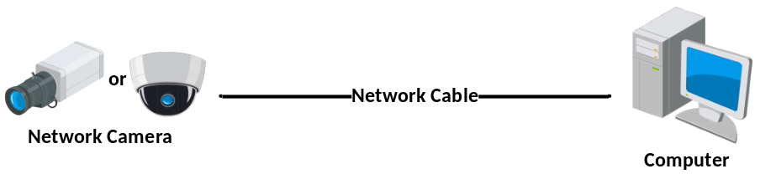
              - Connecting Directly
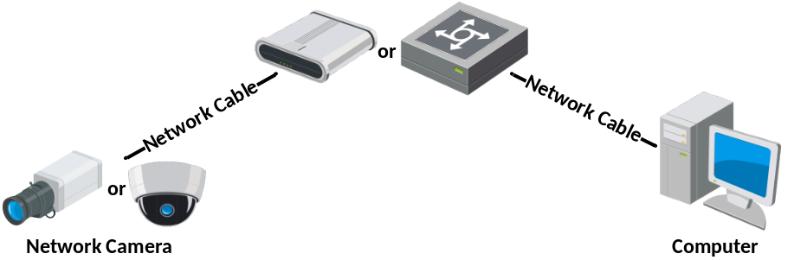
              - Connecting via a Switch or a Router

Activating the Camera
You are required to activate the camera first by setting a strong password for it before you can use the camera.
Activation via Web Browser, Activation via SADP, and Activation via Client Software are all supported.
- Activation via Web Browser
Steps:
1. Power on the camera, and connect the camera to the network.
2. Input the IP address into the address bar of the web browser, and click Enter to enter the activation interface.
Notes:
- The default IP address of the camera is 192.168.1.64.
- The computer and the camera should belong to the same subnet.
- For the camera enables the DHCP by default, you need to use the SADP software to search the IP address.
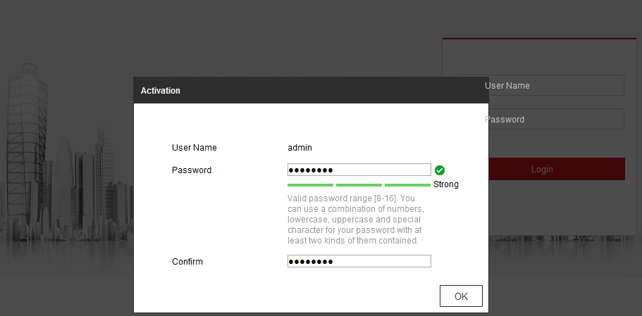
              - Activation via Web Browser
3. Create a password and input the password into the password field.

STRONG PASSWORD RECOMMENDED–We highly recommend you create a strong password of your own choosing (using a minimum of 8 characters, including at least three of the following categories: upper case letters, lower case letters, numbers, and special characters) in order to increase the security of your product. And we recommend you reset your password regularly, especially in the high security system, resetting the password monthly or weekly can better protect your product.
4. Confirm the password.
5. Click OK to save the password and enter the live view interface.
- Activation via SADP Software
SADP software is used for detecting the online device, activating the camera, and resetting the password.
Get the SADP software from the supplied disk or the official website, and install the SADP according to the prompts. Follow the steps to activate the camera.
Steps:
          - Run the SADP software to search the online devices.
          - Check the device status from the device list, and select the inactive device.
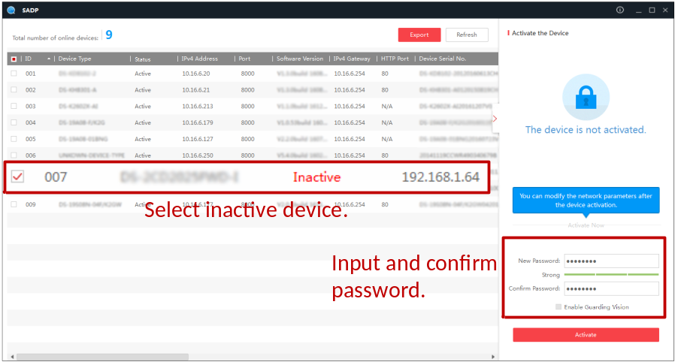
              - SADP Interface
Note:
The SADP software supports activating the camera in batch. Refer to the user manual of SADP software for details.
          - Create a password and input the password in the password field, and confirm the password.
Strong Password recommended– We highly recommend you create a strong password of your own choosing (using a minimum of 8 characters, including at least three of the following categories: upper case letters, lower case letters, numbers, and special characters) in order to increase the security of your product. And we recommend you reset your password regularly, especially in the high security system, resetting the password monthly or weekly can better protect your product.
Note:
You can enable the Guarding Vision service for the device during activation.
          - Click Activate to save the password.
You can check whether the activation is completed on the popup window. If activation failed, please make sure that the password meets the requirement and try again.
          - Change the device IP address to the same subnet with your computer by either modifying the IP address manually or checking the checkbox of Enable DHCP.
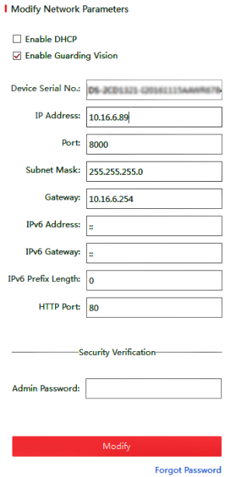
              - Modify the IP Address
          - Input the password and click the Modify button to activate your IP address modification.
The batch IP address modification is supported by the SADP. Refer to the user manual of SADP for details.

- Activation via Client Software
The client software is versatile video management software for multiple kinds of devices.
Get the client software from the supplied disk or the official website, and install the software according to the prompts. Follow the steps to activate the camera.
Steps:
          - Run the client software and the control panel of the software pops up, as shown in the figure below.
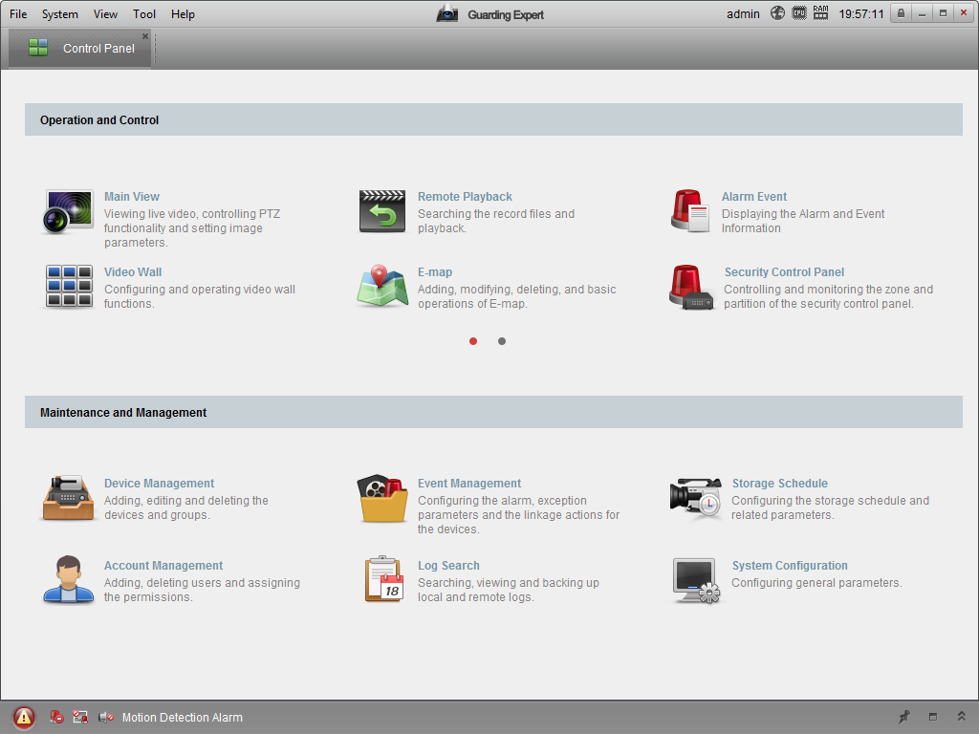
              - Control Panel
          - Click the Device Management icon to enter the Device Management interface, as shown in the figure below.
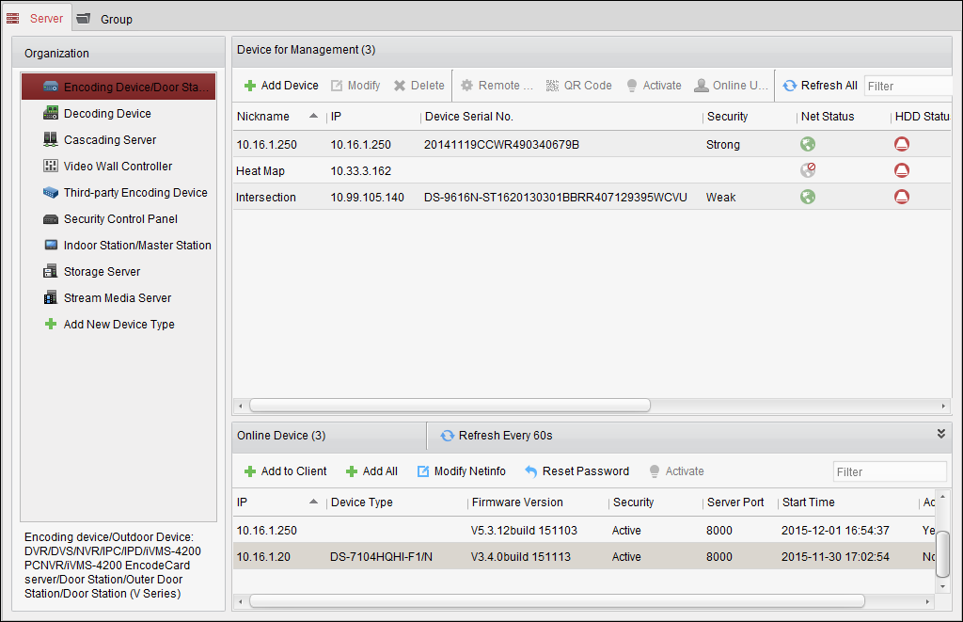
              - Device Management Interface
          - Check the device status from the device list, and select an inactive device.
          - Click the Activate button to pop up the Activation interface.
          - Create a password and input the password in the password field, and confirm the password.
Strong Password recommended–We highly recommend you create a strong password of your own choosing (using a minimum of 8 characters, including at least three of the following categories: upper case letters, lower case letters, numbers, and special characters) in order to increase the security of your product. We recommend you reset your password regularly, especially in the high security system, resetting the password monthly or weekly can better protect your product.
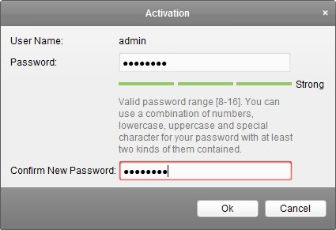
              - Activation Interface (Client Software)
          - Click OK button to start activation.
          - Click the Modify Netinfo button to pop up the Network Parameter Modification interface, as shown in the figure below.
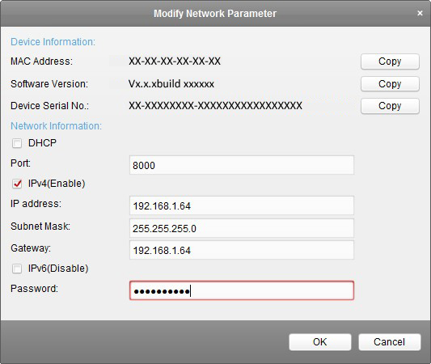
              - Modifying the Network Parameters
          - Change the device IP address to the same subnet with your computer by either modifying the IP address manually or checking the checkbox of Enable DHCP.
          - Input the password to activate your IP address modification.

Setting the Network Camera over the WAN
Purpose:
This section explains how to connect the network camera to the WAN with a static IP or a dynamic IP.

Static IP Connection
Before you start:
Please apply a static IP from an ISP (Internet Service Provider). With the static IP address, you can connect the network camera via a router or connect it to the WAN directly.
- Connecting the network camera via a router
Steps:
- Connect the network camera to the router.
- Assign a LAN IP address, the subnet mask and the gateway. Refer to Section 2.1.2 for detailed IP address configuration of the network camera.
- Save the static IP in the router.
- Set port mapping, e.g., 80, 8000, and 554 ports. The steps for port mapping vary according to the different routers. Please call the router manufacturer for assistance with port mapping.
Note: Refer to Appendix 2 for detailed information about port mapping.
- Visit the network camera through a web browser or the client software over the internet.
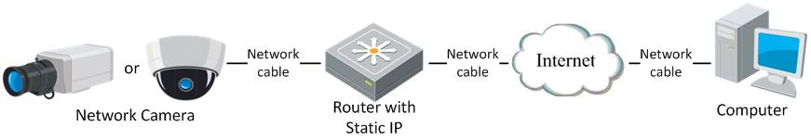
              - Accessing the Camera through Router with Static IP
- Connecting the network camera with static IP directly
You can also save the static IP in the camera and directly connect it to the internet without using a router. Refer to Section 2.1.2 for detailed IP address configuration of the network camera.
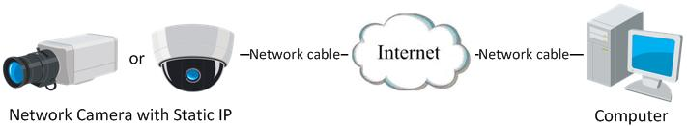
              - Accessing the Camera with Static IP Directly

Dynamic IP Connection
Before you start:
Please apply a dynamic IP from an ISP. With the dynamic IP address, you can connect the network camera to a modem or a router.
- Connecting the network camera via a router
Steps:
- Connect the network camera to the router.
- In the camera, assign a LAN IP address, the subnet mask and the gateway. Refer to Section 2.1.2 for detailed IP address configuration of the network camera.
- In the router, set the PPPoE user name, password and confirm the password.
- Set port mapping. E.g. 80, 8000, and 554 ports. The steps for port mapping vary depending on different routers. Please call the router manufacturer for assistance with port mapping.
Note: Refer to Appendix 2 for detailed information about port mapping.
- Apply a domain name from a domain name provider.
- Configure the DDNS settings in the setting interface of the router.
- Visit the camera via the applied domain name.

Access to the Network Camera

Accessing by Web Browsers
Steps:
          - Open the web browser.
          - In the browser address bar, input the IP address of the network camera, and press the Enter key to enter the login interface.
Note:
The default IP address is 192.168.1.64. You are recommended to change the IP address to the same subnet with your computer.
          - Input the user name and password and click Login.
The admin user should configure the device accounts and user/operator permissions properly. Delete the unnecessary accounts and user/operator permissions.
Note:
The IP address gets locked if the admin user performs 7 failed password attempts (5 attempts for the user/operator).
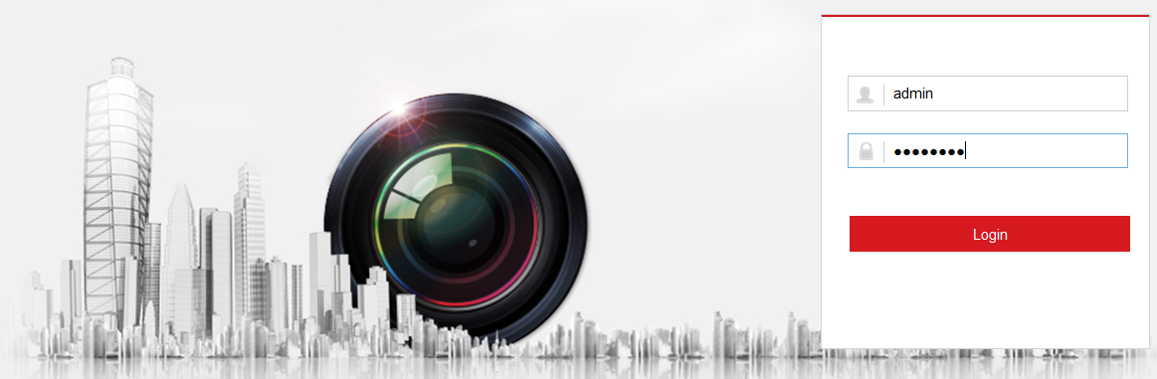
              - Login Interface
          - Click Login.
          - Install the plug-in before viewing the live video and operating the camera. Please follow the installation prompts to install the plug-in.
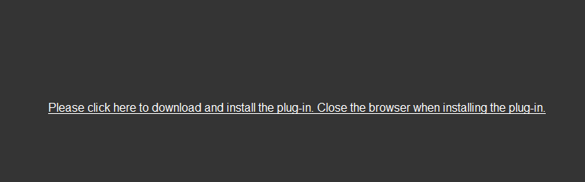
              - Download and Install Plug-in
Note: You may have to close the web browser to finish the installation of the plug-in.
          - Reopen the web browser after the installation of the plug-in and repeat steps 2 to 4 to login.
Note: For detailed instructions of further configuration, please refer to the user manual of network camera.

Accessing by Client Software
The product CD contains the Guarding Expert client software. You can view the live video and manage the camera with the software.
Follow the installation prompts to install the software. The control panel and live view interface of Guarding Expert client software are shown as below.
              - Guarding Expert Control Panel
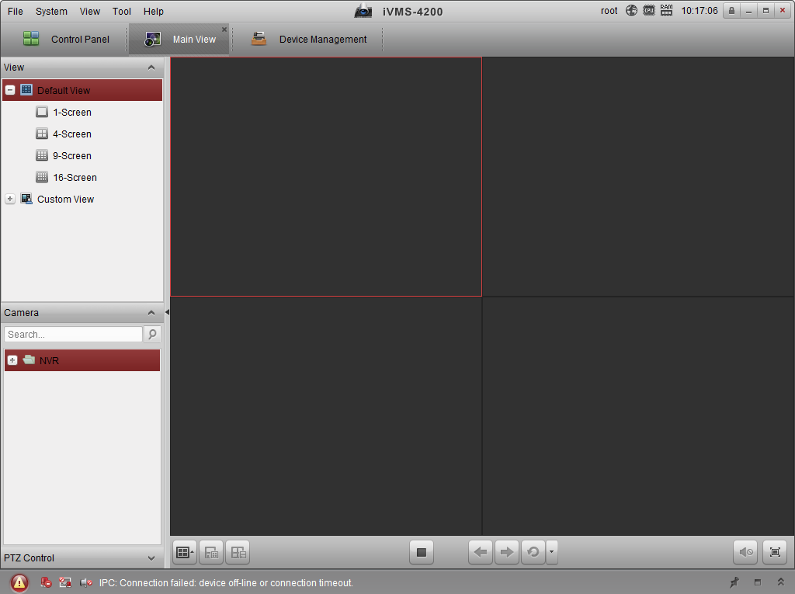
              - Guarding Expert Main View

People Counting
Purpose:
People counting function is used to calculate the number of people entering, exiting, and passing by an area. It is widely applied to the entrances and exits.
Before you start:
The camera is recommended to be installed right above the entrance/exit, and make sure it is installed properly.
Refer to Quick Start Guide of Dual-Lens People Counting Camera for installation advice.
About the task:
To complete the configuration, you should:
- Set up counting rule.
- Set up data uploading.
- Set up advanced parameters.

Rule Setting
Rule setting is compulsory for proper functioning of the camera.

Rule
Steps:
- Enter configuration interface: Configuration > People Counting
- Enable people counting function.
- Set up camera calibration. Auto calibration and manual calibration are selectable.
Auto Calibration: camera automatically calculates the lens height.
Manual Calibration: lens height should be measured by the users.
Note:
If the level ground area occupies less than 25% of the whole image, use manual calibration.
  - Auto Calibration
    - Select calibration mode as Auto.
    - Drag the calibration area (the green rectangle in image) to cover a level area of the ground. You can adjust the size of the green rectangle by dragging its angles.
Notes:
- The calibration area is recommended to cover a richly-textured surface with balanced brightness distribution.
- Do not put the calibration area near the edge of the image.
    - Click Calibration.
The camera calculates the lens height and returns the value, and displays the red count area and the orange detection line in image.
    - Check the returned lens height and compare it with the actual lens height to see if the camera is properly calibrated.
A convenient way is that you check the Display Height checkbox (People Counting > Advanced), ask a 180 cm person to go pass the camera, and check the calculated height of the person displayed in live image. If the error is less than 5%, then the auto calibration is considered as a valid one.
If the auto calibration is considered invalid, repeat above steps again. Or you can use manual calibration.
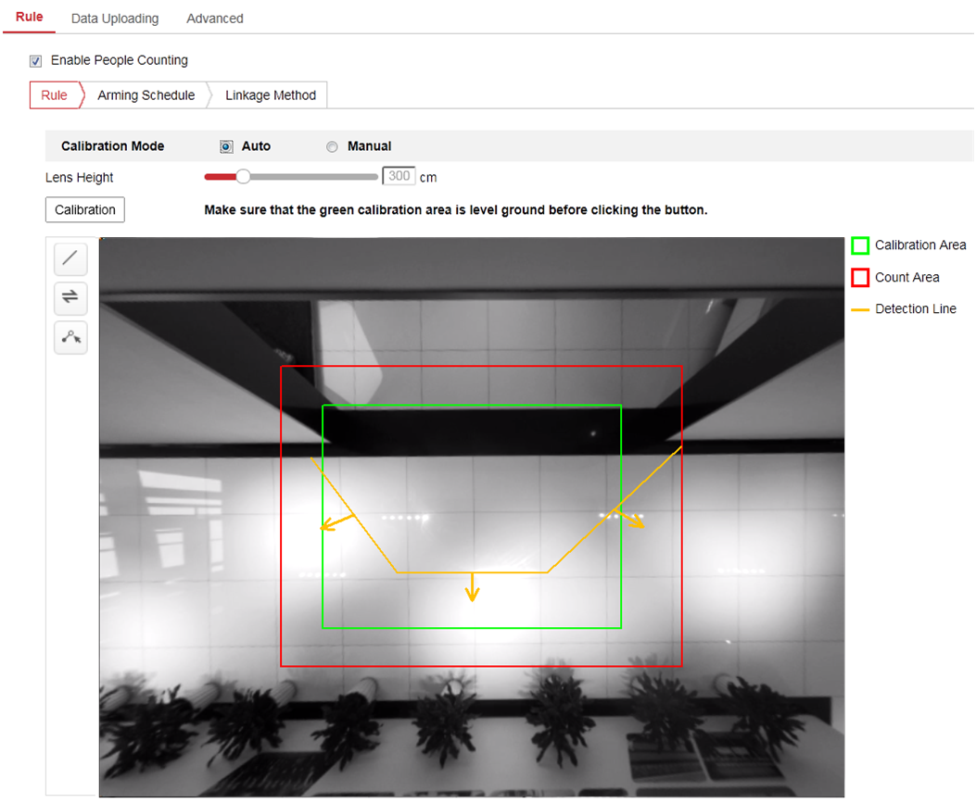
              - Auto Calibration
  - Manual Calibration
Manual calibration is recommended if it is easy to measure the lens height.
    - Select calibration mode as Manual.
    - Measure the lens height from the ground. Input the value into the Lens Height field.
    - Click Calibration.
The camera displays the red count area and the orange detection line in image.
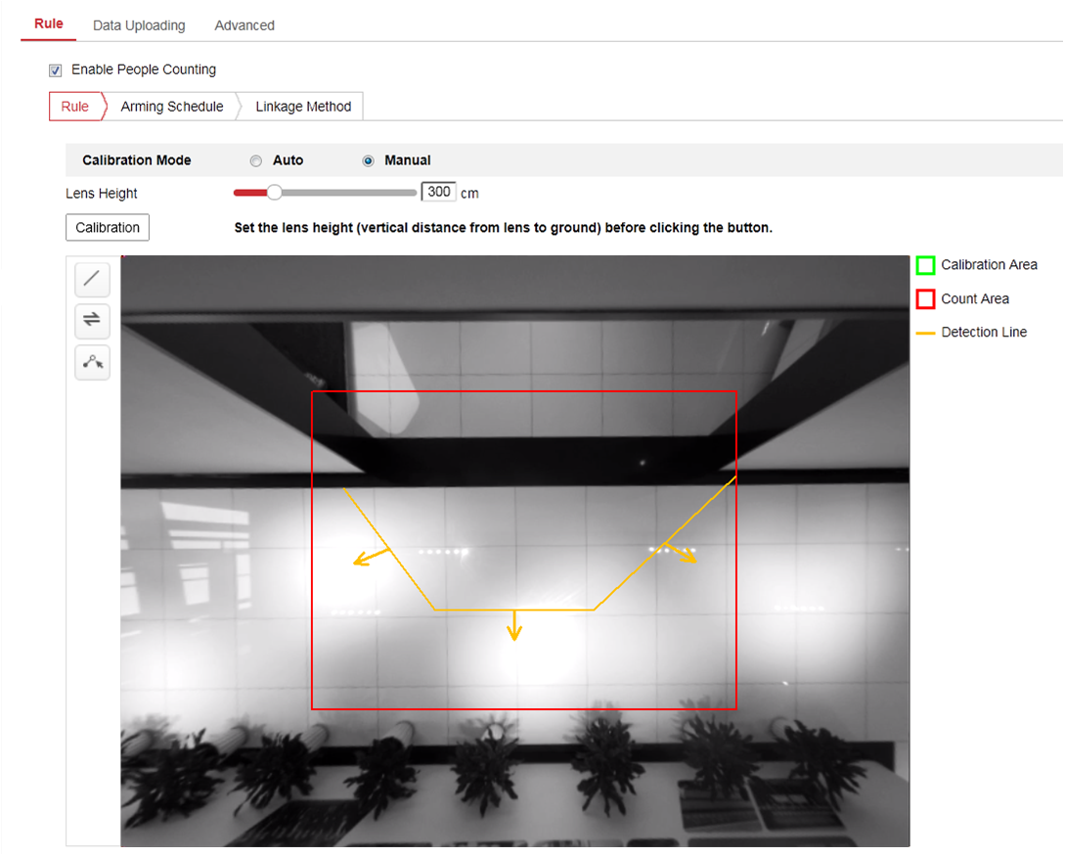
              - Manual Calibration
- Adjust detection line and the direction.
You can drag the straight line and its endpoints to adjust its position and length to better cover the entrance/exit. Click to change the direction of the detection line arrow. The arrow stands for the direction of entering.
If the returned straight line cannot cover the entrance/exit, you can click 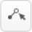 and adjust the position and shape of the returned polyline. Click to change the direction of the detection line arrow. The arrow stands for the direction of entering.
Notes:
  - The detection line should completely cover the entrance/exit after adjustment. No person could pass without crossing the detection line.
  - The detection line should be placed within the count area.
  - The detection line should be placed at ground area of the image.

Arming Schedule
Steps:
- Click Arming Schedule to edit the arming schedule.
- Click on the time bar and drag the mouse to select the time period.
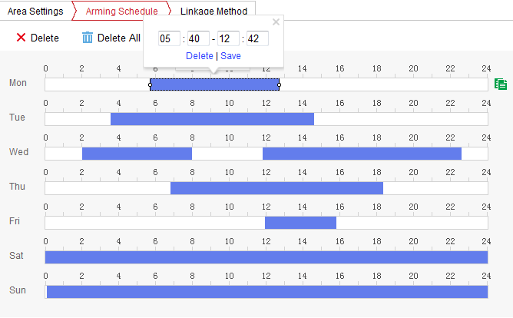
              - Arming Schedule
Note: Click on the selected time period, you can adjust the time period to the desired time by either moving the time bar or input the exact time period.
- (Optional) Click Delete to delete the current arming schedule, or click Save to save the settings.
- Move the mouse to the end of each day, a copy dialogue box pops up, and you can copy the current settings to other days.
- Click Save to save the settings.
Note: The time of each period can’t be overlapped. Up to 8 periods can be configured for each day.

Linkage Method
Check the checkbox to select the linkage method. Audible Warning, Send Email, Notify Surveillance Center, Upload to FTP/Memory Card/NAS, Trigger Channel and Trigger Alarm Output are selectable. You can specify the linkage method when an event occurs.
Note: The linkage methods vary according to the different camera models.
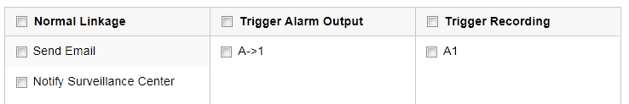
              - Linkage Method
- Audible Warning
Trigger the audible warning locally. And it only supported by the device that have the audio output.
- Notify Surveillance Center
Send an exception or alarm signal to remote management software when an event occurs.
- Send Email
Send an email with alarm information to a user or users when an event occurs.
Note: To send the Email when an event occurs, please refer to Section 1.5.2 to complete Email setup in advance.
- Upload to FTP/Memory Card/NAS
Capture the image when an alarm is triggered and upload the picture to a FTP server.
Notes:
- Set the FTP address and the remote FTP server first. Refer to Section 1.5.1Configuring FTP Settings for detailed information.
- Go to Configuration > Storage > Schedule Settings> Capture > Capture Parameters page, enable the event-triggered snapshot, and set the capture interval and capture number.
- The captured image can also be uploaded to the available SD card or network disk.
- Trigger Recording
The video will be recorded when the motion is detected. You have to set the recording schedule to realize this function.
- Trigger Alarm Output
Trigger one or more external alarm outputs when an event occurs.
Note: To trigger an alarm output when an event occurs, please refer to Section 1.5.5 Configuring Alarm Output to set the related parameters.

Data Uploading Setting
Data uploading is about how and when the counting data can be sent to clients and users.
- You can upload people counting data to surveillance center and client software through SDK and HTTP (if configured).
To upload real-time data, check the Real-Time Upload Data checkbox.
To upload data regularly, set the Data Statistics Cycle as desired.
Note: If data uploading by HTTP is required, set up the HTTP Data Transmission parameters.
- You can send people counting report to configured email address.
Select report type (daily report, weekly report, monthly report, and annual report) to activate the function.
Note: Go to Configuration > Network > Advanced Settings > Email to set up email. Refer to Section 1.5.2.

Advanced Settings
Advanced page shows some maintenance settings which are not necessary for proper functioning.
- Display Rule info. on Stream
Check to write rule information of people counting on video stream.
- Display Height
Calculated height information can be displayed on persons in the live image.
Note: To display height on person, you should first enable Display POS Information at Local settings.
- Height Filter
Enable the function and set a height value. Persons and objects shorter than the set value are not counted as a valid target.
- Flow Overlay
It displays real-time flow information on screen. You can select displayed data type from the drop-down list.
- Counting Status
It displays the current status of the camera. You can click the Refresh button to refresh the status.
- Reset Counter
You can set up a daily reset time. Or you can reset the counter manually by click Manual Reset.
- Clear Local Counting Data
To clear stored data on flash memory of the camera, you can click the Clear button.
Note: Always do the operation with caution. Deleted data cannot be restored.

Statistics Output
You can search and output the counting statistics on Application tab.
Steps:
- Select the report type. Daily report, weekly report, monthly report, and annual report are selectable.
Daily report calculates the data on the date you selected; weekly report calculates for the week your selected date belongs to; monthly report calculates for the month your selected date belongs to; and the annual report calculates for the year your selected date belongs to.
- Select the statistics type. People Entered, People Exited and People Passing by are selectable.
- Select the start time, and click Counting.
The counting result displays in the statistic result area. Click Table, Bar Chart, or Line Chart to display the result in different way.
Note: If you select table to display the statistics, there is an Export button to export the data in an excel file.
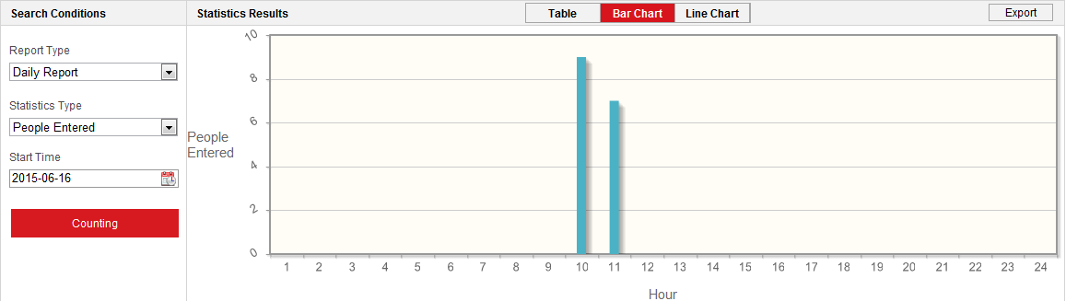
              - Statistics

Live View

Live View Page
Purpose:
The live view page allows you to view the real-time video, capture images, and configure video parameters.
Log in the network camera to enter the live view page, or you can click Live View on the menu bar of the main page to enter the live view page.
Descriptions of the live view page:
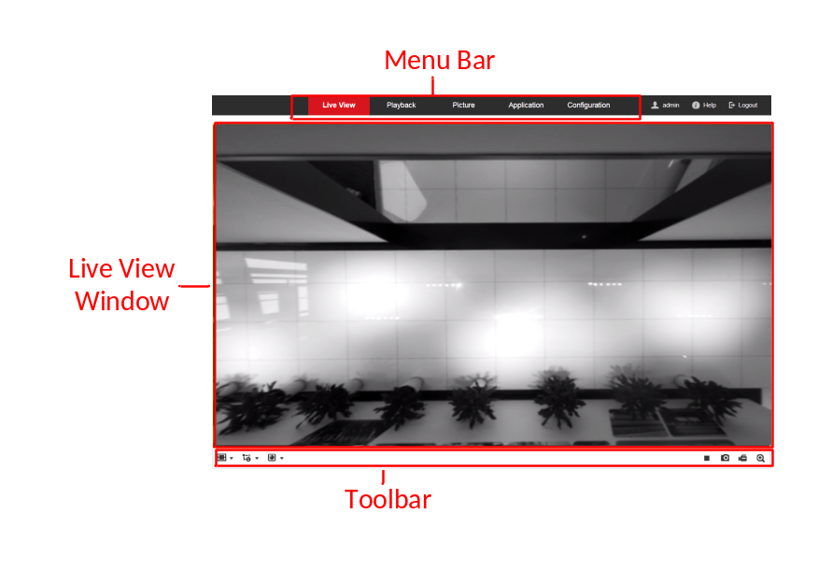
              - Live View Page
Menu Bar:
Click each tab to enter Live View, Playback, Picture, Application, and Configuration page respectively.
Live View Window:
Display the live video.
Toolbar:
Toolbar allows you to adjust the live view window size, the stream type, and the plug-ins. It also allows you to process the operations on the live view page, e.g., start/stop live view, capture, record, start/stop digital zoom, etc.
For IE (Internet Explorer) users, plug-ins as webcomponents and quick time are selectable. And for Non-IE users, webcomponents, quick time, VLC or MJPEG is selectable if they are supported by the web browser.

Starting Live View
In the live view window, click on the toolbar to start the live view of the camera.
              - Live View Toolbar
                - Descriptions of the Toolbar
Icon | Description
/ | Start/Stop live view.
 | The window size is 4:3.
 | The window size is 16:9.
 | The original widow size.
 | Self-adaptive window size.
 | Live view with the main stream.
 | Live view with the sub stream.
 | Click to select the third-party plug-in.
 | Manually capture the picture.
/ | Manually start/stop recording.
/ | Start/stop digital zoom function.
Note: The icons vary according to the different camera models.

Recording and Capturing Pictures Manually
In the live view interface, click on the toolbar to capture the live pictures or click to record the live view. The saving paths of the captured pictures and clips can be set on the Configuration > Local page.
Note: The captured image will be saved as JPEG file or BMP file in your computer.

Network Camera Configuration

Configuring Local Parameters
Purpose:
The local configuration refers to the parameters of the live view, record files and captured pictures. The record files and captured pictures are the ones you record and capture using the web browser and thus the saving paths of them are on the PC running the browser.
Steps:
- Enter the Local Configuration interface: Configuration > Local.
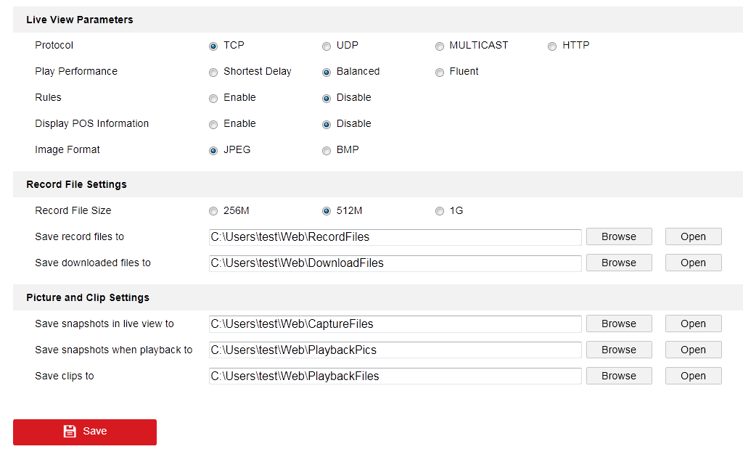
              - Local Configuration Interface
- Configure the following settings:
- Live View Parameters: Set the protocol type and live view performance.
- Protocol Type: TCP, UDP, MULTICAST and HTTP are selectable.
TCP: Ensures complete delivery of streaming data and better video quality, yet the real-time transmission will be affected.
UDP: Provides real-time audio and video streams.
HTTP: Allows the same quality as of TCP without setting specific ports for streaming under some network environments.
MULTICAST: It’s recommended to select MCAST type when using the Multicast function. For detailed information about Multicast, refer to Section 7.1.1 Configuring TCP/IP Settings.
- Play Performance: Set the play performance to Shortest Delay or Auto.
- Rules: It refers to the rules on your local browser, select enable or disable to display or not display the colored marks when the motion detection, face detection, or intrusion detection is triggered. E.g., enabled as the rules are, and the face detection is enabled as well, when a face is detected, it will be marked with a green rectangle on the live view.
- Display POS Information: POS information is returned values and information by embedded algorithm. It can be height information of persons, license plate number, and so on.
- Image Format: Choose the image format for picture capture.
- Record File Settings: Set the saving path of the recorded video files. Valid for the record files you recorded with the web browser.
- Record File Size: Select the packed size of the manually recorded and downloaded video files to 256M, 512M or 1G. After the selection, the maximum record file size is the value you selected.
- Save record files to: Set the saving path for the manually recorded video files.
- Save downloaded files to: Set the saving path for the downloaded video files in playback mode.
- Picture and Clip Settings: Set the saving paths of the captured pictures and clipped video files. Valid for the pictures you capture with the web browser.
- Save snapshots in live view to: Set the saving path of the manually captured pictures in live view mode.
- Save snapshots when playback to: Set the saving path of the captured pictures in playback mode.
- Save clips to: Set the saving path of the clipped video files in playback mode.
- Note: You can click Browse to change the directory for saving the clips and pictures, and click Open to open the set folder of clips and picture saving.
- Click Save to save the settings.

Configure System Settings
Purpose:
Follow the instructions below to configure the system settings, include System Settings, Maintenance, Security, and User Management, etc.

Configuring Basic Information
Enter the Device Information interface: Configuration > System > System Settings > Basic Information.
In the Basic Information interface, you can edit the Device Name and Device No..
Other information of the network camera, such as Model, Serial No., Firmware Version, Encoding Version, Number of Channels, Number of HDDs, Number of Alarm Input and Number of Alarm Output are displayed. The information cannot be changed in this menu. It is the reference for maintenance or modification in future.
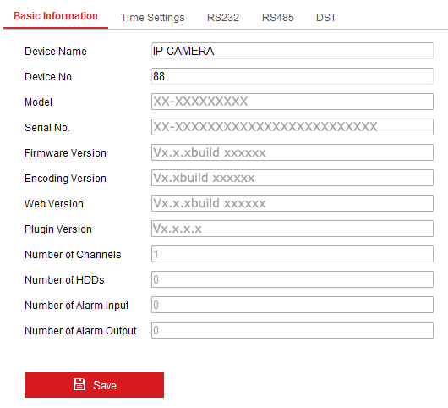
              - Basic Information

Configuring Time Settings
Purpose:
You can follow the instructions in this section to configure the time synchronization and DST settings.
Steps:
- Enter the Time Settings interface, Configuration > System> System Settings > Time Settings.
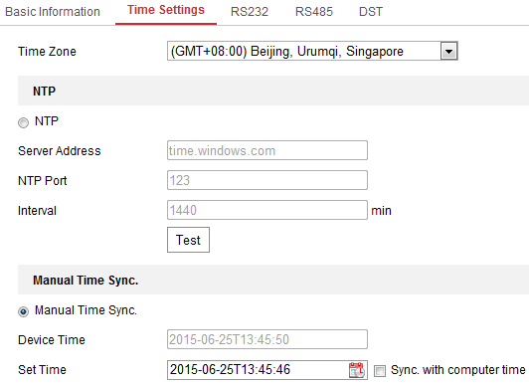
              - Time Settings
- Select the Time Zone of your location from the drop-down menu.
- Configure the NTP settings.
  - Click to enable the NTP function.
  - Configure the following settings:
Server Address: IP address of NTP server.
NTP Port: Port of NTP server.
Interval: The time interval between the two synchronizing actions with NTP server.
  - (Optional) You can click the Test button to test the time synchronization function via NTP server.
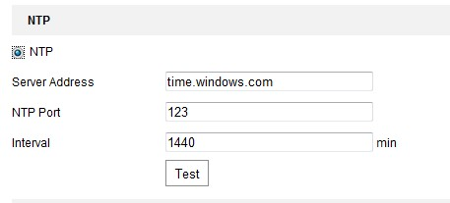
              - Time Sync by NTP Server
Note: If the camera is connected to a public network, you should use a NTP server that has a time synchronization function, such as the server at the National Time Center (IP Address: 210.72.145.44). If the camera is set in a customized network, NTP software can be used to establish a NTP server for time synchronization.
- Configure the manual time synchronization.
- Check the Manual Time Sync. item to enable the manual time synchronization function.
- Click the icon to select the date, time from the pop-up calendar.
- (Optional) You can check Sync. with computer time item to synchronize the time of the device with that of the local PC.
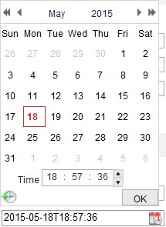
              - Time Sync Manually
- Click Save to save the settings.

Configuring RS232 Settings
The RS232 port can be used in two ways:
- Parameters Configuration: Connect a computer to the camera through the serial port. Device parameters can be configured by using software such as HyperTerminal. The serial port parameters must be the same as the serial port parameters of the camera.
- Transparent Channel: Connect a serial device directly to the camera. The serial device will be controlled remotely by the computer through the network.

Steps:
- Enter RS232 Port Setting interface: Configuration> System > System Settings > RS232.
- Configure the Baud Rate, Data Bit, Stop Bit, Parity, Flow Control, and Usage.
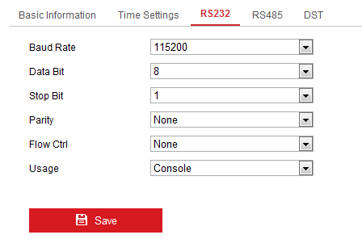
              - RS232 Settings
Note: If you want to connect the camera by the RS232 port, the parameters of the RS232 should be exactly the same with the parameters you configured here.
- Click Save to save the settings.

Configuring RS485 Settings
Purpose:
The RS485 serial port is used to control the PTZ of the camera. The configuring of the PTZ parameters should be done before you control the PTZ unit.
Steps:
- Enter RS-485 Port Setting interface: Configuration > System > System Settings > RS485.
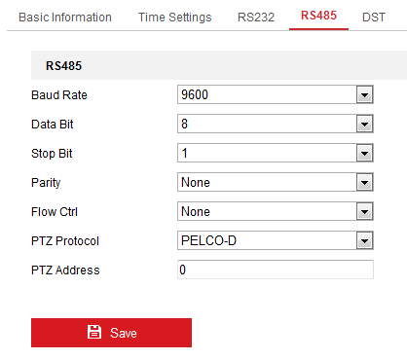
              - RS-485 Settings
- Set the RS485 parameters and click Save to save the settings.
By default, the Baud Rate is set as 9600 bps, the Data Bit is 8, the stop bit is 1 and the Parity and Flow Control is None.
Note: The Baud Rate, PTZ Protocol and PTZ Address parameters should be exactly the same as the PTZ camera parameters.

Configuring DST Settings
Purpose:
Daylight Saving Time (DST) is a way of making better use of the natural daylight by setting your clock forward one hour during the summer months, and back again in the fall.
Configure the DST according to your actual demand.
Steps:
- Enter the DST configuration interface.
Configuration > System > System Settings > DST
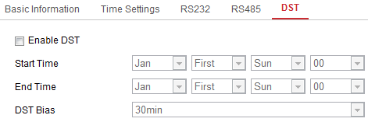
              - DST Settings
- Select the start time and the end time.
- Select the DST Bias.
- Click Save to activate the settings.

Maintenance

Upgrade & Maintenance
Purpose:
The upgrade & maintenance interface allows you to process the operations, including reboot, partly restore, restore to default, export/import the configuration files, and upgrade the device.
Enter the Maintenance interface:
Configuration > System > Maintenance > Upgrade & Maintenance
- Reboot: Restart the device.
- Restore: Reset all the parameters, except the IP parameters and user information, to the default settings.
- Default: Restore all the parameters to the factory default.
Note: After restoring the default settings, the IP address is also restored to the default IP address, please be careful for this action.
- Export/Import Config. File: Configuration file is used for the batch configuration of the camera, which can simplify the configuration steps when there are a lot of cameras needing configuring.
Steps:
- Click Device Parameters to export the current configuration file, and save it to certain place.
- Click Browse to select the saved configuration file and then click Import to start importing configuration file.
Note: You need to reboot the camera after importing configuration file.
- Upgrade: Upgrade the device to a certain version.
Steps:
- Select firmware or firmware directory to locate the upgrade file.
Firmware: Locate the exact path of the upgrade file.
Firmware Directory: Only the directory the upgrade file belongs to is required.
- Click Browse to select the local upgrade file and then click Upgrade to start remote upgrade.
Note: The upgrading process will take 1 to 10 minutes. Please don't disconnect power of the camera during the process, and the camera reboots automatically after upgrade.

Log
Purpose:
The operation, alarm, exception and information of the camera can be stored in log files. You can also export the log files on your demand.
Before you start:
Please configure network storage for the camera or insert a SD card in the camera.
Steps:
- Enter log searching interface: Configuration > System > Maintenance > Log.
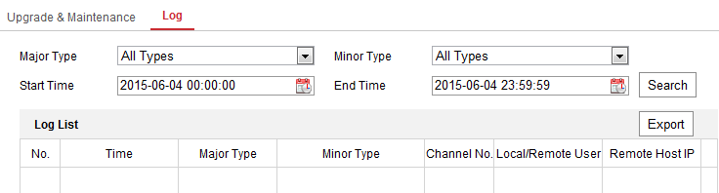
              - Log Searching Interface
- Set the log search conditions to specify the search, including the Major Type, Minor Type, Start Time and End Time.
- Click Search to search log files. The matched log files will be displayed on the log list interface.
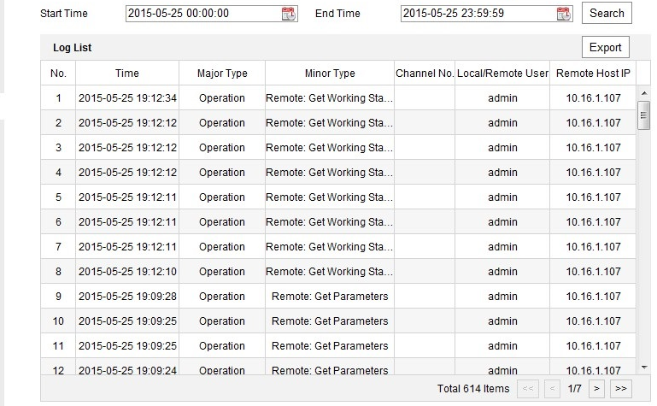
              - Log Searching
- To export the log files, click Export to save the log files.

System Service
System service settings refer to the hardware service the camera supports. Supported functions vary according to the different cameras. For the cameras support IR LED, ABF (Auto Back Focus), Auto Defog, or Status LED, you can select to enable or disable the corresponding service according to the actual demands.

Security Settings
Configure the parameters, including Authentication, Anonymous Visit, IP Address Filter, and Security Service from security interface.

Authentication
Purpose:
You can specifically secure the stream data of live view.
Steps:
- Enter the Authentication interface: Configuration > System > Security > Authentication.
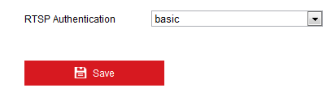
              - RTSP Authentication
- Select the RTSP Authentication type basic or disable in the drop-down list to enable or disable the RTSP authentication.
Note: If you disable the RTSP authentication, anyone can access the video stream by the RTSP protocol via the IP address.
- Click Save to save the settings.

Security Service
To enable the remote login, and improve the data communication security, the camera provides the security service for better user experience.
Steps:
- Enter the security service configuration interface: Configuration > System > Security > Security Service.
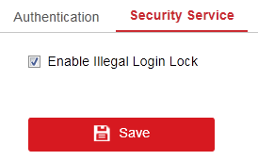
              - Security Service
- Check the checkbox of Enable Illegal Login Lock, and then the IP address will be locked if the admin user performs 7 failed user name/password attempts (5 times for the operator/user).
Note: If the IP address is locked, you can try to login the device after 30 minutes.

User Management

User Management
Purpose:
The admin user can add, delete or modify user accounts, and grant them different permissions. We highly recommend you manage the user accounts and permissions properly.
Steps:
- Enter the User Management interface: Configuration >System >User Management
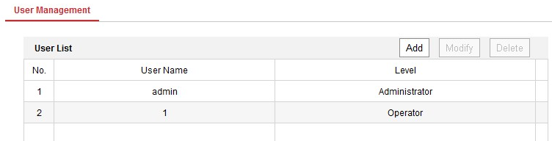
              - User Management Interface
- Adding a User
The admin user has all permissions by default and can create/modify/delete other accounts.
The admin user cannot be deleted and you can only change the admin password.
Steps:
- Click Add to add a user.
- Input the User Name, select Level and input Password.
Notes:
- Up to 31 user accounts can be created.
- Users of different levels own different default permissions. Operator and user are selectable.
- Strong Password recommended–We highly recommend you create a strong password of your own choosing (using a minimum of 8 characters, including at least three of the following categories: upper case letters, lower case letters, numbers, and special characters) in order to increase the security of your product. And we recommend you reset your password regularly, especially in the high security system, resetting the password monthly or weekly can better protect your product.
- You can check or uncheck the permissions for the new user.
- Click OK to finish the user addition.
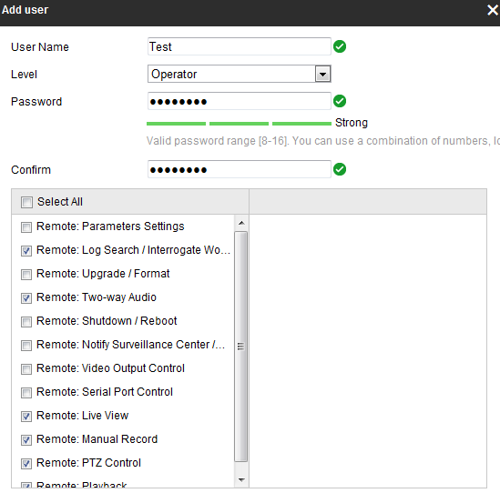
              - Add a User
- Modifying a User
Steps:
- Left-click to select the user from the list and click Modify.
- Modify the User Name, Level and Password.
- Strong Password recommended–We highly recommend you create a strong password of your own choosing (using a minimum of 8 characters, including at least three of the following categories: upper case letters, lower case letters, numbers, and special characters) in order to increase the security of your product. And we recommend you reset your password regularly, especially in the high security system, resetting the password monthly or weekly can better protect your product.
- You can check or uncheck the permissions.
- Click OK to finish the user modification.
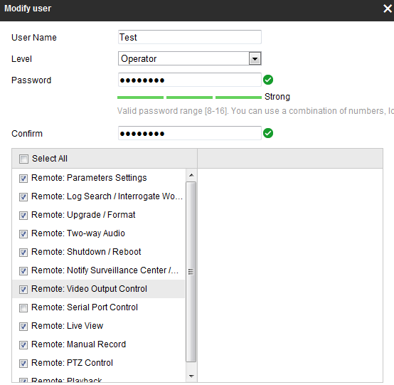
              - Modify a User
- Deleting a User
Steps:
- Click to select the user you want to delete and click Delete.
- Click OK on the pop-up dialogue box to confirm the deletion.

Network Settings
Purpose:
Follow the instructions in this chapter to configure the basic settings and advanced settings.

Configuring Basic Settings
Purpose:
You can configure the parameters, including TCP/IP, DDNS, Port, and NAT, etc., by following the instructions in this section.

Configuring TCP/IP Settings
Purpose:
TCP/IP settings must be properly configured before you operate the camera over network. The camera supports both the IPv4 and IPv6. Both versions can be configured simultaneously without conflicting to each other, and at least one IP version should be configured.
Steps:
- Enter TCP/IP Settings interface: Configuration > Network > Basic Settings > TCP/IP
- Purpose:
- You can configure the parameters, including TCP/IP, DDNS, Port, and NAT, etc., by following the instructions in this section.
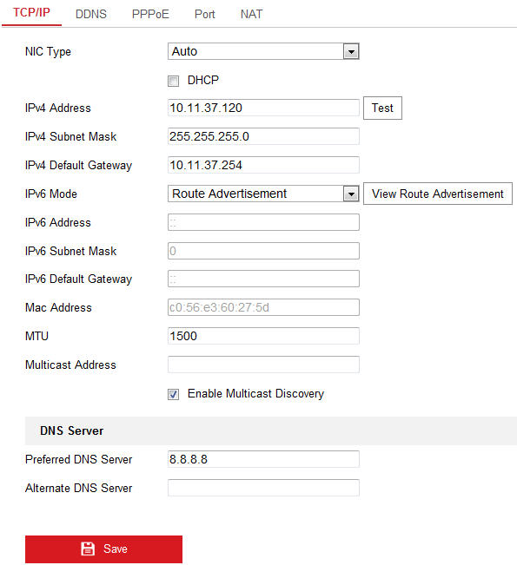
              - TCP/IP Settings
- Configure the basic network settings, including the NIC Type, IPv4 or IPv6 Address, IPv4 or IPv6 Subnet Mask, IPv4 or IPv6 Default Gateway, MTU settings and Multicast Address.
- (Optional) Check the checkbox of Enable Multicast Discovery, and then the online network camera can be automatically detected by client software via private multicast protocol in the LAN.
- Configure the DNS server. Input the preferred DNS server, and alternate DNS server.
- Click Save to save the above settings.
Notes:
- The valid value range of MTU is 1280 to 1500.
- The Multicast sends a stream to the multicast group address and allows multiple clients to acquire the stream at the same time by requesting a copy from the multicast group address. Before utilizing this function, you have to enable the Multicast function of your router.
- A reboot is required for the settings to take effect.

Configuring DDNS Settings
Purpose:
If your camera is set to use PPPoE as its default network connection, you can use the Dynamic DNS (DDNS) for network access.
Before you start:
Registration on the DDNS server is required before configuring the DDNS settings of the camera.
Steps:
- Enter the DDNS Settings interface: Configuration > Network > Basic Settings > DDNS.
- Check the Enable DDNS checkbox to enable this feature.
- Select DDNS Type. Two DDNS types are selectable: DynDNS and NO-IP.
  - DynDNS:
Steps:
- Enter Server Address of DynDNS (e.g. members.dyndns.org).
- In the Domain text field, enter the domain name obtained from the DynDNS website.
- Enter the User Name and Password registered on the DynDNS website.
- Click Save to save the settings.
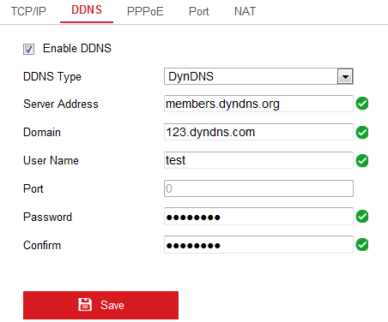
              - DynDNS Settings
  - NO-IP:
Steps:
- Choose the DDNS Type as NO-IP.
              - NO-IP DNS Settings
- Enter the Server Address as www.noip.com
- Enter the Domain name you registered.
- Enter the User Name and Password.
- Click Save and then you can view the camera with the domain name.
Note: Reboot the device to make the settings take effect.

Configuring Port Settings
Purpose:
You can set the port No. of the camera, e.g., HTTP port, RTSP port and HTTPS port.
Steps:
- Enter the Port Settings interface, Configuration > Network > Basic Settings > Port
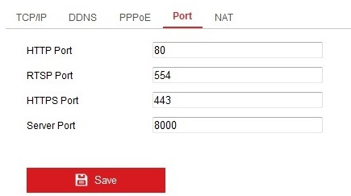
              - Port Settings
- Set the HTTP port, RTSP port, HTTPS port and server port of the camera.
HTTP Port: The default port number is 80, and it can be changed to any port No. which is not occupied.
RTSP Port: The default port number is 554 and it can be changed to any port No. ranges from 1 to 65535.
HTTPS Port: The default port number is 443, and it can be changed to any port No. which is not occupied.
Server Port: The default server port number is 8000, and it can be changed to any port No. ranges from 2000 to 65535.
- Click Save to save the settings.
Note: A reboot is required for the settings to take effect.

Configure NAT (Network Address Translation) Settings
Purpose:
NAT interface allows you to configure the UPnP™ parameters.
Universal Plug and Play (UPnP™) is a networking architecture that provides compatibility among networking equipment, software and other hardware devices. The UPnP protocol allows devices to connect seamlessly and to simplify the implementation of networks in the home and corporate environments.
With the function enabled, you don’t need to configure the port mapping for each port, and the camera is connected to the Wide Area Network via the router.
Steps:
- Enter the NAT settings interface. Configuration > Network > Basic Settings > NAT.
- Check the checkbox to enable the UPnP™ function.
- Choose a nickname for the camera, or you can use the default name.
- Select the port mapping mode. Manual and Auto are selectable. And for manual port mapping, you can customize the value of the external port.
- Click Save to save the settings.
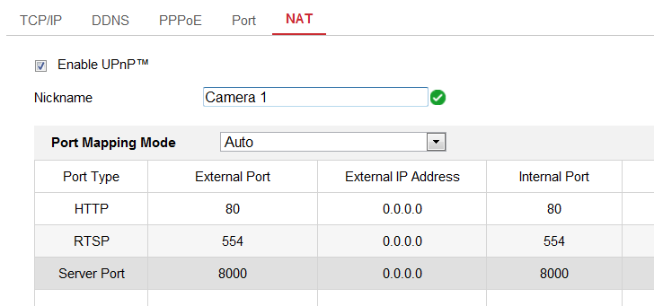
              - UPnP Settings

Configure Advanced Settings
Purpose:
You can configure the parameters, including SNMP, FTP, Email, HTTPS, QoS, 802.1x, etc., by following the instructions in this section.

Configuring FTP Settings
Purpose:
You can configure the FTP server related information to enable the uploading of the captured pictures to the FTP server. The captured pictures can be triggered by events or a timing snapshot task.
Steps:
- Enter the FTP Settings interface: Configuration > Network > Advanced Settings > FTP.
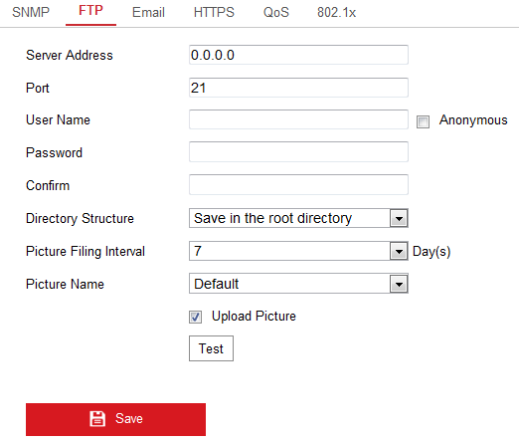
              - FTP Settings
- Input the FTP address and port.
- Configure the FTP settings; and the user name and password are required for the FTP server login.

- For your privacy and to better protect your system against security risks, we strongly recommend the use of strong passwords for all functions and network devices. The password should be something of your own choosing (using a minimum of 8 characters, including at least three of the following categories: upper case letters, lower case letters, numbers and special characters) in order to increase the security of your product.
- Proper configuration of all passwords and other security settings is the responsibility of the installer and/or end-user.
- Set the directory structure and picture filing interval.
Directory: In the Directory Structure field, you can select the root directory, parent directory and child directory. When the parent directory is selected, you have the option to use the Device Name, Device Number or Device IP for the name of the directory; and when the Child Directory is selected, you can use the Camera Name or Camera No. as the name of the directory.
- Check the Upload Picture checkbox to enable the function.
Upload Picture: To enable uploading the captured picture to the FTP server.
Anonymous Access to the FTP Server (in which case the user name and password won’t be required.): Check the Anonymous checkbox to enable the anonymous access to the FTP server.
Note: The anonymous access function must be supported by the FTP server.
- Click Save to save the settings.

Configuring Email Settings
Purpose:
The system can be configured to send an Email notification to all designated receivers if an alarm event is detected, e.g., motion detection event, video loss, video tampering, etc.
Before you start:
Please configure the DNS Server settings under Configuration > Network > Basic Settings > TCP/IP before using the Email function.
Steps:
- Enter the TCP/IP Settings (Configuration > Network > Basic Settings > TCP/IP) to set the IPv4 Address, IPv4 Subnet Mask, IPv4 Default Gateway and the Preferred DNS Server.
Note: Please refer to Section 7.1.1 Configuring TCP/IP Settings for detailed information.
- Enter the Email Settings interface: Configuration > Network >Advanced Settings > Email.
- Configure the following settings:
Sender: The name of the email sender.
Sender’s Address: The email address of the sender.
SMTP Server: IP address or host name (e.g., smtp.263xmail.com) of the SMTP Server.
SMTP Port: The SMTP port. The default TCP/IP port for SMTP is 25 (not secured). And the SSL SMTP port is 465.
Email Encryption: None, SSL, and TLS are selectable. When you select SSL or TLS and disable STARTTLS, e-mails will be sent after encrypted by SSL or TLS. The SMTP port should be set as 465 for this encryption method. When you select SSL or TLS and enable STARTTLS, emails will be sent after encrypted by STARTTLS, and the SMTP port should be set as 25.
Note: If you want to use STARTTLS, make sure that the protocol is supported by your e-mail server. If you check the Enable STARTTLS checkbox when the protocol is not supported by your e-mail sever, your e-mail will not be encrypted.
Attached Image: Check the checkbox of Attached Image if you want to send emails with attached alarm images.
Interval: The interval refers to the time between two actions of sending attached pictures.
Authentication (optional): If your email server requires authentication, check this checkbox to use authentication to log in to this server and input the login user name and password.
- For your privacy and to better protect your system against security risks, we strongly recommend the use of strong passwords for all functions and network devices. The password should be something of your own choosing (using a minimum of 8 characters, including at least three of the following categories: upper case letters, lower case letters, numbers and special characters) in order to increase the security of your product.
- Proper configuration of all passwords and other security settings is the responsibility of the installer and/or end-user.
The Receiver table: Select the receiver to which the email is sent. Up to 3 receivers can be configured.
Receiver: The name of the user to be notified.
Receiver’s Address: The email address of user to be notified.
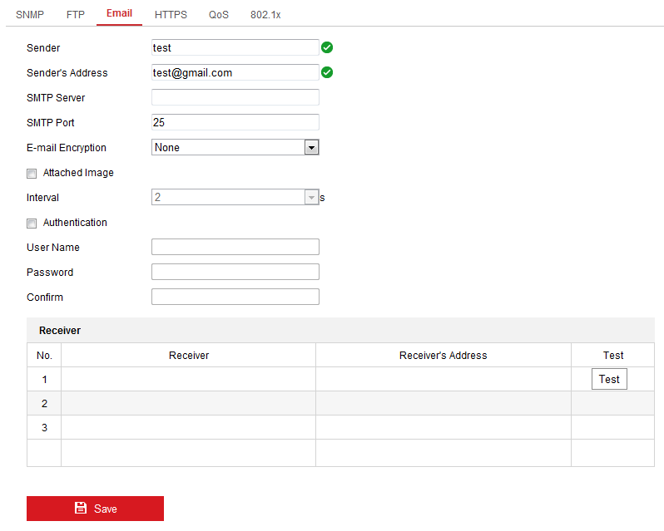
              - Email Settings
- Click Save to save the settings.

HTTPS Settings
Purpose:
HTTPS provides authentication of the web site and its associated web server, which protects against Man-in-the-middle attacks. Perform the following steps to set the port number of https.
E.g., If you set the port number as 443 and the IP address is 192.168.1.64, you may access the device by inputting https://192.168.1.64:443 via the web browser.
Steps:
- Enter the HTTPS settings interface. Configuration > Network > Advanced Settings > HTTPS.
- Check the checkbox of Enable to enable the function.
- Create the self-signed certificate or authorized certificate.
  - Create the self-signed certificate
- Select Create Self-signed Certificate as the Installation Method.
- Click Create button to enter the creation interface.
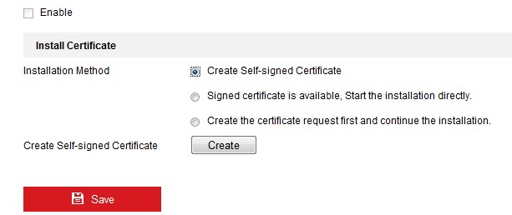
              - Create Self-signed Certificate
- Enter the country, host name/IP, validity and other information.
- Click OK to save the settings.
Note: If you already had a certificate installed, the Create Self-signed Certificate is grayed out.
  - Create the authorized certificate
- Select Create the certificate request first and continue the installation as the Installation Method.
- Click Create button to create the certificate request. Fill in the required information in the popup window.
- Download the certificate request and submit it to the trusted certificate authority for signature.
- After receiving the signed valid certificate, import the certificate to the device.
- There will be the certificate information after your successfully creating and installing the certificate.
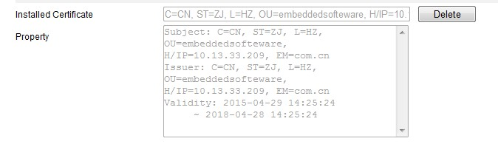
              - Installed Certificate
- Click the Save button to save the settings.

Configuring QoS Settings
Purpose:
QoS (Quality of Service) can help solve the network delay and network congestion by configuring the priority of data sending.
Steps:
- Enter the QoS Settings interface: Configuration > Network > Advanced Settings > QoS
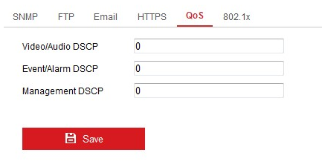
              - QoS Settings
- Configure the QoS settings, including Video/Audio DSCP, Event/Alarm DSCP and Management DSCP.
The valid value range of the DSCP is 0 to 63. The bigger the DSCP value is, the higher the priority is.
Note: DSCP refers to the Differentiated Service Code Point; and the DSCP value is used in the IP header to indicate the priority of the data.
- Click Save to save the settings.
Note: A reboot is required for the settings to take effect.

Configuring 802.1X Settings
Purpose:
The IEEE 802.1X standard is supported by the network cameras, and when the feature is enabled, the camera data is secured and user authentication is needed when connecting the camera to the network protected by the IEEE 802.1X.
Before you start:
The authentication server must be configured. Please apply and register a user name and password for 802.1X in the server.
- For your privacy and to better protect your system against security risks, we strongly recommend the use of strong passwords for all functions and network devices. The password should be something of your own choosing (using a minimum of 8 characters, including at least three of the following categories: upper case letters, lower case letters, numbers and special characters) in order to increase the security of your product.
- Proper configuration of all passwords and other security settings is the responsibility of the installer and/or end-user.
Steps:
- Enter the 802.1X Settings interface, Configuration > Network > Advanced Settings > 802.1X
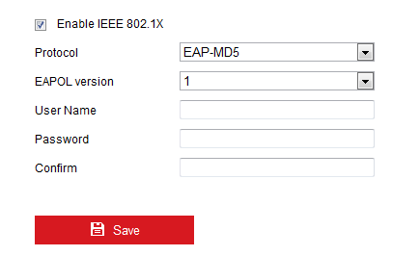
              - 802.1X Settings
- Check the Enable IEEE 802.1X checkbox to enable the feature.
- Configure the 802.1X settings, including Protocol, EAPOL version, User Name, Password and Confirm.
Note: The EAPOL version must be identical with that of the router or the switch.
- Enter the user name and password to access the server.
- Click Save to finish the settings.
Note: A reboot is required for the settings to take effect.

Video/Audio Settings

Configuring Video Settings
Steps:
- Enter the Video Settings interface, Configuration > Video/Audio > Video
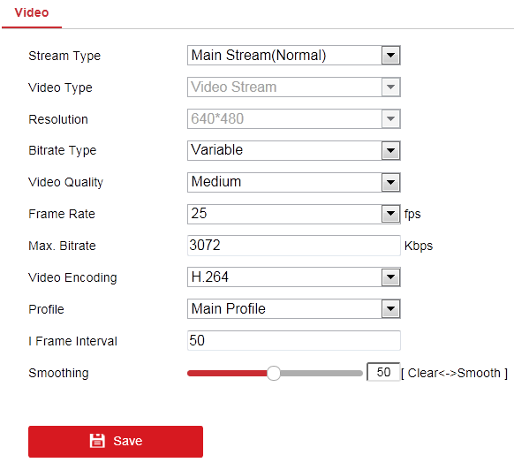
              - Video Settings
- Select the Stream Type of the camera to main stream (normal) or sub-stream.
Notes: The main stream is usually for recording and live view with good bandwidth, and the sub-stream can be used for live view when the bandwidth is limited.
- You can customize the following parameters for the selected stream type.
Video Type:
Select the stream type to video stream, or video & audio composite stream. The audio signal will be recorded only when the Video Type is Video & Audio.
Resolution:
Select the resolution of the video output.
Bitrate Type:
Select the bitrate type to constant or variable.
Video Quality:
When bitrate type is selected as Variable, 6 levels of video quality are selectable.
Frame Rate:
Set the frame rate. The frame rate is to describe the frequency at which the video stream is updated and it is measured by frames per second (fps). A higher frame rate is advantageous when there is movement in the video stream, as it maintains image quality throughout.
Max. Bitrate:
Set the max. bitrate from 32 to 16384 Kbps. The higher value corresponds to the higher video quality, but the better bandwidth is required.
Note: The maximum limit of the max. bitrate value varies according to different camera platforms. For certain cameras, the maximum limit is 8192 Kbps or 12288 Kbps.
Max. Average Bitrate:
When you set a maximum bitrate, its corresponding recommended maximum average bitrate will be shown in the Max. Average Bitrate box. You can also set the maximum average bitrate manually from 32 Kbps to the value of the set maximum bitrate.
Profile:
Basic profile, Main Profile, and High Profile for coding are selectable.
I Frame Interval:
Set I Frame Interval from 1 to 400.
Smoothing:
It refers to the smoothness of the stream. The higher value of the smoothing is, the better fluency of the stream will be, though, the video quality may not be so satisfactory. The lower value of the smoothing is, the higher quality of the stream will be, though it may appear not fluent.
- Click Save to save the settings.
Note:
The video parameters vary according to different camera models. Refer to the actual display page for camera functions.

Image Settings
Purpose:
Follow the instructions in this chapter to configure the image parameters, including display settings, and OSD settings.

Configuring Display Settings
Purpose:
Configure the image adjustment, exposure settings, day/night switch, backlight settings, white balance, image enhancement, video adjustment, and other parameters in display settings.
Note: The display parameters vary according to the different camera models. Please refer to the actual interface for details.
Steps:
- Enter the Display Settings interface, Configuration > Image > Display Settings.
- Image Adjustment
Brightness describes bright of the image, which ranges from 1 to 100.
Sharpness describes the edge contrast of the image, which ranges from 1 to 100.
- Exposure Settings
If the camera is equipped with the fixed lens, only Manual is selectable, and the iris mode is not configurable.
The Exposure Time refers to the electronic shutter time, which ranges from 1 to 1/100,000s. Adjust it according to the actual luminance condition.
Gain of image can also be manually configured from 0 to 100. The bigger the value is, the brighter would the image be, and the noise would also be amplified to a larger extent.
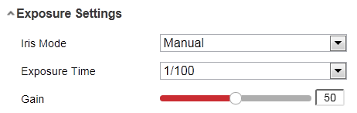
              - Exposure Settings
- Day/Night Switch
Day/Night Switch controls the status of supplement light.
Day, Night, Auto, and Scheduled-Switch are selectable for day/night switch.
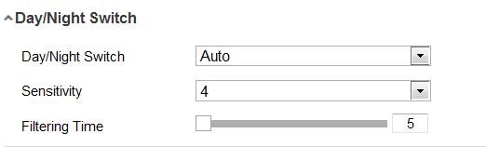
              - Day/Night Switch
Day: the camera stays at day mode.
Night: the camera stays at night mode.
Auto: the camera switches between the day mode and the night mode according to the illumination automatically. The sensitivity ranges from 0 to 7, the higher the value is, the easier the mode switches. The filtering time refers to the interval time between the day/night switch. You can set it from 5s to 120s.
Scheduled-Switch: Set the start time and the end time to define the duration for day/night mode.
- Image Enhancement
Digital Noise Reduction: DNR reduces the noise in the video stream. OFF, Normal and Expert are selectable. Set the DNR level from 0 to 100 in Normal Mode.
- Video Adjustment
Video Standard: 50 Hz and 60 Hz are selectable. Choose according to the different video standards; normally 50 Hz for PAL standard and 60 Hz for NTSC standard.
Capture Mode: It’s the selectable video input mode to meet the different demands of field of view and resolution.

Configuring OSD Settings
Purpose:
You can customize the camera name, time/date format, display mode, and OSD size displayed on the live view.
Steps:
- Enter the OSD Settings interface: Configuration > Image > OSD Settings.
- Check the corresponding checkbox to select the display of camera name, date or week if required.
- Edit the camera name in the text field of Camera Name.
- Select from the drop-down list to set the time format and date format.
- Select from the drop-down list to set the time format, date format, display mode, OSD size and OSD color.
- Configure the text overlay settings.
- Check the checkbox in front of the textbox to enable the on-screen display.
- Input the characters in the textbox.
- Click Save to save the settings.

Event Settings

Basic Events
You can configure the basic events by following the instructions in this section, including video tampering, alarm input, alarm output, and exception, etc. These events can trigger the linkage methods, such as Notify Surveillance Center, Send Email, Trigger Alarm Output, etc.
Note: Check the checkbox of Notify Surveillance Center if you want the alarm information to be pushed to PC or mobile client software as soon as the alarm is triggered.

Configuring Video Tampering Alarm
You can configure the camera to trigger the alarm when the lens is covered and take certain alarm response actions.
Steps:
- Enter the video tampering Settings interface, Configuration > Event > Basic Event > Video Tampering.
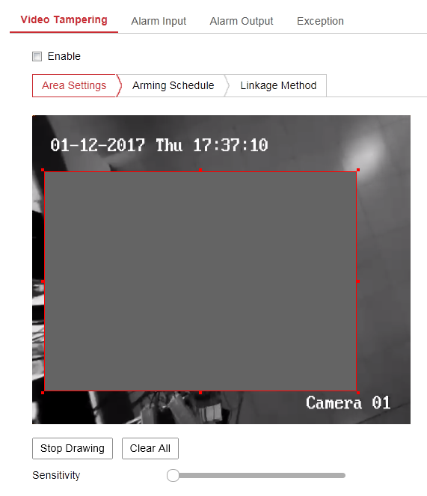
              - Video Tampering Alarm
- Check Enable Video Tampering checkbox to enable the video tampering detection.
- Set the video tampering area.
- Set arming schedule for video tampering. Refer to Section .
- Check the checkbox to select the linkage method taken for the video tampering. Refer to Section 1.2.3.
- Click Save to save the settings.

Configuring Alarm Input
Steps:
- Enter the Alarm Input Settings interface: Configuration > Event > Basic Event > Alarm Input.
- Choose the alarm input No. and the Alarm Type. The alarm type can be NO (Normally Open) and NC (Normally Closed). Edit the name to set a name for the alarm input (optional).
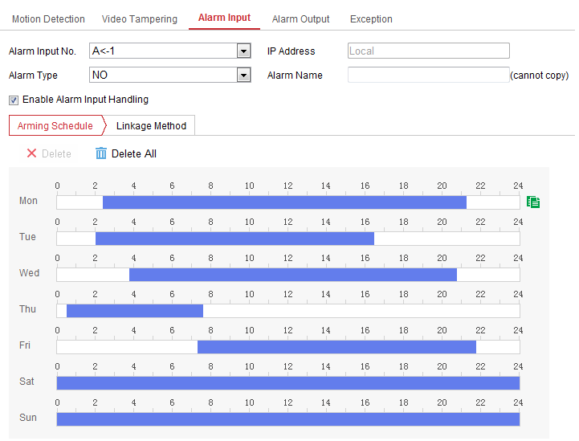
              - Alarm Input Settings
- Click Arming Schedule to set the arming schedule for the alarm input. Refer to Section .
- Click Linkage Method and check the checkbox to select the linkage method taken for the alarm input. Refer to Section 1.2.3.
- You can copy your settings to other alarm inputs.
- Click Save to save the settings.

Configuring Alarm Output
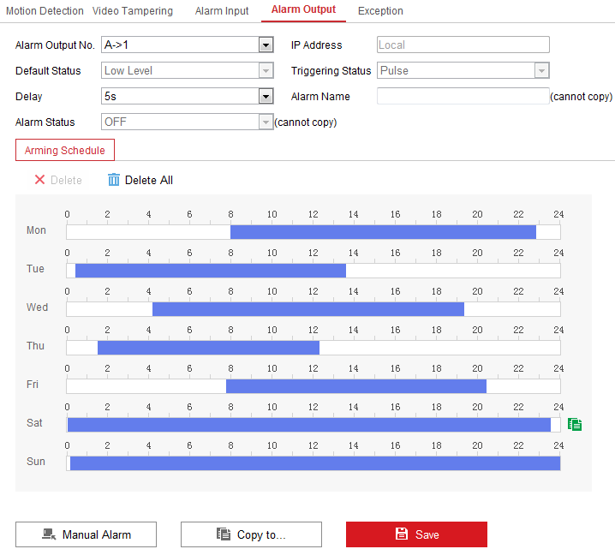
              - Alarm Output Settings
Steps:
- Enter the Alarm Output Settings interface: Configuration> Event > Basic Event > Alarm Output.
- Select one alarm output channel in the Alarm Output drop-down list. You can also set a name for the alarm output (optional).
- The Delay time can be set to 5sec, 10sec, 30sec, 1min, 2min, 5min, 10min or Manual. The delay time refers to the time duration that the alarm output remains in effect after alarm occurs.
- Click Arming Schedule to enter the Edit Schedule Time interface. The time schedule configuration is the same as the settings of the arming schedule for motion detection. Refer to Section .
- You can copy the settings to other alarm outputs.
- Click Save to save the settings.

Handling Exception
The exception type can be HDD full, HDD error, network disconnected, IP address conflicted and illegal login to the cameras.
Steps:
- Enter the Exception Settings interface: Configuration > Event > Basic Event > Exception.
- Check the checkbox to set the actions taken for the Exception alarm. Refer to Section 1.2.3.
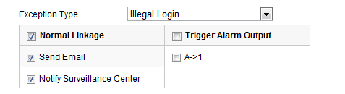
              - Exception Settings
- Click Save to save the settings.

Appendix

Appendix 1 SADP Software Introduction
- Description of SADP
SADP (Search Active Devices Protocol) is a kind of user-friendly and installation-free online device search tool. It searches the active online devices within your subnet and displays the information of the devices. You can also modify the basic network information of the devices using this software.
- Search active devices online
  - Search online devices automatically
After launch the SADP software, it automatically searches the online devices every 15 seconds from the subnet where your computer locates. It displays the total number and information of the searched devices in the Online Devices interface. Device information including the device type, IP address and port number, etc. will be displayed.
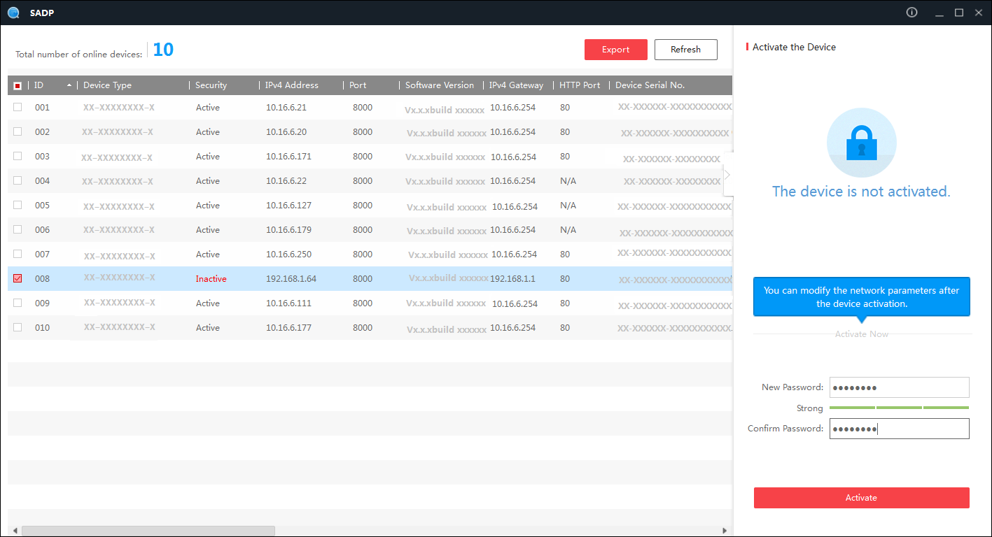
Figure A.1.1 Searching Online Devices
Note:
Device can be searched and displayed in the list in 15 seconds after it went online; it will be removed from the list in 45 seconds after it went offline.
  - Search online devices manually
You can also click 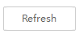 to refresh the online device list manually. The newly searched devices will be added to the list.
 You can click or on each column heading to order the information; you can click to expand the device table and hide the network parameter panel on the right side, or click to show the network parameter panel.
- Modify network parameters
Steps:
- Select the device to be modified in the device list and the network parameters of the device will be displayed in the Modify Network Parameters panel on the right side.
- Edit the modifiable network parameters, e.g. IP address and port number.
- Enter the password of the admin account of the device in the Admin Password field and click  to save the changes.

- For your privacy and to better protect your system against security risks, we strongly recommend the use of strong passwords for all functions and network devices. The password should be something of your own choosing (using a minimum of 8 characters, including at least three of the following categories: upper case letters, lower case letters, numbers and special characters) in order to increase the security of your product.
- Proper configuration of all passwords and other security settings is the responsibility of the installer and/or end-user.
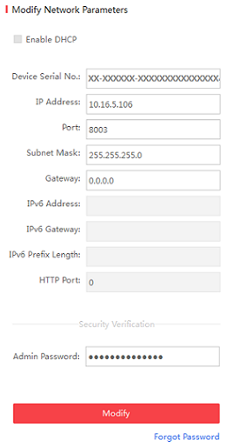
Figure A.1.2 Modify Network Parameters

Appendix 2 Port Mapping
The following settings are for TP-LINK router (TL-WR641G). The settings vary depending on different models of routers.
Steps:
- Select the WAN Connection Type, as shown below:
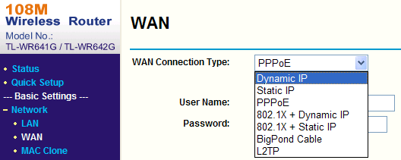
Figure A.2.1 Select the WAN Connection Type

- Set the LAN parameters of the router as in the following figure, including IP address and subnet mask settings.
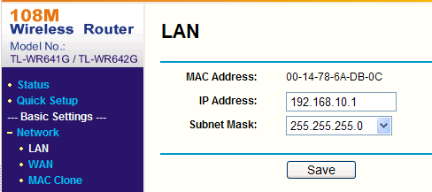
Figure A.2.2 Set the LAN parameters

- Set the port mapping in the virtual severs of Forwarding. By default, camera uses port 80, 8000 and 554. You can change these ports value with web browser or client software.
Example:
When the cameras are connected to the same router, you can configure the ports of a camera as 80, 8000, and 554 with IP address 192.168.1.23, and the ports of another camera as 81, 8001, 555, 8201 with IP 192.168.1.24. Refer to the steps as below:
Steps:
- As the settings mentioned above, map the port 80, 8000, 554 and 8200 for the network camera at 192.168.1.23
- Map the port 81, 8001, 555 and 8201 for the network camera at 192.168.1.24.
- Enable ALL or TCP protocols.
- Check the Enable checkbox and click Save to save the settings.
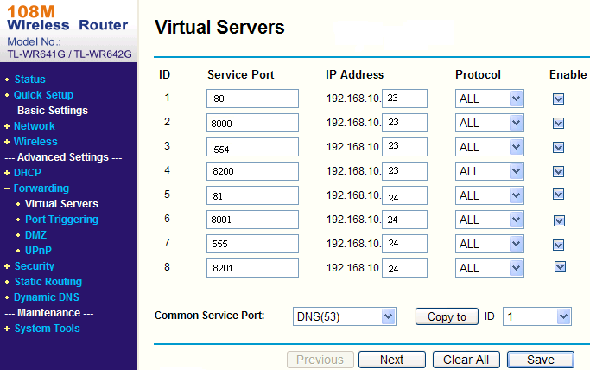
Figure A.2.3 Port Mapping

Note: The port of the network camera cannot conflict with other ports. For example, some web management port of the router is 80. Change the camera port if it is the same as the management port.



